Executive summary
Introduction
Centre for Mental Health was commissioned by Dudley Metropolitan Borough Council to assess the social, emotional and mental health needs of the borough’s children and young people, aged up to 25.
The Centre’s report is presented in four parts:
- An assessment of children and young people’s needs for mental health support in Dudley, using local and national data and intelligence
- A review of existing provision for children and young people’s mental health, drawing on information from services and consultations with professionals, parents and carers and young people in the borough
- An assessment of the gaps between current need and provision and the opportunities to improve support to children, young people and families in Dudley
- An analysis of priority areas for action going forward and recommendations on how these might best be addressed.

- Needs assessment
Children and young people’s mental health
One child in ten and one-fifth of young adults have a diagnosable mental health difficulty at any one time. Many more will be struggling to thrive or will have difficulties that put them at risk of poor mental health without effective early help.
At any one time, a child or young person may be anywhere on a spectrum between being healthy and unwell (see figure 1). There is a wide range of interventions that can help to promote children’s wellbeing at any age.
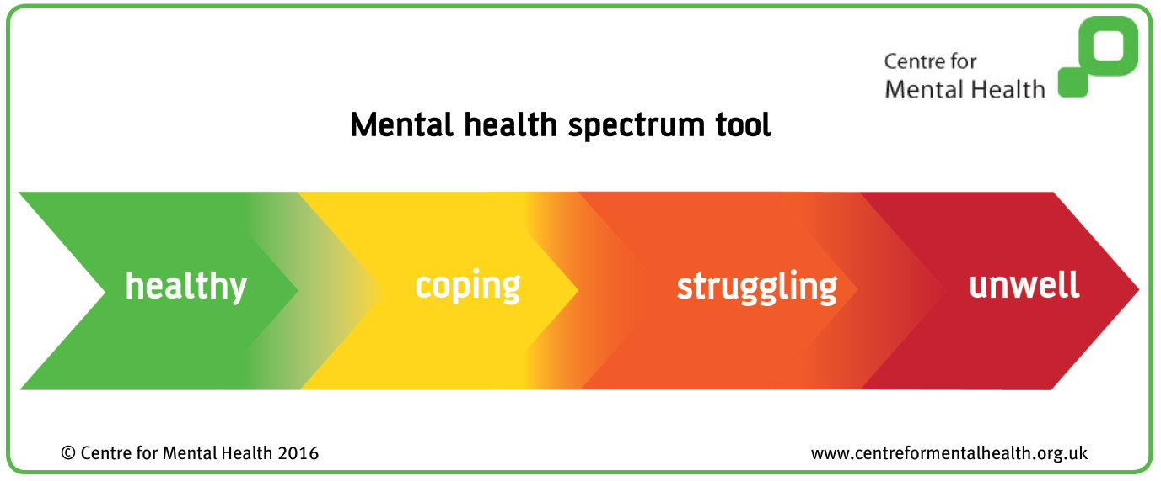
Figure 1: mental health spectrum of need tool
Good mental health is a foundation stone for healthy child development, for attainment at school and for a productive adult life.
Children’s mental health is everyone’s business. From the first spark of life, any public service coming into contact with a family can influence a child’s mental health.
Children and young people in Dudley
There are 93,291 children and young people aged 0-25 in Dudley, 60,000 of whom are under 17. About one-fifth of the school-age population is from a minority ethnic community. There are wide variations in income between and sometimes within localities in the borough, and an estimated 12,795 children live in poverty.
Surveys conducted in Dudley between 2012 and 2016 indicate that children and college students in the borough have slightly higher levels of wellbeing than the national average.
Any child can experience poor mental health but some face higher risks than others. Children facing the highest risks of poor mental health include:
- Children whose mothers have mental health difficulties during and after pregnancy (approximately 564 children born each year in Dudley)
- Children whose mothers smoke during pregnancy (601 a year)
- Children exposed to maltreatment and violence (10,000 children aged 0-16 at any one time)
- Children with lone parents (4,550) or in households where no adult is in employment (3,120) or at least one parent has a long-term disability (3,415)
- Children with poor school readiness (7,743)
- Children who are bullied (5,279 in primary schools and 3,887 in secondary schools) and those who bully
- Children with learning disabilities (2,895) or speech and language difficulties (1,550)
- Young carers (380 aged under 16 and 1,700 aged 16-24)
- Young people in the youth justice system (of whom 135 a year enter the system for the first time in Dudley)
Many children will face several of these risk factors. Those with the most risks and the most prolonged exposure are at greatest risk of poor mental health.
Looked After Children have an especially high risk of poor mental health. Dudley has a high rate of Looked After Children: a total of 653 of whom at least an estimated 261 (40%) are likely to have a diagnosable mental health difficulty.
Mental health needs among children in Dudley
Most children enjoy good mental health but will benefit from universal programmes that promote good mental health, coping skills and resilience for all. Others are at risk of poor mental health and they need targeted or early support to strengthen their wellbeing and reduce the risks they face. A number experience common mental health problems and a minority have complex, diagnosable difficulties for which they need specialist help – including in a small number of children needing highly specialist help.
We have assessed how many children and young people of different age groups in Dudley are likely to be at each of these levels at any point in time.
Infants aged 0-5
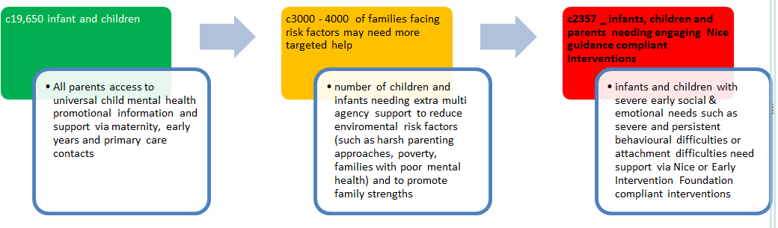
Figure 2 summarises opportunities to promote infant and child mental health providing broad estimates of the number of children in Dudley facing risks and with diagnosable level needs.
Figure 2: estimate of likely social, emotional and mental health need in 0 to 4 year olds in Dudley
Children and young people aged 5-16
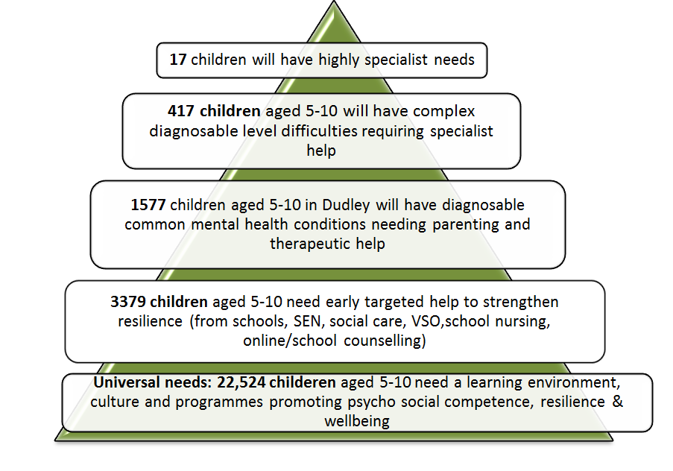
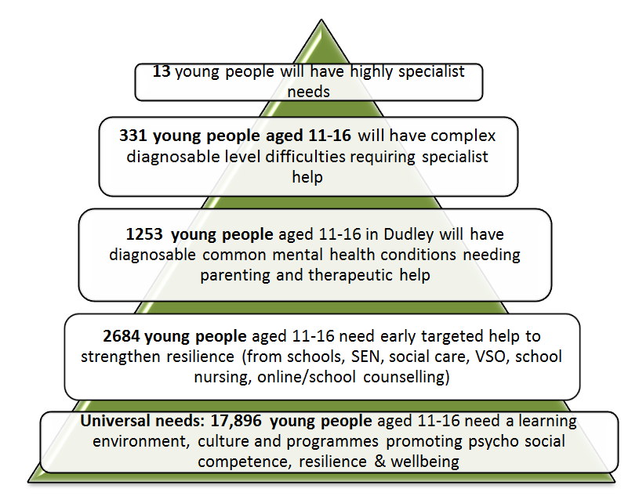
Figures 3 and 4 summarise how many school aged children and young people you would expect to find presenting with various different levels of need in Dudley. All children and young people should receive some input to strengthen their mental health and well being, some will be exposed to risk factors which undermine their mental health requiring whole system responses to strengthen resilience. A smaller number will have common diagnosable mental health conditions and will require swift action to support and restore mental health.
Figure 3 children aged 5-10 years and their social, emotional and mental health needs
Figure 4: young people aged 11-16 years and their social, emotional and mental health needs

Young adults, 16-24
The table below summarises the numbers of young people and young adults likely to present with diagnosable or subthreshold distress. As is the case with earlier age ranges, young people at this age still require support to develop their resileince as they transition to adult years.
Likely numbers of 16-24 year olds in Dudley with diagnosable level and sub threshold mental health difficulties based on 2016 population estimates.
 | Likely diagnosable rates (2016 population estimate) | Estimate of lower level difficulties/symptoms who may need some support (based on 2016 population estimate)
Common mental health difficulties (e.g. anxiety and depression) | 3,023 | 1,289
PTSD – current positive screen | 1,561 | NA
Eating disorders | 1,163 | 4,352
ADHD | 365 | 4,584
Psychosis | 66 | NA
Anti-social personality disorder | 266 | NA
Borderline personality disorder | 100 | NA
Total | 6,544 | 10,225

- Review of current provision in Dudley
The Centre spoke with 195 people, including service providers, practitioners, parents, carers and young people about children and young people’s mental health in Dudley. The professionals we consulted were from across the child, youth and family workforce in the borough, including schools and social care.
We found a widespread recognition that children’s mental health was everyone’s business and passion and commitment among staff in all services to get it right for children and young people.
Major concerns were expressed about the lack of prevention and early intervention to build strong mental health among children and offer effective help before problems escalate into eventual crisis.
Young people wanted trusted and open access help that didn’t hurry them, placed their views and wishes centre stage and helped them quickly get back on track when their resilience or mental health was tested. They very much disliked being assessed and categorised when they were in distress. Parents also wanted support that listened to their perspective, was compassionate, that provided practical advice and strategies and that worked in partnership with them.
Missed opportunities identified in the consultations included:
- Insufficient focus on promoting children and young people’s resilience and mental health as they grew
- A lack of attention to and coordinated action to address adverse childhood experiences and family-based risk factors for poor mental health
- Poor early intervention when children became unwell
- A confusing pathway when attempting to secure help
Many respondents described a system of support for children’s mental health in Dudley that gravitated towards children slipping into crisis. Parents, young people and many professionals seeking help described long waits and high thresholds, especially for specialist services but also for other community therapeutic services. Insufficient therapeutic services for children with common mental health problems (for example school and community counselling) was a major concern, which put added pressure on specialist services.
Referrals systems for getting help were described as confusing and frustrating. Changes to specialist CAMHS referral processes (perceived by many as now requiring a GP referral) were said to have left parents ‘passed from pillar to post’ and facing ‘dead ends’ in the system. This was seen particularly to disadvantage parents with the biggest risk factors with less trust in formal services.
Fragmentation of provision was another major concern, with services described as being increasingly complex yet with poor inter-agency working and services ‘retreating into silos’ because of budget cuts.
Schools felt they were under particular pressure to manage a perceived growth in poor mental health among children and young people. But many also expressed positive views about recent developments, including the healthy Schools initiative, increased visibility of schools nurses and having a named educational psychologist.
There was widespread agreement that services should be led and informed by the needs, wishes and views of children, young people and their parents and carers. Parents, carers and young people said they wanted easier access to help, to be listened to and seen as partners in support, and to get earlier help to prevent or de-escalate problems. Many spoke of considerable difficulties in getting early help before they got into a crisis, of not having their views or experiences heard. A small minority described getting good quality help and the difference it made to them.
- Current provision and opportunities for improvement
Universal services
There is little data about current provision of universal services to support all children’s wellbeing and mental health. Priority areas for development in Dudley should include:
- Improving help for women during pregnancy, for example to identify and treat those with mental health difficulties and to stop smoking
- Taking effective action to reduce levels of maltreatment, for example adopting programmes such as Child First
- Building mental health literacy among parents to help them give their child the best start, talk to their children and find the right help
- Supporting schools and colleges to take a ‘whole school approach’, including anti-bullying interventions, having social and emotional learning programmes in classrooms and a youth and staff ‘champion’ in every school.
Targeted services
Targeted services help children who are exposed to higher environmental risks and whose wellbeing is often already beginning to deteriorate. It is estimated that around 6,000 children, young people and families in Dudley will need extra help to strengthen their resilience or to prevent incremental deterioration of wellbeing. Data on coordinated activity to strengthen family child and youth resilience was not drawn together in Dudley so the full scale of current support is unclear. However, the broader consultation took the view that more could be done to promote family, child and youth assets and wellbeing. Young people facing challenges to their wellbeing wanted an open access resource at such points so that they could get the right amount of help when they needed it. Kooth.com (an online counselling service) was an example of this type of resource reaching around 800 young people a year. However, there was also evidence from young people that they wanted face to face help.
Services for children and young people with common mental health problems.
Data on services dealing with more common mental health difficulties (e.g. anxiety and depression, behavioural problems and anger) suggested a major shortfall in what was currently available. Services at this level currently include:
- School and other counselling services
- The What Centre (which also provides specialist support)
- Triple P Parenting programmes
- Kooth.com online help
- The Phase Trust (which works with more vulnerable groups).
We estimate that these services currently reach about 1,403 children a year, considerably below the estimated number of children with these more common diagnosable mental health difficulties (2,830). This is a significant shortfall which is probably the major driver for therapeutic services/specialist CAMHS feeling ‘overloaded’.
We also estimate that Triple P parenting support only currently reaches about 14% of the families who could benefit from this evidence-based intervention which provides proven strategies for settling children’s behaviour. Severe behavioural problems are the most common childhood mental health problem.
Specialist CAMHS services
Children and young people with more complex needs and serious mental health difficulties predominantly receive help from specialist CAMHS in Dudley. Current provision includes a specialist CAMHS team with 32 WTE practitioners (including Early Intervention in Psychosis), a specialist learning disability CAMHS team (3.4 WTE), a CAMHS deaf team and a part-time Youth Offending Team worker.
A team previously working with Looked After Children no longer exists. This represents a significant gap in provision given the large numbers of children in care in Dudley.
Specialist CAMHS (and to a lesser extent The What?Centre and the Barnardos First Step counselling service for victims of sexual abuse) also operate to meet young people’s needs at this level. All have waiting lists some of which are very lengthy.
Specialist CAMHS receive about 2,000 referrals a year and accept around 95% of referrals. This is broadly in line with the estimated numbers likely to present with serious and complex mental health needs in Dudley (approx. 1,800 a year). They provide a range of interventions and a limited eating disorder service but no Home Treatment Team for young people in a crisis and no CAMHS specific place of safety. The number of hospital admissions each year (21) is below the expected number (30) and lower than the national average but there are concerns about the lengths of stay in hospital for children and young people with acute difficulties, placement of children in inappropriate emergency settings when they are in mental health crisis and their location some distance from home.
The Centre received limited whole system data on children’s outcomes following contact with mental health services and on the current scale of financial investment in whole system social, emotional and mental health support. Consultation suggested that there was limited joint commissioning and few jointly developed shared outcomes in this area.
Transition to adults
It is not possible to estimate the numbers of young adults (18-24) receiving support for their mental health in Dudley. We estimate that about 3,000 young adults have a diagnosable difficulty (most of which will be common mental health problems) and from consultation responses it is likely that current provision falls well short of meeting young people’s needs. There is a particular need to support colleges to develop their offer for young people in Dudley.
- Implications and recommendations
Over the next 4 years, NHS England has committed to increasing investment in services supporting children and young people’s social, emotional and mental health identifying some key areas requiring national improvement (e.g. improved access, crisis care, eating disorders etc). However, any planned improvements must be firmly anchored in the specific needs of children, young people and families in Dudley.
Prevention and earlier intervention
- As a priority, Dudley needs to shift investment and whole-system activity from dealing with mental health crises to earlier intervention. This will give children and young people the best start, will help build resilience and will help facilitate early help to restore good mental health and benefit the public purse. Improved outcome data should be collected and monitored to evidence that this shift has taken place.

- A multi-stakeholder task and finish group (including parents, carers and young people) should work together developing a generic pathway for children’s social, emotional and mental health needs in Dudley. This pathway should help build a common language and understanding of everyone’s roles and contribution to promoting, de-escalating and responding effectively to improve children’s mental health.

- There are high numbers of Children in Need and Looked after Children in Dudley. Maltreatment is a significant risk factor for poor child mental health and life chances. Commissioners should consider jointly implementing more evidence based early intervention approaches to reduce maltreatment (e.g. Child First)

- Dudley’s commissioners should double the number of children with early starting severe behavioural difficulties aged 2-10 years whose parents are reached by Triple P and other NICE guidance compliant parenting interventions. This should result in reaching 200 more children and young people thereby contributing to half of annual NHS England goals to improve access.

- Schools and colleges are key settings for children and young people to access universal and targeted support. Whole School Approaches, social and emotional learning and anti-bullying programmes should be encouraged to promote strong resilience.

- Dudley’s commissioners should increase investment in talking therapies to address the current shortfall in pre CAMHS resources. The Centre supports proposals to develop Emotional Health and Wellbeing teams located in and working closely with schools/colleges, the broader workforce in day-to-day contact with children/young people and with GPs. A team of 5 workers would allow Dudley to intervene earlier with around another 200 children a year.

- The What?Centre and kooth.com should be fully commissioned to cover current delivery of talking therapies.
Access
- Improving access to help was a major concern of the majority of those consulted through this needs assessment. It requires urgent attention to improve children and young people’s access to help with close monitoring of data returns from all therapeutic providers to evidence change.

- Action is needed to simplify and clarify referral processes to specialist CAMHS.

High quality and relevant services that have the best chance of supporting change
- Dudley should work with regional partners to implement a Children and Young People’s Workforce IAPT training initiative which should support the work of all organisations providing therapeutic services in Dudley. An audit should take place of the extent to which current provision reflects CYP IAPT recommended activity.

- CYP and parent/carer satisfaction rates should be provided to commissioners and considered systematically for all therapeutic services locally.
Addressing crisis
- The priority in Dudley at present is to address pressing gaps in early intervention to prevent children’s escalation into crisis. Once inroads are made into earlier unmet need, a Home Treatment Service should be developed in Dudley. Current data indicates that it should primarily meet the needs of young people presenting with patterns of serious self-harm.
Integrated activity and working
- A multi-disciplinary workforce development plan should be produced. During consultation the workforce and parents/carers also expressed interest in more opportunities for joint training on the social, emotional and mental health needs of children.

- All agencies in Dudley should work together on a range of detailed whole sector pathways focusing on specific priority issues highlighted by this needs assessment including ‘supporting healthy behaviour’ (including anti- bullying activity, school exclusion and CSE prevention and de-escalation and ADHD pathway development), promoting attachment and helping children affected by trauma.

- Approaches that support positive outcomes for children and young people’s emotional health and well-being should be built into all contracts and service specifications in Dudley.

- There is a need for more joint commissioning arrangements and the creation of a jointly agreed social, emotional and mental health strategic framework and outcomes for supporting children, young people and families in Dudley. Outcomes should make sense to children, young people and children.

- Commissioners should produce a dashboard of key performance indicators tightly drawing together whole system activity. These should be reviewed quarterly by the Transformation Board and Children’s Alliance Board. Data should feed into the Five Year Forward View Dashboard.

Increasing children’s, young people’s and parents/carers’ active participation in shaping the system
- The Transformation Board should have a broader membership including wider voluntary sector representatives, parent/carers and young people.

- A task and finish group (including therapeutic providers, social care, parents/carers and children and young people) should be created to facilitate better partnership between parents/carers and local therapeutic services.

- Work should continue with local young people to co-develop and design the best model of early ‘open access’ help for local children and young people.

- Commissioners, school forum leads, parent/carers and children should work together to create an age-appropriate social, emotional, mental health and wellbeing template which can be adapted for school/college websites. This should help local children and families access good quality information on child and youth mental health and improve signposting to help and advice.

- The Dudley Governance structure for social, emotional and mental health should include a systematic process for children, young people and parents/carers to feed into, shape and refine developments.
Vulnerable children
- Looked after Children and children with child sexual exploitation have needs which are unmet in Dudley. A therapeutic team (made up of specialist CAMHS workers, primary mental health support workers and outreaching voluntary sector organisations) should be re-commissioned to support these needs and to provide practical advice and support to foster parents in the borough.

- There should be consideration of the feasibility of implementing personal budgets for Looked after Children (as encouraged by NHS England).

- Task and finish groups should consider how well the needs of other more vulnerable children and young people are met in Dudley – particularly those underserved or overrepresented in the local population (BAME young people, LGBT young people, children at risk of or excluded from school, those with learning disabilities and with non-statemented SEN needs etc)

- Vanguard mental health developmental work should consider the potential to support children and young people with the most complex long term physical health and co-existing social, neuro developmental and emotional conditions who require more integrated care.
Workforce development
- Dudley should link with regional partners to implement a Children and Young People’s Workforce IAPT training initiative which should support the work of all organisations providing therapeutic services in Dudley. An audit should take place of the extent to which current provision reflects CYP IAPT recommended activity.

Sixteen to twenty four year olds
- The What?Centre should be formally commissioned to meet need for this 18 plus age group.

- An audit should take place of the percentage reach of number of Improving Access to Psychological Therapies (IAPT) Services to this 16 to 25 year old cohort. The audit should also analyse satisfaction feedback for this age group and perceptions of the service’s youth friendliness and acceptability to this age group. If percentage reach is low after this IAPT audit, swift compensatory commissioning action should be taken to address unmet need.

Report prepared by Lorraine Khan and Geena Saini, Centre for Mental Health.

Based on McManus et al, 2007 which sets out sub threshold symptoms for some diagnosable difficulties

