COVID-19 (Coranavirus) Awareness Bulletin for Commissioners

A weekly bulletin produced by knowledgeservices@dudley.gov.uk on Friday 27th March 2020. Containing information up to and including Thursday 26th March 2020.
This information is provided to keep you up to date with the fast moving evidence on the COVID-19 pandemic. If you have any comments or would like to suggest any improvements please contact us at the email above.
Please note that while every effort is made to ensure that this information is up to date and accurate this bulletin is not a substitute for medical or legal advice.
If unsure you should always seek professional advice and Knowledge Services and Dudley MBC will not be held responsible for any use or misuse of this information.
Who is this for?
Commissioning and clinical staff.
Technical Note:
If you are experiencing problems with a link right click to cut and paste directly into a browser. Please let us know if you are having problems accessing any item.
Contents (Click on heading or scroll down)
News
Guidance
Accessibility
Dashboards and statistics
Clinical Information
Including Epidemiology, Infection Control , Protection, Infection Control, Research and Pharmacology
Palliative Care
Local Information
Wellbeing and Health
Employment
Fact Checking and Myth-Busting

News and Opinion

Your questions answered - an update (24-03-2020): Professor Steven Riley on the current status of the COVID-19 Coronavirus pandemic and the latest report on transmission, economic activity and social distancing strategies in China.
https://www.youtube.com/watch?v=87PaliteOJw&feature=youtu.be
Source: UK University
Last updated: 24/03/20

Employee sharing' eases labor(sic) crunch amid COVID-19 outbreak
Chinese companies have come up with a creative way to optimize human resources during the COVID-19 epidemic. Called "employee sharing," the method lets businesses temporarily hire employees from companies that have yet to resume operations or are only partially operating due to the outbreak.
http://www.china.org.cn/business/2020-03/24/content_75853822.htm
Source: Chinese State broadcasting
Updated: 24/03/20

UK launches whole genome sequence alliance to map spread of coronavirus
The Wellcome Sanger Institute will collaborate with expert groups across the country to analyse the genetic code of COVID-19 samples circulating in the UK, providing public health agencies with a unique tool to combat the virus
https://www.sanger.ac.uk/news/view/uk-launches-whole-genome-sequence-alliance-map-spread-coronavirus
Source: UK University
Last updated: 23/03/20

Clinical trials suspended in UK to prioritise covid-19 studies and free up staff
https://www.bmj.com/content/368/bmj.m1172.short?rss=1&utm_source=feedburner&utm_medium=feed&utm_campaign=Feed%3A+bmj%2Frecent+%28Latest+from+BMJ%29
Source: Journal
Last updated: 23/03/20

Coronavirus Bill: Overview
The Coronavirus Bill (Bill 122 of 2019-21) was introduced to the House of Commons on 19 March 2020. The Bill is part of the Government's response to the Covid-19 pandemic and is intended to enable the Government to respond to an emergency situation and manage the effects of a pandemic.
The Library has produced a set of briefings before all stages of the Bill are scheduled in the House of Commons on Monday 23 March 2020.
https://commonslibrary.parliament.uk/research-briefings/cbp-8857/
Source: House of Commons Library
Last updated: 23/03/20

Hospitals get ramped up for delivery of protective kit to staff fighting coronavirus
Millions more items of personal protective equipment (PPE) for frontline staff have been delivered to NHS services across the country in the last few days as part of the fight against coronavirus.
Source: NHS
Last updated: 23/03/2020

Offline: COVID-19—a reckoning
Analysis and opinion published in the Lancet.
https://www.thelancet.com/journals/lancet/article/PIIS0140-6736(20)30669-3/fulltext
Source: Correspondence to journal
Last updated: 21/03/20

Coronavirus Bill: What is the sunset clause provision?
https://commonslibrary.parliament.uk/social-policy/health/coronavirus-bill-what-is-the-sunset-clause-provision/?mc_cid=cc903f2b38&mc_eid=f8bcef62e1&utm_campaign=cc903f2b38-EMAIL_CAMPAIGN_2020_03_21_08_00&utm_medium=email&utm_source=HOC%20Library%20-%20Research%20alerts&utm_term=0_a9da1c9b17-cc903f2b38-103729249
Source: House of Commons Library
Last updated: 20/03/20

Government pledges £2.9bn to vulnerable in COVID-19 battle
“Of the £2.9bn, £1.6bn will be used to enable local authorities to respond to other COVID-19 pressures across all the services they deliver, including stepping up support for the adult social care workforce and for services helping the most vulnerable, including homeless people.”
https://www.carehomeprofessional.com/breaking-news-government-pledges-2-9bn-to-vulnerable-in-covid-19-battle/
Source: Trade paper
Last updated: 19/03/2020
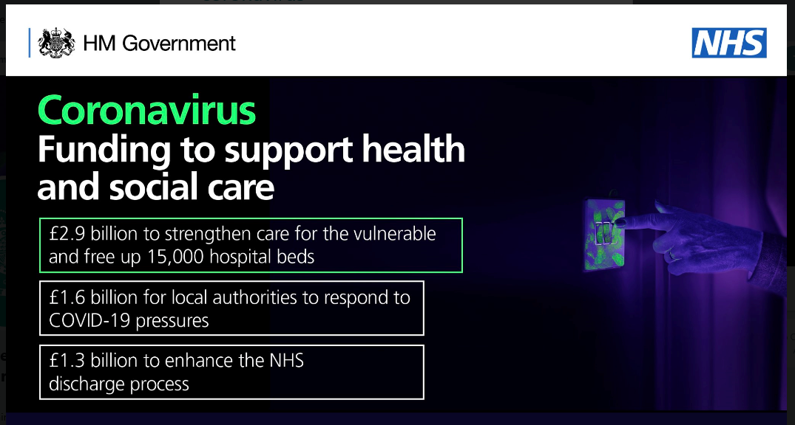
From: https://twitter.com/DHSCgovuk/status/1240722207778705417/photo/1

Covid-19: all non-urgent elective surgery is suspended for at least three months in England
HS hospitals in England have been told to suspend all non-urgent elective surgery for at least three months from 15 April to help the service deal with the covid-19 pandemic.
Trusts are also advised to urgently discharge inpatients who are medically fit to leave. In addition, the NHS will block-buy capacity in independent hospitals within the next fortnight to “expand critical care capacity to the maximum,” NHS bosses have said.
https://www.bmj.com/content/368/bmj.m1106
Source: Journal
Last updated: 18/03/20

Covid-19 exposes weaknesses in European response to outbreaks
Despite high level political commitment from the EU, the ongoing spread of covid-19 exposes important obstacles to developing a comprehensive European response to infectious disease outbreaks. Member states have long guarded their national responsibility for health services.3 There are provisions within European treaties for acting together on public health issues, but they are limited. While existing arrangements allow action on “serious cross border health threats,”4 the EU must respect member states’ autonomy in operating their own health systems.
https://www.bmj.com/content/368/bmj.m1075
Source: Journal
Last updated: 18/03/20

BBC London Coronavirus care workers
Raises the issue of people who can’t access self-care or 111 independently and how they would self-isolate. Also the safety of care workers who work with these individuals.
https://www.youtube.com/watch?v=_CJksoRuGjs&feature=youtu.be
Source: BBC London TV
Last updated: 16/03/2020

CQC Routine inspections suspended in response to coronavirus outbreak
The letters, sent to providers today, expand on an update we sent on 4 March. The changes they describe include:
- stopping routine inspections from today
- a shift towards other, remote methods to give assurance of safety and quality of care
- some inspection activity in a small number of cases, for example where there are allegations of abuse
- giving extra support to registered managers in adult social care
https://www.cqc.org.uk/news/stories/routine-inspections-suspended-response-coronavirus-outbreak
Source: Care Quality Commission
Updated: 16/03/2020

We Need Strong Public Health Care to Contain the Global Corona Pandemic
Now is the time to take stock and to assess the responses of different countries to the outbreak so far. What we can learn from the global Corona pandemic so far is that strong public health systems have the resilience to address massive health threats with the collective responses they require. Privatization of health services and individualization of risks might further undermine our ability to address this and future global pandemics.
https://journals.sagepub.com/doi/10.1177/0020731420916725
Source: Journal
Last updated: 03/20
Coronavirus: Warning of spike in scams linked to crisis
https://www.bbc.co.uk/news/uk-51964507
Source: BBC
Last updated: 03/20

Guidance

COVID-19: guidance on shielding and protecting people defined on medical grounds as extremely vulnerable
Information for shielding and protecting people defined on medical grounds as extremely vulnerable from COVID-19
https://www.gov.uk/government/publications/guidance-on-shielding-and-protecting-extremely-vulnerable-persons-from-covid-19
Source: UK government
Last updated: 24/03/20

Considerations related to the safe handling of bodies of deceased persons with suspected or confirmed COVID-19
This document aims to support public health preparedness planning and response activities on the safe handling of bodies of deceased persons with suspected or confirmed COVID-19: at the site of death, during transport, storage and preparation before burial/cremation, and during burial/cremation.
https://www.ecdc.europa.eu/en/publications-data/considerations-related-safe-handling-bodies-deceased-persons-suspected-or
Source: European Union
Last updated: 23/03/20

Covid-19: doctors in final trimester of pregnancy should avoid direct patient contact
Women who are more than 28 weeks pregnant should avoid direct contact with patients—whether or not they could be infected with covid-19, says updated guidance. Those who are less than 28 weeks pregnant, however, can continue to work in patient facing roles provided they use the right personal protection equipment (PPE).
https://www.bmj.com/content/368/bmj.m1173.short?rss=1&utm_source=feedburner&utm_medium=feed&utm_campaign=Feed%3A+bmj%2Frecent+%28Latest+from+BMJ%29
Source: Journal
Last updated: 23/03/20

COVID-19: guidance on shielding and protecting people defined on medical grounds as extremely vulnerable
Information for shielding and protecting people defined on medical grounds as extremely vulnerable from COVID-19.
https://www.gov.uk/government/publications/guidance-on-shielding-and-protecting-extremely-vulnerable-persons-from-covid-19
Source: Public Health England
Last updated: 21/03/20

COVID-19: guidance on home care provision
This guidance is aimed at local authorities, clinical commissioning groups (CCGs) and registered providers, who support and deliver care to people in their own homes, including community health services.
This guidance sets out key messages to support planning and preparation in the event of an outbreak or widespread transmission of COVID-19.
https://www.gov.uk/government/publications/covid-19-residential-care-supported-living-and-home-care-guidance/covid-19-guidance-on-home-care-provision
Source: UK government
Last updated: 19/03/20

COVID-19: guidance for supported living provision
This guidance sets out key messages to support planning and preparation in the event of an outbreak or widespread transmission of COVID-19.
It is aimed at local authorities, clinical commissioning groups (CCGs), community health services and providers of care and support delivered within supported living environments (people in their own homes), including for people with mental health conditions, learning disabilities or autistic adults.
https://www.gov.uk/government/publications/covid-19-residential-care-supported-living-and-home-care-guidance/covid-19-guidance-for-supported-living-provision
Source: UK government
Updated: 19/03/20

COVID-19 and the consequences of isolating the elderly
As countries are affected by coronavirus disease 2019 (COVID-19), the elderly population will soon be told to self-isolate for “a very long time” in the UK, and elsewhere.
This attempt to shield the over-70s, and thereby protect over-burdened health systems, comes as worldwide countries enforce lockdowns, curfews, and social isolation to mitigate the spread of severe acute respiratory syndrome coronavirus 2 (SARS-CoV-2).
However, it is well known that social isolation among older adults is a “serious public health concern” because of their heightened risk of cardiovascular, autoimmune, neurocognitive, and mental health problems.
https://www.thelancet.com/journals/lanpub/article/PIIS2468-2667(20)30061-X/fulltext
Source: Peer Reviewed Journal
Last updated: 19/03/20

COVID-19: guidance on residential care provision

- Maintaining Services
- If staff or residents have symptoms
- Minimising the Risk of Transmission
- PPE
- Support from NHS, local authority and central government
https://www.gov.uk/government/publications/covid-19-residential-care-supported-living-and-home-care-guidance/covid-19-guidance-on-residential-care-provision
Source: UK Government
Last updated: 19/03/20

New adult social care guidance to protect the most vulnerable against COVID-19
Adults receiving social care will be better protected by new guidance for councils and care providers as the government works to delay the spread of COVID-19.
https://www.gov.uk/government/news/new-adult-social-care-guidance-to-protect-the-most-vulnerable-against-covid-19
Source: DHSC and PHE
Last updated: 13/03/20

Coronavirus action plan: a guide to what you can expect across the UK
Recognising the respective roles and responsibilities of the UK government and devolved administrations, this document sets out what the UK as a whole has already done – and plans to do further – to tackle the current coronavirus outbreak, based on our wealth of experience dealing with other infectious diseases and our influenza pandemic preparedness work.
https://www.gov.uk/government/publications/coronavirus-action-plan/coronavirus-action-plan-a-guide-to-what-you-can-expect-across-the-uk
Source: UK government
Last updated: 3/03/20

Social care provider resilience during COVID-19: guidance to commissioners
Shared guidance to local authority commissioners from the Association of Directors of Adult Social Services (ADASS), the Local Government Association (LGA) and the Care Provider Alliance (CPA).
https://www.local.gov.uk/coronavirus-information-councils/social-care-provider-resilience-during-covid-19-guidance-commissioners
Source: NGO
Last updated: Unknown

Corona Virus – Older people
Advice from Dudley Metropolitan Council for older and vulnerable people and how they can look after themselves.
https://www.dudley.gov.uk/coronavirusolderpeople
Source: Local Authority
Last updated: unknown
Guidance for infection prevention and control in healthcare settings
- Routes of transmission
- Incubation and Infection Period
- How long COVID-19 survives in the environment

Source: Department of Health and Social Care and Public Health England
Last updated: Unknown

Data protection and coronavirus: what you need to know
FAQs.
We know you might need to share information quickly or adapt the way you work. Data protection will not stop you doing that. It’s about being proportionate - if something feels excessive from the public’s point of view, then it probably is.
https://ico.org.uk/for-organisations/data-protection-and-coronavirus/
Source: NGO
Last updated: Unknown

Accessibility

COVID-19: guidance for households with possible coronavirus infection
Current guidance translated into Arabic, Bengali, Traditional Chinese – Cantonese, Simplified Chinese – Mandarin, French, Guajarati, Polish, Portuguese, Punjabi, Urdu, Welsh and illustrated easy read.
https://www.gov.uk/government/publications/covid-19-stay-at-home-guidance
Source: UK government
Updated: 24/03/20
Alternative Formats - Public Information Resources
https://campaignresources.phe.gov.uk/resources/campaigns/101/resources/5080
Alternative formats of the public health advice about how you can help stop the spread of viruses, like coronavirus (COVID-19), by practising good respiratory and hand hygiene.
https://campaignresources.phe.gov.uk/resources/campaigns/101/resources/5080
Source: Public Health England
Last updated: 17/03/20
NHS Guidance Translated into 34 lanauages
https://www.doctorsoftheworld.org.uk/coronavirus-information/
English, Albanian, Amharic, Arabic, Armenian, Bengali, Bulgarian, Czech, Dari, Farsi, French, Gujarati, Greek, Hindi, Italian, Hungarian, Kurdish Sorani, Lithuanian, Malayalam, Portuguese, Simplified Chinese, Pashto, Polish, Portuguese, Punjabi, Russian, Romanian, Sindhi, Slovak, Spanish, Somali, Tigrinya, Turkish, Urdu, Vietnamese.
Source: Charity
Last updated: 16/03/20

MENCAP Easy Read Guide to COVID
https://www.mencap.org.uk/advice-and-support/health/coronavirus-covid-19
Source: Charity
Last updated: Unknown

Dashboards and Statistics

European Commission Response to Coronavirus
The European Commission is coordinating a common European response to the outbreak of COVID-19. An Information portal and statistics dashboard.
https://ec.europa.eu/info/live-work-travel-eu/health/coronavirus-response_en?utm_source=some_EO&utm_medium=tw_organic&utm_campaign=COVID_response_EU
Source: European Commission
Last updated: Live updates

EPI-WIN: WHO information network for epidemics
From the WHO. EPI-WIN seeks to give everyone access to timely, accurate, and easy-to-understand advice and information from trusted sources on public health events and outbreaks: currently the COVID-19 public health emergency.
Source: International Organisation
Last updated: Live updates

COVID Google Dashboard
Google dashboard containing information, guidance and statistics.
https://www.google.com/covid19/
Source: Google
Last updated: Live updates

An interactive web-based dashboard to track COVID-19 in real time
The dashboard, first shared publicly on Jan 22, illustrates the location and number of confirmed COVID-19 cases, deaths, and recoveries for all affected countries. It was developed to provide researchers, public health authorities, and the general public with a user-friendly tool to track the outbreak as it unfolds.
https://www.thelancet.com/journals/laninf/article/PIIS1473-3099(20)30120-1/fulltext
Source: Peer reviewed journal
Last updated: 19/02/20

Clinical Information

Protection

COVID-19: protecting health-care workers
As the pandemic accelerates, access to personal protective equipment (PPE) for health workers is a key concern. Medical staff are prioritised in many countries, but PPE shortages have been described in the most affected facilities. Some medical staff are waiting for equipment while already seeing patients who may be infected or are supplied with equipment that might not meet requirements. Alongside concerns for their personal safety, health-care workers are anxious about passing the infection to their families. Health-care workers who care for elderly parents or young children will be drastically affected by school closures, social distancing policies, and disruption in the availability of food and other essentials.
https://www.thelancet.com/journals/lancet/article/PIIS0140-6736(20)30644-9/fulltext
Source: Journal
Last updated: 21/03/20

Protecting health-care workers from subclinical coronavirus infection
Health-care workers face an elevated risk of exposure to infectious diseases, including the novel coronavirus (COVID-19) in China. It is imperative to ensure the safety of healthcare workers not only to safeguard continuous patient care but also to ensure they do not transmit the virus. COVID-19 can spread via cough or respiratory droplets, contact with bodily fluids, or from contaminated surfaces.
Source: Peer reviewed journal
Last updated: 13/02/20

Epidemiology

Evidence of initial success for China exiting COVID-19 social distancing policy after achieving containment
In response to the fast-growing epidemic, China imposed strict social distancing in Wuhan on 23 January 2020 followed closely by similar measures in other provinces. At the peak of the outbreak in China (early February), there were between 2,000 and 4,000 new confirmed cases per day. For the first time since the outbreak began there have been no new confirmed cases caused by local transmission in China reported for five consecutive days up to 23 March 2020.
https://www.imperial.ac.uk/mrc-global-infectious-disease-analysis/news--wuhan-coronavirus/
Source: UK University
Last updated: 24/03/20

COVID-19 in Europe: the Italian lesson
All other European countries appear to be in a similar situation, with just a short time-lag of a couple of weeks (figure). We urge all countries to acknowledge the Italian lesson and to immediately adopt very restrictive measures to limit viral diffusion, ensure appropriate health-system response, and reduce mortality, which appears to be higher than previously estimated, with a crude case-fatality rate of almost 4%.
https://www.thelancet.com/journals/lancet/article/PIIS0140-6736(20)30690-5/fulltext
Source: Peer reviewed journal
Last updated: 24/03/20

Considerations relating to social distancing measures in response to COVID-19 – second update
Social distancing is an action taken to minimise contact with other individuals; social distancing measures comprise one category of non-pharmaceutical countermeasures (NPCs)1 aimed at reducing disease transmission and thereby also reducing pressure on health services.
This document builds upon existing ECDC documents, including guidelines for the use of non-pharmaceutical measures to delay and mitigate the impact of 2019-nCoV, a rapid risk assessment: outbreak of novel coronavirus disease – 6th update, a technical report on the use of evidence in decision-making during public health emergencies, and a guidance document on community engagement for public health events caused by communicable disease threats in the EU/EEA.
https://www.ecdc.europa.eu/en/publications-data/considerations-relating-social-distancing-measures-response-covid-19-second
Source: European Union
Last updated: 23/03/20

Canada and COVID-19: learning from SARS
In an exclusive interview with The Lancet, David Naylor, one of Canada's leading experts on pandemic control, says Canada's response to coronavirus disease 2019 (COVID-19) is vastly benefiting from the country's experience with a 2003 epidemic of severe acute respiratory syndrome (SARS) that killed 44 Canadians.
https://www.thelancet.com/journals/lancet/article/PIIS0140-6736(20)30670-X/fulltext
Source: Peer Reviewed Journal
Last updated: 21/03/20

Use of antiviral drugs to reduce COVID-19 transmission
Our objective is to evaluate the reduction in transmissibility of SARS-CoV-2 and in disease progression among the contacts of an index case. The design intervention is based on the design used during the Ebola ça Suffit vaccination trial for Ebola in 2015.
Source: Peer reviewed journal
Last updated: 19/03/20

Prolonged presence of SARS-CoV-2 viral RNA in faecal samples
Respiratory transmission is still the primary route for SARS-CoV-2 and evidence is not yet sufficient to develop practical measures for the group of patients with negative respiratory tract sample results but positive faecal samples. Further research into the viability and infectivity of SARS-CoV-2 in faeces is required.
https://www.thelancet.com/journals/langas/article/PIIS2468-1253(20)30083-2/fulltext
Source: Journal
Last updated: 19/03/20

Guidance on social distancing for everyone in the UK and protecting older people and vulnerable adults
Advice on who should practice social distancing and how:
https://www.gov.uk/government/publications/covid-19-guidance-on-social-distancing-and-for-vulnerable-people/guidance-on-social-distancing-for-everyone-in-the-uk-and-protecting-older-people-and-vulnerable-adults
Source: UK Government
Last updated: 19/03/20

The possibility of COVID‐19 transmission from eye to nose
It has been confirmed that COVID‐19 is mainly transmitted through both respiratory droplets and direct contact. Aerosols are another possible transmission route requiring attention. In February 2020, a report in The Lancet raised the issue that ocular surfaces may be a potential target for SARS‐CoV‐2 invasion.
https://onlinelibrary.wiley.com/doi/full/10.1111/aos.14412
Source: Journal
Last updated: 18/03/20
Covid-19 and community mitigation strategies in a pandemic
No specific drugs or vaccines are available, and health systems are overburdened everywhere. We have to rely on targeted, non-coercive, community interventions with sufficient transparency and public engagement and trust, and implement them urgently. Such measures may help delay the exponential spread of the outbreak until drugs become available. Transparency and trust are critical to preserving a calm and compliant response to mitigation advice among the public.
https://www.bmj.com/content/368/bmj.m1066
Source: Journal
Last updated: 17/03/20

Epidemiology, causes, clinical manifestation and diagnosis, prevention and control of coronavirus disease (COVID-19) during the early outbreak period: a scoping review.
A scoping review was conducted following the methodological framework suggested by Arksey and O'Malley. In this scoping review, 65 research articles published before 31 January 2020 were analyzed and discussed to better understand the epidemiology, causes, clinical diagnosis, prevention and control of this virus.
https://www.ncbi.nlm.nih.gov/pubmed/32183901
Source: Peer reviewed journal
Last updated: 17/03/20
Potential impact of seasonal forcing on a SARS-CoV-2 pandemic
Here, we explore how seasonal variation in transmissibility could modulate a SARS-CoV-2 pandemic. Data from routine diagnostics show a strong and consistent seasonal variation of the four endemic coronaviruses (229E, HKU1, NL63, OC43) and we parameterise our model for SARS-CoV-2 using these data. The model allows for many subpopulations of different size with variable parameters. Simulations of different scenarios show that plausible parameters result in a small peak in early 2020 in temperate regions of the Northern Hemisphere and a larger peak in winter 2020/2021. Variation in transmission and migration rates can result in substantial variation in prevalence between regions.
https://smw.ch/article/doi/smw.2020.20224
Source: Journal
Last updated: 16/03/20

Real estimates of mortality following COVID-19 infection
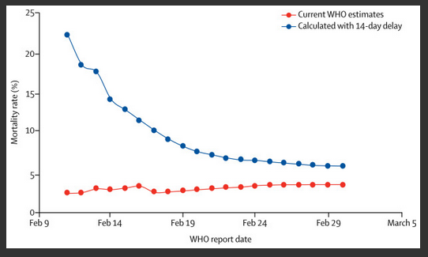
https://www.thelancet.com/journals/laninf/article/PIIS1473-3099(20)30195-X/fulltext
Source: Peer reviewed journal
Last updated: 12/03/20

Interventions to mitigate early spread of SARS-CoV-2 in Singapore: a modelling study
We adapted an influenza epidemic simulation model to estimate the likelihood of human-to-human transmission of severe acute respiratory syndrome coronavirus 2 (SARS-CoV-2) in a simulated Singaporean population. Using this model, we estimated the cumulative number of SARS-CoV-2 infections at 80 days, after detection of 100 cases of community transmission, under three infectivity scenarios (basic reproduction number [R₀] of 1·5, 2·0, or 2·5) and assuming 7·5% of infections are asymptomatic.
https://www.thelancet.com/journals/laninf/article/PIIS1473-3099(20)30162-6/fulltext
Source: Peer reviewed journal
Last updated: Unknown

Infection Control
COVID-19 Guidance for infection prevention and control in healthcare settings
Source: PHE and other NGOs
Last updated: Unknown

Research and Testing

Covid-19: UK government calls on industry to help boost testing capacity to 25 000 people a day
As many as 25 000 people a day will be tested for covid-19 in NHS hospitals within weeks in a push to increase capacity, the government has said.
Source: Journal
Last updated: 26/03/20

Early in the epidemic: impact of preprints on global discourse about COVID-19 transmissibility
For the past three decades, preprint servers have become commonplace in the scientific publication ecosystem, and COVID-19 has prompted a seemingly unprecedented use of these platforms.
Although peer-review is crucial for the validation of science, the ongoing outbreak has showcased the speed with which preprints can disseminate information during emergencies.
https://www.thelancet.com/journals/langlo/article/PIIS2214-109X(20)30113-3/fulltext
Source: Peer reviewed journal
Last updated: 24/03/20

Clinical features and obstetric and neonatal outcomes of pregnant patients with COVID-19 in Wuhan, China: a retrospective, single-centre, descriptive study
The maternal, fetal, and neonatal outcomes of patients who were infected in late pregnancy appeared very good, and these outcomes were achieved with intensive, active management that might be the best practice in the absence of more robust data. The clinical characteristics of these patients with COVID-19 during pregnancy were similar to those of non-pregnant adults with COVID-19 that have been reported in the literature.
https://www.thelancet.com/journals/laninf/article/PIIS1473-3099(20)30176-6/fulltext
Source: Peer reviewed journal
Last updated: 24/03/20
COVID-19 in a patient with chronic lymphocytic leukaemia
Since the outbreak of coronavirus disease 2019 (COVID-19) first began in Wuhan, China, in December, 2019, the viral epidemic has quickly engulfed China. Here we describe a case of a patient with chronic lymphocytic leukaemia with COVID-19.
https://www.thelancet.com/journals/lanhae/article/PIIS2352-3026(20)30074-0/fulltext
Source: Peer reviewed journal
Last updated: 04/20 (pre-pub)

Viral dynamics in mild and severe cases of COVID-19
We previously reported that the viral load of severe acute respiratory syndrome coronavirus 2 (SARS-CoV-2) peaks within the first week of disease onset.Findings from Feb, 2020, indicated that the clinical spectrum of this disease can be very heterogeneous. Here, we report the viral RNA shedding patterns observed in patients with mild and severe COVID-19.
https://www.thelancet.com/journals/laninf/article/PIIS1473-3099(20)30232-2/fulltext
Source: Peer reviewed journal
Last updated: 19/03/20
Clinical course and risk factors for mortality of adult inpatients with COVID-19 in Wuhan, China: a retrospective cohort study
In this retrospective, multicentre cohort study, we included all adult inpatients (≥18 years old) with laboratory-confirmed COVID-19 from Jinyintan Hospital and Wuhan Pulmonary Hospital (Wuhan, China) who had been discharged or had died by Jan 31, 2020. Demographic, clinical, treatment, and laboratory data, including serial samples for viral RNA detection, were extracted from electronic medical records and compared between survivors and non-survivors. We used univariable and multivariable logistic regression methods to explore the risk factors associated with in-hospital death.
https://www.thelancet.com/journals/lancet/article/PIIS0140-6736(20)30566-3/fulltext
Source: Peer reviewed journal
Last updated: 11/03/20

Persistence of coronaviruses on inanimate surfaces and their inactivation with biocidal agents
Currently, the emergence of a novel human coronavirus, SARS-CoV-2, has become a global health concern causing severe respiratory tract infections in humans. Human-to-human transmissions have been described with incubation times between 2-10 days, facilitating its spread via droplets, contaminated hands or surfaces.
https://www.journalofhospitalinfection.com/article/S0195-6701(20)30046-3/abstract
Source: Journal
Last updated: 03/20

Pharmacology

SCIO briefing on TCM's important role and a list of effective drugs in COVID-19 prevention and control
http://www.china.org.cn/china/2020-03/25/content_75857989.htm
Source: Chinese state broadcasting
Last updated: 25/03/20

Management of pregnant women infected with COVID-19
With immunocompromised status and physiological adaptive changes during pregnancy, pregnant women could be more susceptible to COVID-19 infection than the general population. As COVID-19 is rapidly spreading, maternal management and fetal safety become a major concern, but there is scarce information of assessment and management of pregnant women infected with COVID-19, and the potential risk of vertical transmission is unclear. In The Lancet Infectious Diseases, Nan Yu and colleagues report the clinical features and obstetric and neonatal outcomes of pregnancy with COVID-19 pneumonia in Wuhan, China. Seven pregnant women with COVID-19 pneumonia were assessed and the onset symptoms were similar to those reported in non-pregnant adults with COVID-19.
https://www.thelancet.com/journals/laninf/article/PIIS1473-3099(20)30191-2/fulltext
Source: Peer reviewed journal
Last updated: 24/03/20

Immunosuppression for hyperinflammation in COVID-19: a double-edged sword?
The authors hypothesise that approaches such as corticosteroids or Janus kinase (JAK) inhibitors could be considered if hyperinflammation is present.
Broad immunosuppression in patients with overwhelming viral illness might be inadvisable. Beneficial anti-inflammatory effects should be weighed up against the potentially detrimental effects of inhibiting anti-viral immunity, thereby delaying virus clearance and perpetuating illness.
https://www.thelancet.com/journals/lancet/article/PIIS0140-6736(20)30691-7/fulltext
Source: Peer reviewed journal
Last updated: 24/03/20

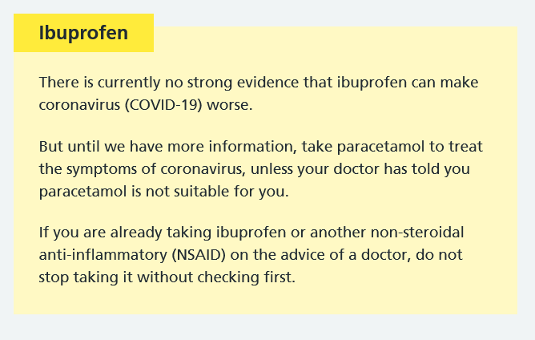
From: https://www.nhs.uk/conditions/coronavirus-covid-19/self-isolation-advice/
Last updated: 19/03/20

Should patients stop their biologic treatment during the COVID-19 pandemic
At this point, there is no specific clinical data on COVID-19 in patients with dermatologic disease or on biologics. While guidelines and package inserts suggest that biologics are contraindicated in case of clinically important active infections, these guides do not recommend stopping treatment because of potential infection risks in the community. Moreover, there does not seem to be evidence that TNF-α inhibition will increase the risk of SARS-CoV-2 infection, specifically. In seasonal influenza and H1N1 influenza, patients on an anti-TNF agents have a similar risk of infection compared with the general population.
https://www.tandfonline.com/doi/full/10.1080/09546634.2020.1742438
Source: Journal
Last updated: 19/03/20

The possibility of COVID‐19 transmission from eye to nose
Combined with all this information, we assert that, when coming into contact with confirmed or suspected cases of COVID‐19, healthcare workers should wear eye safety goggles. This should become one of the critical measures for preventing the spread of COVID‐19. The authors hope this topic is helpful for work in the outbreak area.
https://onlinelibrary.wiley.com/doi/full/10.1111/aos.14412
Source: Journal
Last updated: 18/03/20

Is nicotine exposure linked to cardiopulmonary vulnerability to COVID‐19 in the general population?
Here, we focus on those individuals who have been exposed to nicotine prior to their exposure to the virus. We predict that these individuals are “primed” to be at higher risk because nicotine can directly impact the putative receptor for the virus (ACE2) and lead to deleterious signaling in lung epithelial cells.
https://febs.onlinelibrary.wiley.com/doi/abs/10.1111/febs.15303
Source: Viewpoint from journal
Last updated: 18/03/20

The Emerging Pandemic of Coronavirus: The Urgent Need for Public Health Leadership
Surveillance of communicable diseases of national importance was first defined by Langmuir as the critical watchfulness over the distribution and trends of incidence through the systematic collection, consolidation, and regular dissemination of data to all who need to know.Since that time, as noted by Henderson, surveillance systems have increased in number and sophistication with advances in data collection, analysis, and communication.
https://www.amjmed.com/article/S0002-9343(20)30207-2/fulltext
Source: Journal
Last Updated: 18/03/20

COVID-19: consider cytokine storm syndromes and immunosuppression
All patients with severe COVID-19 should be screened for hyperinflammation using laboratory trends (eg, increasing ferritin, decreasing platelet counts, or erythrocyte sedimentation rate) and the HScore to identify the subgroup of patients for whom immunosuppression could improve mortality. Therapeutic options include steroids, intravenous immunoglobulin, selective cytokine blockade (eg, anakinra or tocilizumab) and JAK inhibition.
https://www.thelancet.com/journals/lancet/article/PIIS0140-6736(20)30628-0/fulltext
Source: Peer reviewed journal
Last updated: 16/03/20

Are patients with hypertension and diabetes mellitus at increased risk for COVID-19 infection?
We suggest that patients with cardiac diseases, hypertension, or diabetes, who are treated with ACE2-increasing drugs, are at higher risk for severe COVID-19 infection and, therefore, should be monitored for ACE2-modulating medications, such as ACE inhibitors or ARBs.
https://www.thelancet.com/journals/lanres/article/PIIS2213-2600(20)30116-8/fulltext
Source: Peer reviewed journal
Last updated: 11/03/20

Should biologics for psoriasis be interrupted in the era of COVID-19?
With daily media warnings of a looming pandemic, physicians are understandably concerned about immunosuppressive or immunomodulating effects that might render patients on biologic therapies more susceptible to COVID-19 infection. At this early stage, we do not have specific data about susceptibility to the virus, but we have data on infectious complications for biologic therapies from their pivotal trials for psoriasis.
Source: Journal
Last updated: 6/03/20
Radiotherapy in the time of the Coronavirus pandemic: when less is better.
https://www.ncbi.nlm.nih.gov/pubmed/32199942?dopt=Abstract
In addition to the challenge of containing the spread of COVID-19, the hospital management of infected patients remains a major burden for the health care system. Though not in the front line in fighting the disease, radiation oncologists are nevertheless directly impacted by this situation.First, radiation oncology departments, as other hospital departments, have to face staff shortage due to quarantine holding and requisitioning. Second, cancer patients treated in radiation oncology departments are often frail and immunocompromised and at risk of being severely affected if infected by COVID-19. The more time they spend in hospitals and public environment the more they are likely to be infected and/or to spread COVID-19.
https://www.ncbi.nlm.nih.gov/pubmed/32199942?dopt=Abstract
Source: Journal
Last updated: 03/20

Palliative Care
European Association for Palliative Care
Advice and experience from European partners. Including useful resources.
https://www.eapcnet.eu/publications/coronavirus-and-the-palliative-care-response
Source: Multi-national association
Last updated: Unknown
Coronavirus Guidance (COVID-19) from Hospice UK
Hospice UK has brought together links to official guidance and resources to provide information for people about the current outbreak of Coronavirus in the UK. We also have links to statements given by hospices in response.
Source: Charity
Last updated: Unknown

Palliative care and COVID-19
We are sharing here some observations based on a rapid, non-systematic review of key literature on palliative care in pandemic and related contexts, such as humanitarian disasters of various kinds. We try to highlight some of the issues that require consideration. In doing so we want to contribute to the rapidly developing dialogue about COVID-19 and palliative care, which is occurring between service providers, researchers, community groups and others wishing to pool knowledge and information in the interests of informed strategies and collective action.
http://endoflifestudies.academicblogs.co.uk/palliative-care-and-covid-19/
Source: UK University
Last updated: 19/03/20

The challenge of providing holistic care in a viral epidemic: opportunities for palliative care
Dealing with a novel viral epidemic creates spiritual and psychosocial issues similar to those encountered in a palliative care practice. Palliative care workers would do well to be aware of such issues and act proactively when such epidemics arise.
https://journals.sagepub.com/doi/abs/10.1191/0269216304pm859oa
Source: Journal
Last updated: January 2004

Local Information
Dudley CVS COVID-19 Community Action and Support
DudleyCVS has been asked to lead on co-ordinating the community response to COVID-19 in Dudley borough, working with existing voluntary and community groups and the volunteer centre and connecting people that need support to assets in their local community.
http://dudleycvsreview.org/covid-19-community-action-and-support/
Source: Voluntary Organisation
Last updated: Unknown

Wellbeing and Mental Health

ADVICE FOR SUSTAINING STAFF WELLBEING IN CRITICAL CARE DURING AND BEYOND COVID-19
Source: Professional body
Last Updated: Unknown

Mental Health Strategies to Combat the Psychological Impact of COVID-19 Beyond Paranoia and Panic.
https://www.ncbi.nlm.nih.gov/pubmed/32200399
Source: Journal
Last updated: 23/03/20

Social Isolation - How to Help Patients be Less Lonely
Diagnosis and management of social isolation.
https://patient.info/doctor/Social-Isolation-How-to-Help-Patients-be-Less-Lonely
Source: Healthcare partner
Last updated: 28/12/16

Coping with COVID stress
Tips for coping with COVID19 stress from a MSF psychiatrist
https://twitter.com/MSF/status/1240699557308248068
Source: Charity
Last updated: 19/03/20

Covid-19: Home based exercise activities could help during self isolation
We believe that what is lacking from the current advice, and the behavioural changes considered for the public, is the possibility to harness pre-exposure conditioning as a positive way to help our fellow human beings prepare physically and psychologically for infection and its sequelae. [1] Prior to anticipated medical stresses such as elective surgery or pregnancy, standard advice is to optimise physical fitness. [2] This is particularly pertinent since the covid-19 quarantine-like measures may appear to be favouring a more sedentary approach with individuals waiting indoors, hoping to avoid the perceived inevitable infection. [3]
https://blogs.bmj.com/bmj/2020/03/16/covid-19-home-based-exercise-activities-could-help-during-self-isolation/
Source: Peer reviewed journal
Last updated: 16/03/20

Physical activity guidelines for older adults
Older adults should do some type of physical activity every day. Any type of activity is good for you. The more you do the better.
https://www.nhs.uk/live-well/exercise/physical-activity-guidelines-older-adults/
Source: NHS
Last updated: 8/10/19

Employment

COVID-19 Health, safety and wellbeing
Preserving and protecting the health, safety and wellbeing of staff is critical for NHS organisations as they respond to the COVID-19 outbreak.
https://www.nhsemployers.org/covid19/health-safety-and-wellbeing
Source: NHS Confederation
Last updated: Unknown

Key Worker Information
This includes but is not limited to doctors, nurses, midwives, paramedics, social workers, care workers, and other frontline health and social care staff including volunteers; the support and specialist staff required to maintain the UK’s health and social care sector; those working as part of the health and social care supply chain, including producers and distributers of medicines and medical and personal protective equipment.
https://www.gov.uk/government/publications/coronavirus-covid-19-maintaining-educational-provision/guidance-for-schools-colleges-and-local-authorities-on-maintaining-educational-provision
Source: UK Government
Last updated: 19/03/20

Guidance for employers and businesses on coronavirus (COVID-19)
https://www.gov.uk/government/publications/guidance-to-employers-and-businesses-about-covid-19/guidance-for-employers-and-businesses-on-coronavirus-covid-19
Source: UK Government
Last updated: 20/03/20

Coronavirus (COVID-19): your rights (GMB)
https://www.gmb.org.uk/coronavirus-covid-19-your-rights

Coronavirus: your rights at work (Unison)
Last updated: Unknown
Source: Trade union
https://www.unison.org.uk/coronavirus-rights-work/
Last updated: 20/03/20
Source: Trade union
COVID Rapid Response

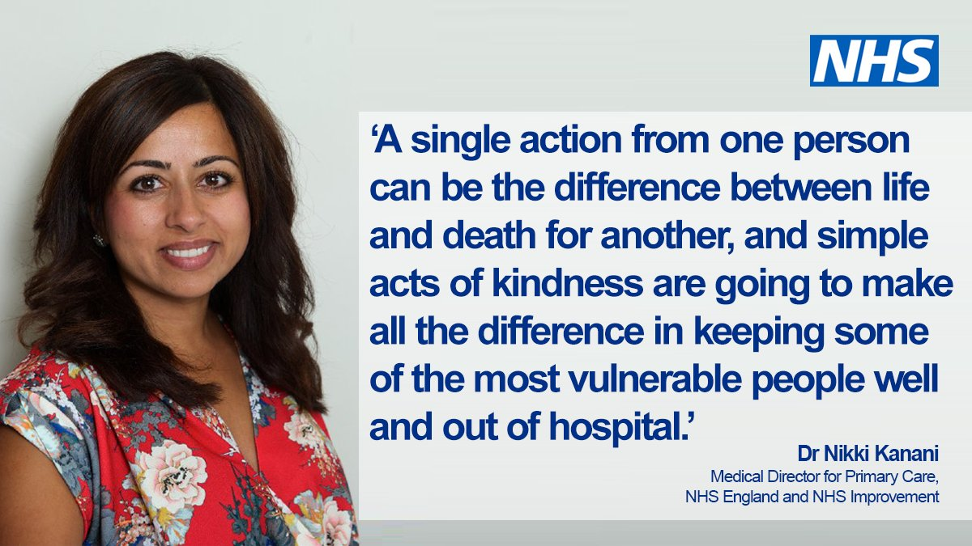
https://www.nhsprofessionals.nhs.uk/rapid-response
Source: NHS
Last updated: Unknown

Training

Free COVID-19 e-learning programme
Health Education England e-Learning for Healthcare (HEE e-LfH) has created an e-learning programme in response to COVID-19.
The programmes are free to access for the entire UK health and care workforce, including those working in the NHS, the independent sector and social care.
https://www.nhsemployers.org/news/2020/03/covid%2019%20elearning
Source: Health Education England
Updated: 24/03/20

Fact Checking and Myth Busting

COVID Myth-busting Thread
Twitter thread by blue-ticked US medic.
https://twitter.com/faheemyounus/status/1241812326019485698
Source: Blue ticked US medic
Last updated: 22/03/20

Coronavirus disease 2019: the harms of exaggerated information and non‐evidence‐based measures
The evolving coronavirus disease 2019 (COVID‐19) pandemic is certainly cause for concern. Proper communication and optimal decision‐making is an ongoing challenge, as data evolve. The challenge is compounded, however, by exaggerated information. This can lead to inappropriate actions. It is important to differentiate promptly the true epidemic from an epidemic of false claims and potentially harmful actions.
Source: Journal
Last updated: 19/03/20

Coronavirus: the spread of misinformation
There has been a global rise recently in the spread of misinformation that has plagued the scientific community and public. Disconnect between scientific consensus and members of the public on topics such as vaccine safety, the shape of the earth, or climate change has existed for a number of years. However, this has progressively worsened as society has become further divided in the political climate of today. In turn, it has created an optimal environment for antiscience groups to gain footing and propagate their false theories and information. The public health crisis emerging due to the coronavirus (COVID-19) is also now beginning to feel the effects of misinformation.
https://bmcmedicine.biomedcentral.com/articles/10.1186/s12916-020-01556-3
Source: Journal
Last updated: 18/03/20

COVID-19: coronavirus myths debunked
Coronavirus disease 2019: the harms of exaggerated information and non‐evidence‐based measures
The evolving coronavirus disease 2019 (COVID‐19) pandemic¹ is certainly cause for concern. Proper communication and optimal decision‐making is an ongoing challenge, as data evolve. The challenge is compounded, however, by exaggerated information. This can lead to inappropriate actions. It is important to differentiate promptly the true epidemic from an epidemic of false claims and potentially harmful actions.
https://onlinelibrary.wiley.com/doi/abs/10.1111/eci.13222
Source: Peer reviewed journal
Last updated: 19/03/20

Coronavirus disease (COVID-19) advice for the public: Myth busters
https://www.who.int/emergencies/diseases/novel-coronavirus-2019/advice-for-public/myth-busters
Source: World Health Organization
Last updated: unknown
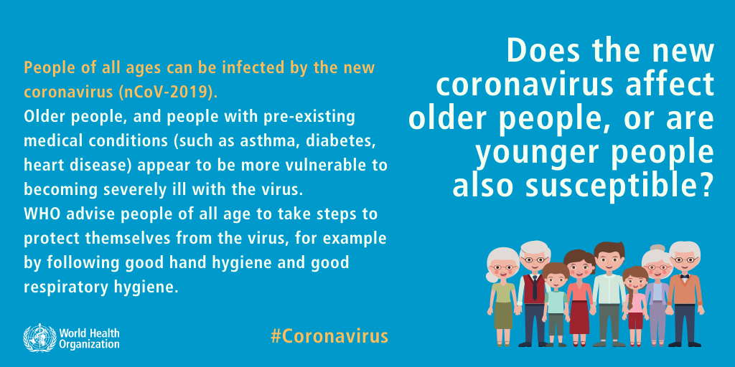
From: https://www.who.int/emergencies/diseases/novel-coronavirus-2019/advice-for-public/myth-busters

Q&A: Similarities and differences – COVID-19 and influenza
As the COVID-19 outbreak continues to evolve, comparisons have been drawn to influenza. Both cause respiratory disease, yet there are important differences between the two viruses and how they spread. This has important implications for the public health measures that can be implemented to respond to each virus.
https://www.who.int/news-room/q-a-detail/q-a-similarities-and-differences-covid-19-and-influenza
Source: World Health Organization
Last updated: 17/03/20

