Public Health Outcomes Framework

Supporting information for Dudley compared to England

16 January 2019

Indicator | Page
% population aged 65+ | 2
% population aged under 18 | 2
% population from ethnic minorities | 3
Deprivation score (IMD 2015) | 3

The percentage of the resident population aged 65 and over
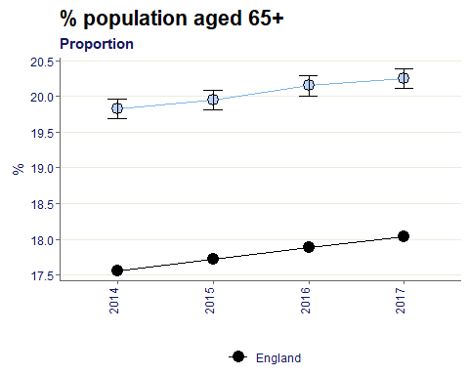

Compared to England, Dudley has a higher proportion of people aged 65+, by 2% on average.

The percentage of the resident population aged 0-17 years
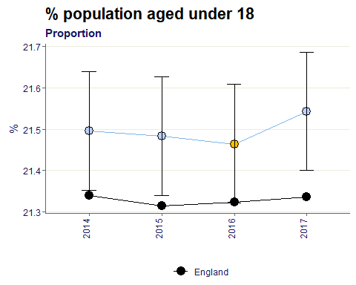
The proportion of the population that is under 18 is very much the same as England, being within 1% point throughout the given years.

The number of people who stated their ethnicity as Mixed/multiple, Asian/Asian British, Black/African/Caribbean/Black British, or Other, as a percentage of the total population (16+).
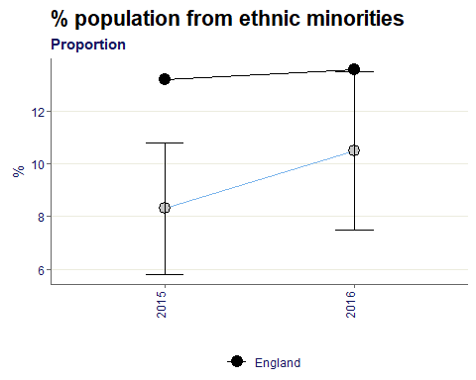
The proportion of Dudley’s 16+ population that is from an ethnic minority is around 9.5% on average, which is less than the England value by roughly 2%.

The English Indices of Deprivation 2015 use 37 separate indicators, organised across seven distinct domains of deprivation which can be combined, using appropriate weights, to calculate the Index of Multiple Deprivation 2015 (IMD 2015). This is an overall measure of multiple deprivation experienced by people living in an area.
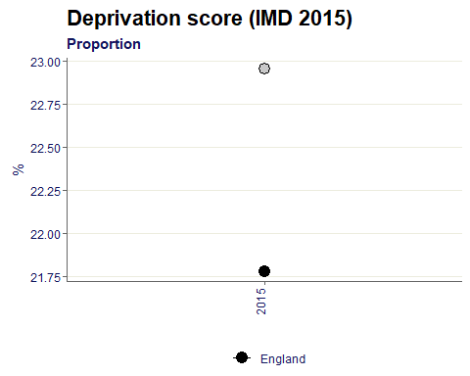
The 2015 deprivation score for Dudley is 23, slightly higher than the England value of 21.8.

Citations:
All data sourced from https://fingertips.phe.org.uk/ under the terms and conditions of the Open Government Licence via the following software/packages:
R Core Team (2018). R: A language and environment for statistical computing. R Foundation for
Statistical Computing, Vienna, Austria. URL https://www.R-project.org/.

Sebastian Fox and Julian Flowers (2018). fingertipsR: Fingertips Data for Public Health.
R package version 0.2.0. https://CRAN.R-project.org/package=fingertipsR

Sebastian Fox (2018). fingertipscharts: Produce Charts that you See on the Fingertips
Website. R package version 0.0.3. https://CRAN.R-project.org/package=fingertipscharts

