Public Health Outcomes Framework

Health Care and premature mortality for Dudley compared to England

15 January 2019
Indicator | Page
Infant mortality | 3
Proportion of five year old children free from dental decay | 3
Mortality rate from causes considered preventable | 4
Under 75 mortality rate from all cardiovascular diseases | 4
Under 75 mortality rate from cardiovascular diseases considered preventable | 5
Under 75 mortality rate from cancer | 5
Under 75 mortality rate from cancer considered preventable | 6
Under 75 mortality rate from liver disease | 6
Under 75 mortality rate from liver disease considered preventable | 7
Under 75 mortality rate from respiratory disease | 7
Under 75 mortality rate from respiratory disease considered preventable | 8
Mortality rate from a range of specified communicable diseases, including influenza | 8
Excess under 75 mortality rate in adults with serious mental illness | 9
Proportion of adults in the population in contact with secondary mental health services | 9
Suicide rate | 10
Emergency readmissions within 30 days of discharge from hospital | 10
Preventable sight loss - age related macular degeneration (AMD) | 11
Preventable sight loss - glaucoma | 11
Preventable sight loss - diabetic eye disease | 12
Preventable sight loss - sight loss certifications | 12
Health related quality of life for older people | 13
Hip fractures in people aged 65 and over | 13
Hip fractures in people aged 65 and over - aged 65-79 | 14
Hip fractures in people aged 65 and over - aged 80+ | 14
Excess winter deaths index (single year, all ages) | 15
Excess winter deaths index (single year, age 85+) | 15
Excess winter deaths index (3 years, all ages) | 16
Excess winter deaths index (3 years, age 85+) | 16
Estimated dementia diagnosis rate (aged 65+) | 17

Infant mortality - Rate of deaths in infants aged under 1 year per 1,000 live births
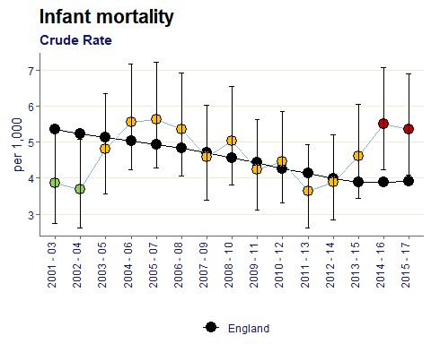
Dudley’s rate was similar to the England baseline for a decade but recently the infant mortality rate has increased to become significantly worse since 2014-16.

Percentage of 5 year olds who are free from obvious dental decay
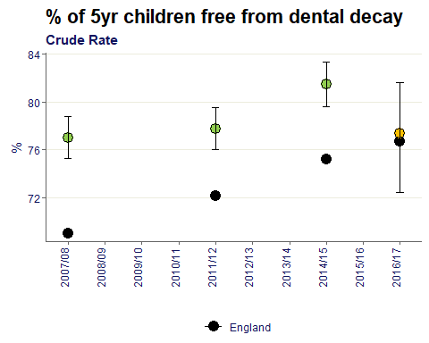
The Dudley percentage of 5 year olds free from dental decay has been static around 77% with the exclusion of 2014/15 peak.
The England value has been increasing overtime and in the latest survey is similar to the Dudley value being within 1% point.

Age-standardised rate of mortality from causes considered preventable per 100,000 population
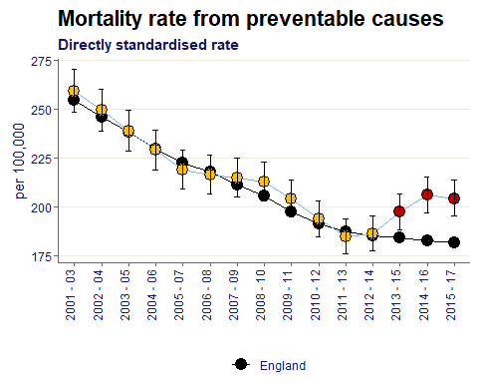
The Dudley rate was decreasing whilst remaining similar to England’s value, however since 2013-15 the trend reversed and is now significantly worse than England.

Age-standardised rate of mortality from all cardiovascular diseases (including heart disease and stroke) in persons less than 75 years of age per 100,000 population
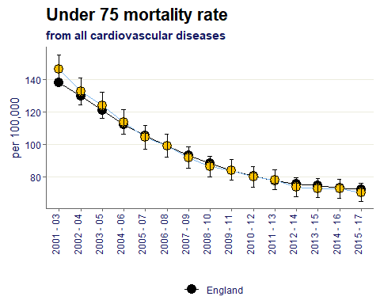
The Dudley rate is decreasing and is statistically similar to the England value for all data points since 2001-03.

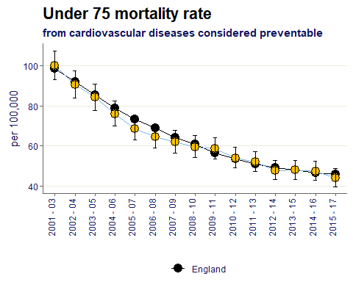
Age-standardised rate of mortality considered preventable from all cardiovascular diseases (incl. heart disease) in those aged <75 per 100,000 population

The Dudley rate is decreasing and is statistically similar to the England value for all data points since 2001-03.

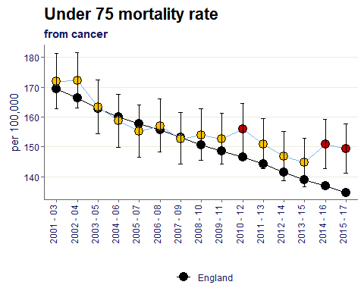
Age-standardised rate of mortality from all cancers in persons less than 75 years of age per 100,000 population

The Dudley value was decreasing in line the England baseline, however in the latest two data points the rate per 100,000 has become significantly worse than baseline.

Age-standardised rate of mortality considered preventable from all cancers in those aged <75 per 100,000 population
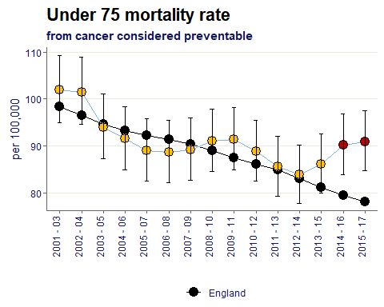
The Dudley value was decreasing in line the England baseline, however in the latest two data points the rate per 100,000 has become significantly worse than baseline.

Age-standardised rate of mortality from liver disease in persons less than 75 years of age per 100,000 population
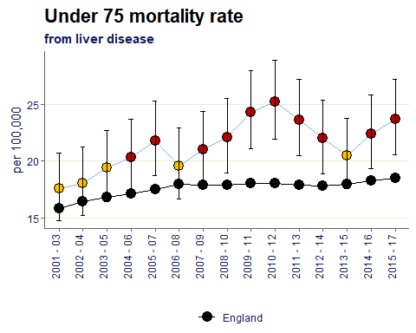
For the majority of data points, Dudley’s value has been significantly worse than England’s rate, with the most two recent time periods being significantly worse.

Age-standardised rate of mortality considered preventable from liver disease in those aged <75 per 100,000 population
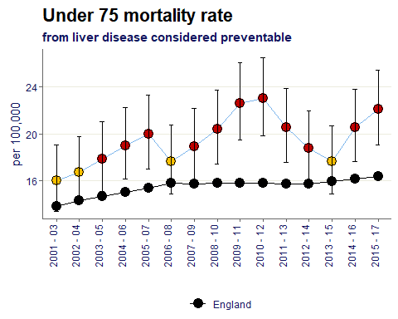
For the majority of data points, Dudley’s value has been significantly worse than England’s rate, with the most two recent time periods being significantly worse.

Age-standardised rate of mortality from respiratory disease in persons less than 75 years per 100,000 population
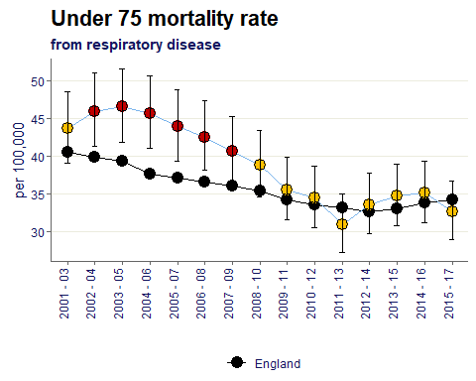
Dudley’s rate shows a downward trend and for the most recent 8 time periods has been similar to the England value.

Age-standardised rate of mortality considered preventable from respiratory disease in those aged <75 per 100,000 population
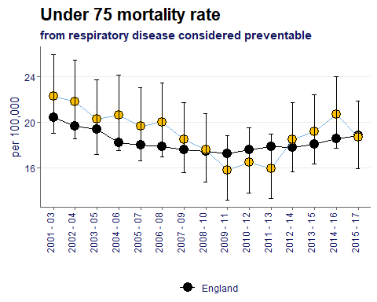
For all time period’s shown Dudley value is similar to the England baseline, however has recently increased since the lowest values seen in 2009-13.

Age-standardised rate of mortality from communicable diseases per 100,000 population
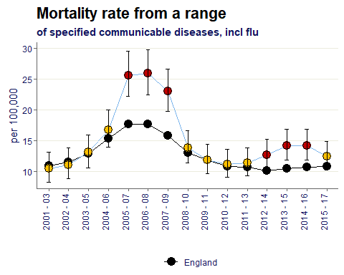
Dudley’s mortality rate shows two clear peaks where the value became significantly worse than the England value. Seen in the chart around 2005-09 and 2012-16.
However in the most recent time period shown, 2015-17 the value is similar to the England rate.

Excess under 75 mortality rate in adults with serious mental illness
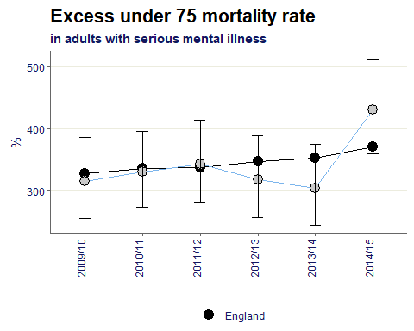
The Dudley value has spiked in the most recent time period to 430%. Significantly higher than the previous peak seen in 2011/12 of 343%.
The England trend is increasing over time.

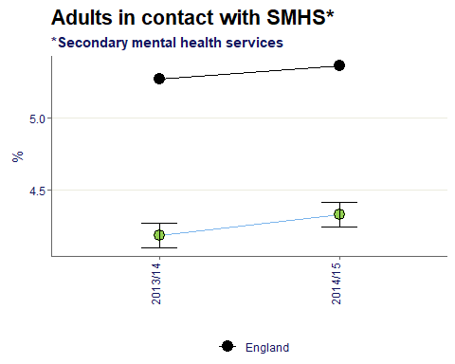
The percentage of the population in contact with Secondary Mental Health Services

For both time periods given the Dudley value is significantly better than England.

Age-standardised mortality rate from suicide and injury of undetermined intent per 100,000 population
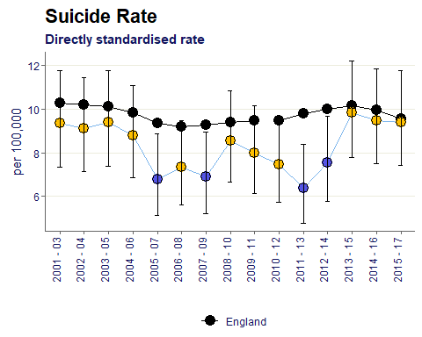

For all time period Dudley’s rate of suicide has at least been similar to the England value, and in four separate years has been better. The most recent data point shows the rate to be 9.4 per 100,000, only 0.2 different from England.

Indirectly standardised % of emergency admissions to any hospital within 30 days of the previous discharge from hospital
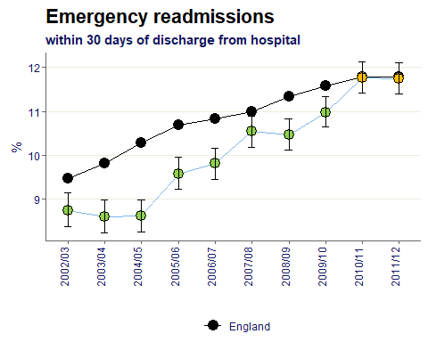
The Dudley trend is increasing overtime which is the case for England also. Historically Dudley had a significantly better percentage but in the last two data periods has become similar to the baseline.

Crude rate of sight loss due to age related macular degeneration (AMD) in those aged 65+ per 100,000 population
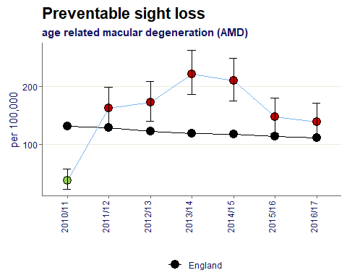
The rate of sight loss in those aged 65+ due to AMD is significantly worse in Dudley compared to England since 2011-12.

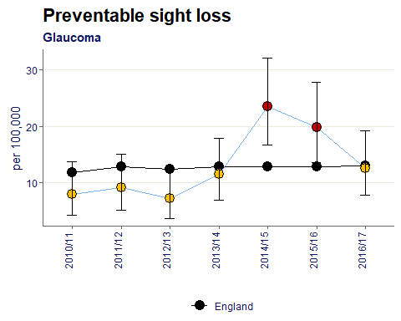
Crude rate of sight loss due to glaucoma in those aged 40+ per 100,000 population

Dudley’s rate of sight loss due to glaucoma in those aged 40+ has been mostly similar to the England baseline overtime, including the most recent data point.
The rate became significantly worse in 2014-16, but has since reduced.

Crude rate of sight loss due to diabetic eye disease in those aged 12+ per 100,000 population
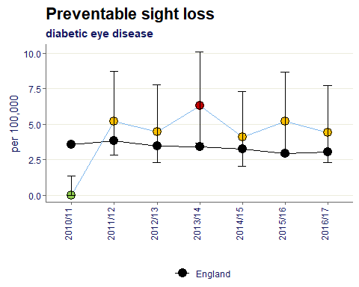
Since 2011/12 the rate of sight loss due to diabetic eye disease has averaged 5 per 100,000 and throughout this time has mostly been similar to the England static trend of around 3 per 100,000.

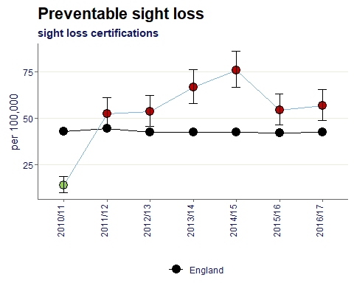
Crude rate of sight loss certifications per 100,000 population

Dudley has had a significantly worse rate of sight loss certifications since 2011.
The England value averages 43 per 100,000. In comparison Dudley’s most recent value is 56.7 which is a reduction compared to the 2014/15 peak of 76.

Average health status score for adults aged 65 and over
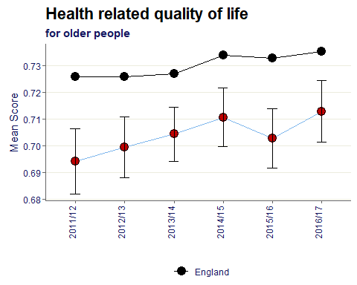
The mean score of health related quality of life for those 65+ is significantly worse in Dudley compared to England. The trend in Dudley however is a slight increase over time.

Age standardised rate of emergency admissions for fractured neck of femur in those aged 65+ per 100,000 population
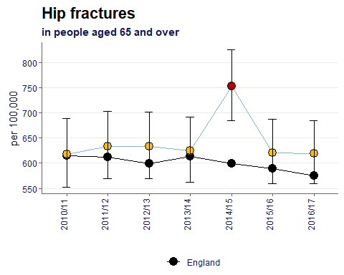
For all but one time periods, Dudley’s rate or hip fracture in the 65+ population has remained similar to the England rate which averages 600 per 100,000.

Age standardised rate of emergency admissions for fractured neck of femur in those aged 65-79 per 100,000 population
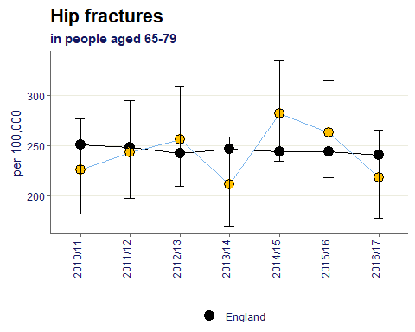
Hip fracture for the 65-79 cohort in Dudley averages 243 per 100,000 and has remained similar to England throughout the given periods.

Age standardised rate of emergency admissions for fractured neck of femur in those aged 80+ per 100,000 population
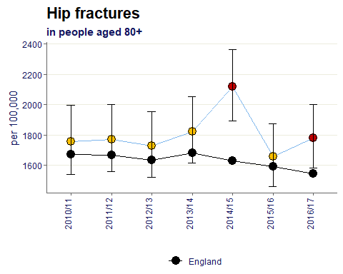

In the older 80+ cohort, Hip fracture over time was mostly similar to the England value, however in the most recent time period given has become significantly worse with a rate of 1,782 per 100,000.

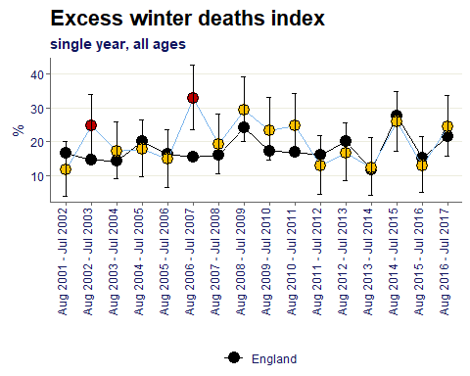
Excess Winter Deaths Index (EWD Index) is the excess winter deaths measured as the ratio of extra deaths from all causes that occur in the winter months compared with the expected number of deaths, based on the average of the number of non-winter deaths.

Over time the Dudley value for excess winter deaths for all ages by year has mostly been similar to the England baseline, including the most recent time period as 24.4%.

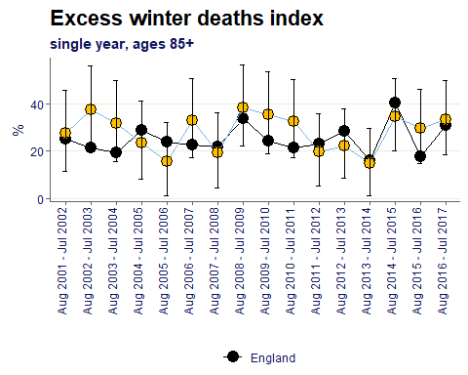
Excess Winter Deaths Index (EWD Index) is the excess winter deaths measured as the ratio of extra deaths from all causes that occur in all those aged 85 and over in the winter months compared with the expected number of deaths, based on the average of the number of non-winter deaths in those aged 85 and over.

In the 85+ cohort Dudley has remained similar to England for all given time periods and averages 28%.

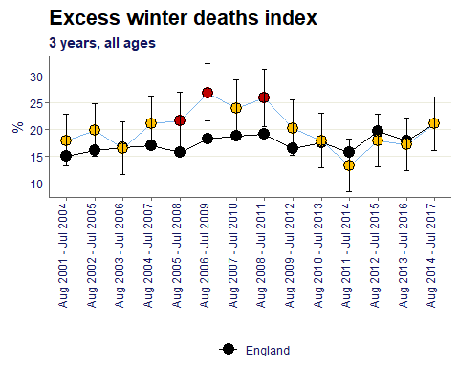
Excess Winter Deaths Index (EWD Index) is the excess winter deaths measured as the ratio of extra deaths from all causes that occur in the winter months compared with the expected number of deaths, based on the average of the number of non-winter deaths.

Similar to the single years, over time the Dudley value for excess winter deaths for 3 years & all ages has mostly been similar to the England baseline, including the most recent time period as 21%.

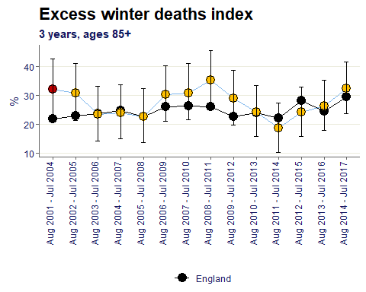
Excess Winter Deaths Index (EWD Index) is the excess winter deaths measured as the ratio of extra deaths from all causes that occur in all those aged 85 and over in the winter months compared with the expected number of deaths, based on the average of the number of non-winter deaths in those aged 85 and over.

Similar to the single years, in the 85+ cohort& 3 years, Dudley has remained similar to England for all given time periods, bar one, and averages 27%.

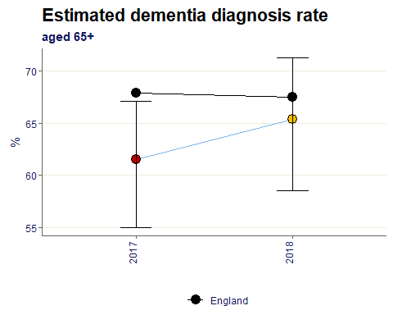
The rate of persons aged 65 and over with a recorded diagnosis of dementia per person estimated to have dementia given the characteristics of the population and the age and sex specific prevalence rates of the Cognitive Function and Ageing Study II, expressed as a percentage with 95% confidence intervals.

The 2018 estimated dementia rate in Dudley is 65.5% and is similar to the England value.

Citations:
All data sourced from https://fingertips.phe.org.uk/ under the terms and conditions of the Open Government Licence via the following software/packages:
R Core Team (2018). R: A language and environment for statistical computing. R Foundation for
Statistical Computing, Vienna, Austria. URL https://www.R-project.org/.

Sebastian Fox and Julian Flowers (2018). fingertipsR: Fingertips Data for Public Health.
R package version 0.2.0. https://CRAN.R-project.org/package=fingertipsR

Sebastian Fox (2018). fingertipscharts: Produce Charts that you See on the Fingertips
Website. R package version 0.0.3. https://CRAN.R-project.org/package=fingertipscharts

