Public Health Outcomes Framework

Health Protection for Dudley compared to England

11 January 2019
Indicator | Page
Fraction of mortality attributable to particulate air pollution | 3
Chlamydia detection rate (15-24 year olds) | 3
Population vaccination coverage - Hepatitis B (1 year old) | 4
Population vaccination coverage - Hepatitis B (2 years old) | 4
Population vaccination coverage - Dtap / IPV / Hib (1 year old) | 5
Population vaccination coverage - Dtap / IPV / Hib (2 years old) | 5
Population vaccination coverage - MenC | 6
Population vaccination coverage - PCV | 6
Population vaccination coverage - PCV booster | 7
Population vaccination coverage - Hib / Men C booster (5 years old) | 7
Population vaccination coverage - Hib / MenC booster (2 years old) | 8
Population vaccination coverage - MMR for one dose (2 years old) | 8
Population vaccination coverage - MMR for one dose (5 years old) | 9
Population vaccination coverage - MMR for two doses (5 years old) | 9
Population vaccination coverage - HPV vaccination coverage for one dose (females 12-13 years old) | 10
Population vaccination coverage - HPV vaccination coverage for two doses (females 13-14 years old) | 10
Population vaccination coverage - PPV | 11
Population vaccination coverage - Flu (aged 65+) | 11
Population vaccination coverage - Flu (at risk individuals) | 12
Population vaccination coverage - Flu (2-3 years old) - current method | 12
Population vaccination coverage - Shingles vaccination coverage (70 years old) | 13
HIV late diagnosis | 13
Treatment completion for TB | 14
Incidence of TB | 14
Adjusted antibiotic prescribing in primary care by the NHS | 15

Fraction of all-cause adult mortality attributable to anthropogenic particulate air pollution (measured as fine particulate matter, PM2.5)
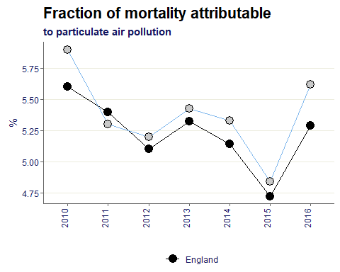
The Dudley trend overtime follows England, although the percentage has been higher in Dudley for all but one time period.
To give this context however the largest gap between Dudley and Baseline is 0.3% points seen in 2010 and 2016.

Rate of chlamydia detection per 100,000 young people aged 15 to 24
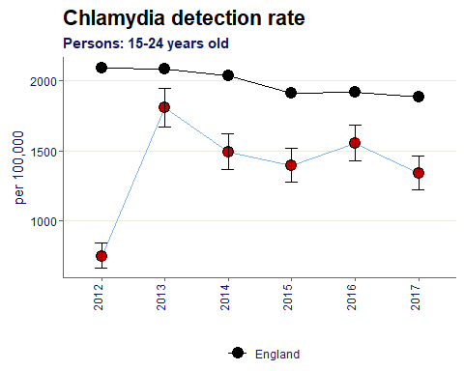
Chlamydia detection rate is significantly worse than England for 2012-2017. Since the best rate achieved in 2013, Dudley’s value has been decreasing, the most recent data in 2017 shows 1,338 per 100,000.

% of eligible children who received 3 doses of Hepatitis B vaccine at any time by their 1st birthday
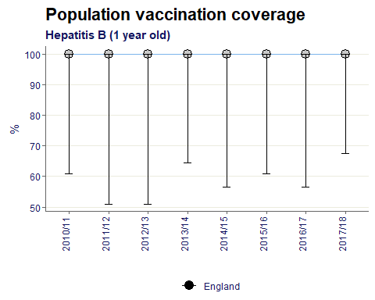
Dudley has a 100% vaccination coverage for Hep B in 1 year for all years.

% of eligible children who received 4 doses of Hepatitis B vaccine at any time by their 2nd birthday
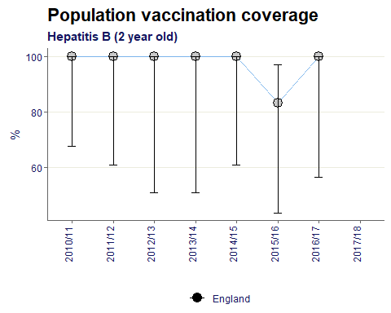
For the majority of years Dudley has a 100% rate of coverage in 2 years olds, with the exception of 2015/16 where the rate fell to 83%.

% of eligible children who received 3 doses of Dtap / IPV / Hib vaccine at any time by their 1st birthday
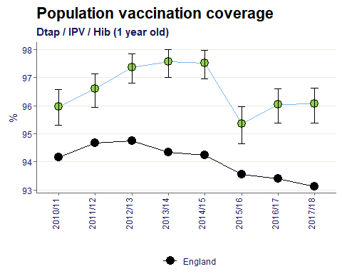
Dudley’s value is significantly better than England for all time periods.
The average percentage of eligible children who received 3 doses by 1 years old is 96.6%.

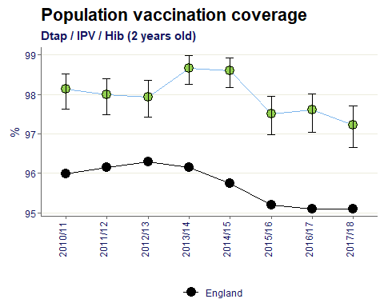
% of eligible children who received 3 doses of Dtap / IPV / Hib vaccine at any time by their 2nd birthday

Dudley’s value is significantly better than England for all time periods.
The average percentage of eligible children who received 3 doses by 2 years old is 98%.

% of eligible children who have received the completed course of Men C vaccine by their 1st birthday
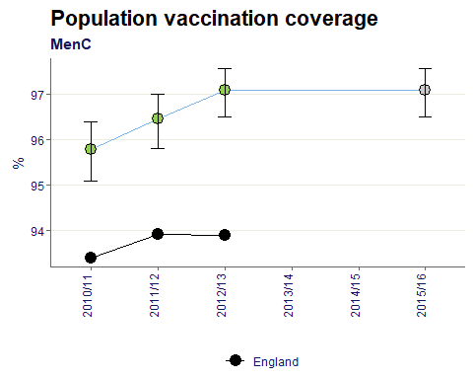

The Dudley value remains at 97.1% in 2015/16.

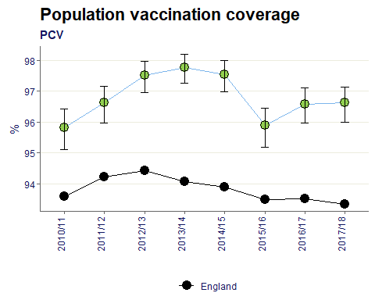
% of eligible children who have received the complete course of PCV vaccine by their 1st birthday

Dudley’s value is significantly better than England for all time periods.
The average percentage of eligible children who received PCV vaccination by 1 years old is 96.8%.

% of eligible children who have received one booster dose of PCV vaccine by their 2nd birthday
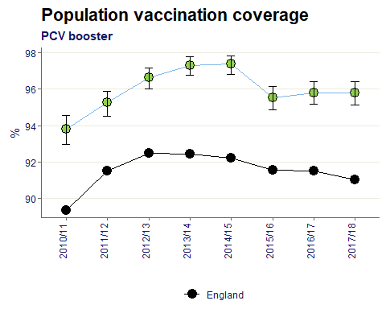

Dudley’s value is significantly better than England for all time periods.
The average percentage of eligible children who received PCV booster by 2 years old is 96%.

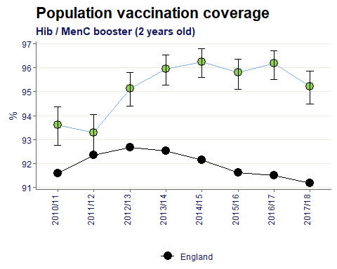
% of eligible children who have received one booster dose of Hib/Men C vaccine by their 2nd birthday

Dudley’s value is significantly better than England for all time periods.
The average percentage of eligible children who received Hib/MenC booster by 2 years old is 96%.

% of eligible children who have received one booster dose of Hib/Men C vaccine by their 5th birthday
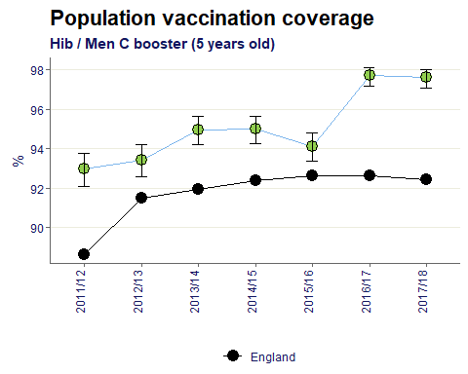
Dudley’s value is significantly better than England for all time periods.
The average percentage of eligible children who received Hib/MenC booster by 5 years old is 95%.

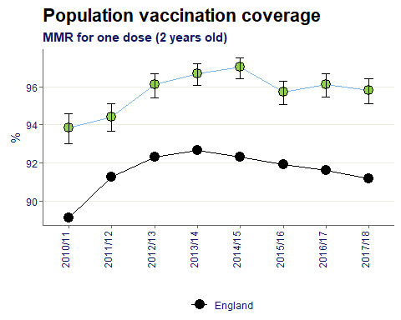
% of eligible children who have received one dose of MMR vaccine on or after their 1st birthday and anytime up to their 2nd birthday

Dudley’s value is significantly better than England for all time periods.
The average percentage of eligible children who received one dose of MMR by 2 years old is 95.7%.

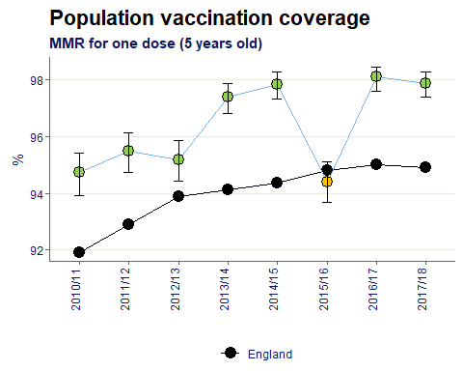
% of eligible children who have received one dose of MMR vaccine on or after their 1st birthday and at any time up to their 5th birthday

Dudley’s value is significantly better than England for the majority of time periods.
The average percentage of eligible children who received one dose of MMR by 5 years old is 96.3%.

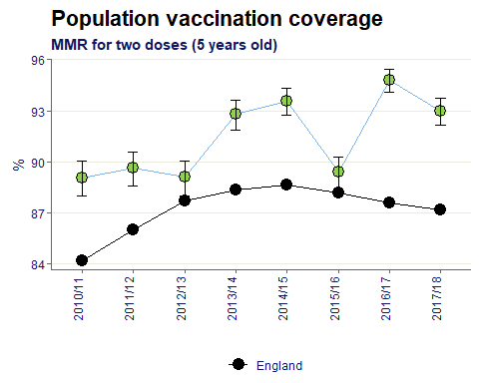
% of eligible children who have received two doses of MMR vaccine on or after their 1st birthday and at any time up to their 5th birthday

Dudley’s value is significantly better than England for all time periods.
The average percentage of eligible children who received two doses of MMR by 5 years old is 91.4%.

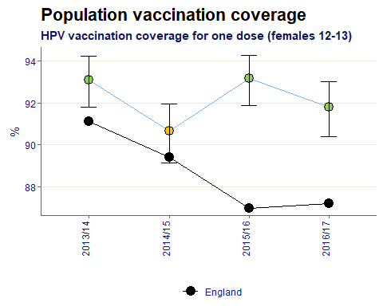
All girls aged 12-13 years who have received the first (priming) dose of the HPV vaccine within each reporting area (local authority - LA) as a percentage of all girls aged 12-13 years within each area

Dudley’s value has generally been significantly better than England, in the most recent data year Dudley’s percentage is 4.6% points greater than England.

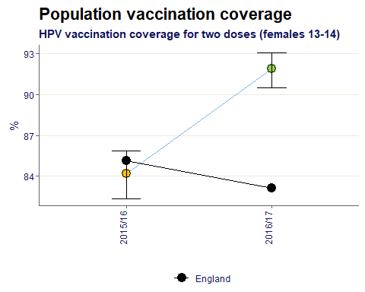
All girls aged 13-14 years who have received the second (completing) dose of the HPV vaccine within each reporting area (local authority - LA) as a percentage of all girls aged 13-14 years within each area

Dudley’s percentage of vaccination coverage has significantly increased between 2015/16 and 2016/17 and is now better than England.

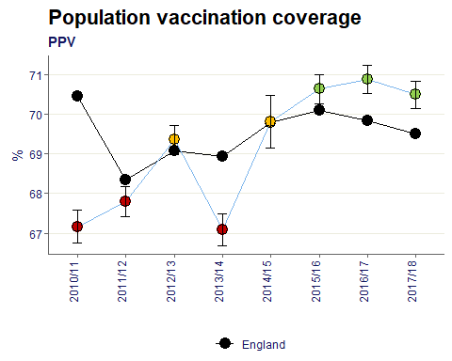
These data describe pneumococcal polysaccharide vaccine (PPV) uptake for the survey year, for those aged 65 years and over.

Dudley’s uptake has improved over time moving from significantly worse than England up to 2013/14 to now being significantly better for the latest 3 data years.

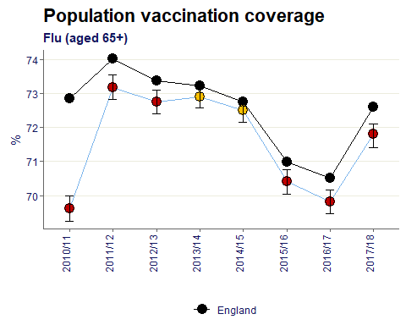
Flu vaccine uptake (%) in adults aged 65 and over, who received the flu vaccination between 1st September to 31st January in a primary care setting (GPs)

For the majority of years shown, Dudley’s flu uptake in adults aged 65+ has been significantly worse than England.

Flu vaccine uptake (%) in at risk individuals aged 6 months to 65 years (excluding pregnant women), who received the flu vaccination between 1st September and 31st January in a primary care setting (GPs)
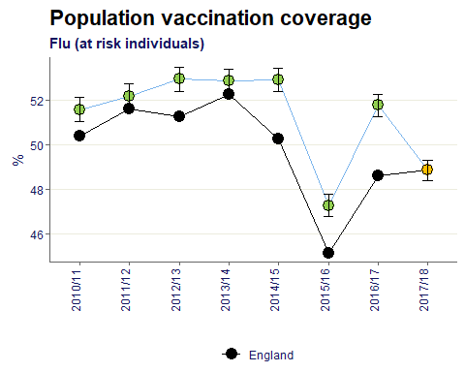
Dudley’s flu vaccination of at risk individuals has historically been better than England, however in 2017/18 dropped to similar to England, achieving the same value of 48.9%.

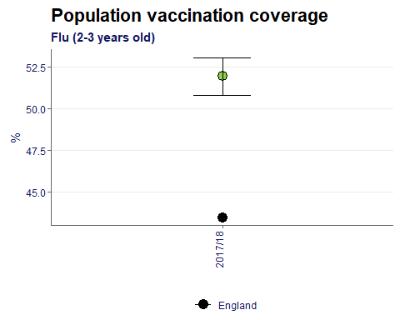
Flu vaccine uptake (%) in children aged 2-3 years old, who received the flu vaccination between 1st September to 31st January for GP registered patients.

Note: there was a recent change to methodology so only one data year available for current method.
Dudley’s value is significantly better than England with a difference of 8.4% points.

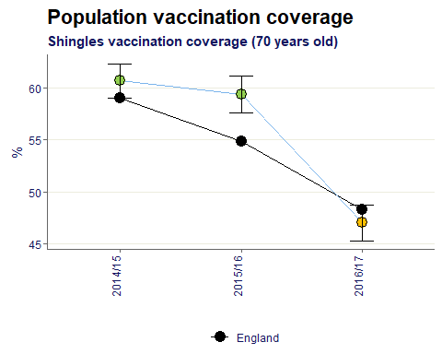
All people aged 70 years who have received a dose of shingles vaccine within each reporting area (local authority - LA) as a percentage of all people aged 70 years within each area

Dudley’s shingle’s vaccination percentage has recently fallen below the England value in 2016/17 and has moved from statistically better to similar.

Percentage of adults (aged 15 or above) newly diagnosed with HIV with a CD4 count less than 350 cells per mm3
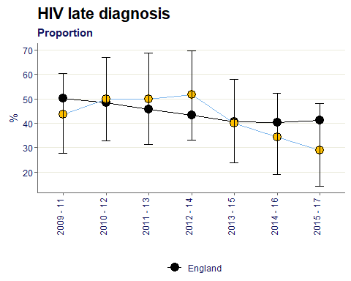
Across all time periods Dudley’s proportion of HIV late diagnosis has remained similar to the England value. However since the 2012-14 peak Dudley’s value has been decreasing.

Proportion of drug sensitive TB cases who had completed a full course of treatment by 12 months
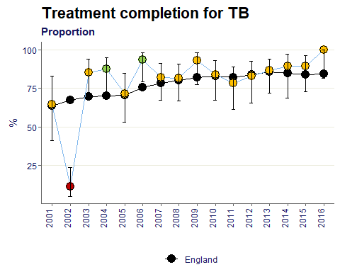

Since 2007 Dudley’s value has been statistically similar to the England baseline.

Three year average incidence of TB per 100,000 population
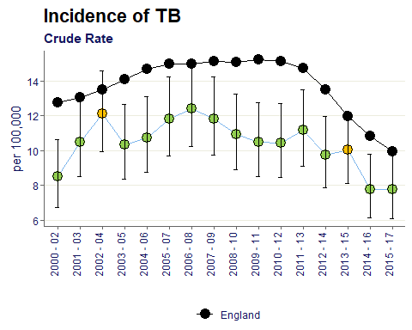
Since 2000-02 the crude rate of incidence of TB in Dudley has been mostly better than England. The most recent data year has seen a record low for Dudley of 7.8%.

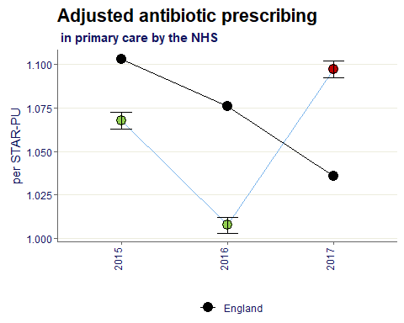
Annual total number of prescribed antibiotic items per STAR-PU (Specific Therapeutic group Age-sex weightings Related Prescribing Unit)

Although the latest time period shows as significantly worse than England for Dudley, the ratio per star-pu has only increased from 1.07 to 1.1 between 2016 and 2017.

Citations:
All data sourced from https://fingertips.phe.org.uk/ under the terms and conditions of the Open Government Licence via the following software/packages:
R Core Team (2018). R: A language and environment for statistical computing. R Foundation for
Statistical Computing, Vienna, Austria. URL https://www.R-project.org/.

Sebastian Fox and Julian Flowers (2018). fingertipsR: Fingertips Data for Public Health.
R package version 0.2.0. https://CRAN.R-project.org/package=fingertipsR

Sebastian Fox (2018). fingertipscharts: Produce Charts that you See on the Fingertips
Website. R package version 0.0.3. https://CRAN.R-project.org/package=fingertipscharts

