Public Health Outcomes Framework

Health Improvement for Dudley compared to England

15 January 2019
Indicator | Page
Low birth weight of term babies | 4
Breastfeeding initiation | 4
Smoking status at time of delivery | 5
Under 18 conceptions | 5
Under 18 conceptions: conceptions in those aged under 16 | 6
Proportion of children aged 2-2½yrs receiving ASQ-3 as part of the Healthy Child Programme or integrated review | 6
Child excess weight in 4-5 and 10-11 year olds - 4-5 year olds | 7
Child excess weight in 4-5 and 10-11 year olds - 10-11 year olds | 7
Hospital admissions caused by unintentional and deliberate injuries in children (aged 0-14 years) | 8
Hospital admissions caused by unintentional and deliberate injuries in children (aged 0-4 years) | 8
Hospital admissions caused by unintentional and deliberate injuries in young people (aged 15-24 years) | 9
Average difficulties score for all looked after children aged 5-16 who have been in care for at least 12 months on 31st March | 9
Percentage of children where there is a cause for concern | 10
Smoking prevalence at age 15 - current smokers (WAY survey) | 10
Smoking prevalence at age 15 - regular smokers (WAY survey) | 11
Smoking prevalence at age 15 - occasional smokers (WAY survey) | 11
Emergency Hospital Admissions for Intentional Self-Harm | 12
Proportion of the population meeting the recommended '5-a-day' on a 'usual day' (adults) | 12
Average number of portions of fruit consumed daily (adults) | 13
Average number of portions of vegetables consumed daily (adults) | 13
Proportion of the population meeting the recommended "5-a-day" at age 15 | 14
Average number of portions of fruit consumed daily at age 15 (WAY survey) | 14
Average number of portions of vegetables consumed daily at age 15 (WAY survey) | 15
Percentage of adults (aged 18+) classified as overweight or obese | 15
Percentage of physically active adults | 16
Percentage of physically inactive adults | 16
Smoking Prevalence in adults - current smokers (APS) | 17
Successful completion of drug treatment - opiate users | 17
Successful completion of drug treatment - non-opiate users | 18
Successful completion of alcohol treatment | 18
Deaths from drug misuse | 19
Adults with substance misuse treatment need who successfully engage in community-based structured treatment following release from prison | 19
Estimated diabetes diagnosis rate | 20
Admission episodes for alcohol-related conditions - narrow definition | 20
Cancer diagnosed at early stage (experimental statistics) | 21
Cancer screening coverage - breast cancer | 21
Cancer screening coverage - cervical cancer | 22
Cancer screening coverage - bowel cancer | 22
Abdominal Aortic Aneurysm Screening - Coverage | 23
Newborn Blood Spot Screening - Coverage | 23
Newborn Hearing Screening - Coverage | 24
Cumulative percentage of the eligible population aged 40-74 offered an NHS Health Check who received an NHS Health Check | 24
Cumulative percentage of the eligible population aged 40-74 who received an NHS Health check | 25
Self-reported wellbeing - people with a low satisfaction score | 25
Self-reported wellbeing - people with a low worthwhile score | 26
Self-reported wellbeing - people with a low happiness score | 26
Self-reported wellbeing - people with a high anxiety score | 27
Emergency hospital admissions due to falls in people aged 65 and over | 27
Emergency hospital admissions due to falls in people aged 65 and over - aged 65-79 | 28
Emergency hospital admissions due to falls in people aged 65 and over - aged 80+ | 28

Live births with a recorded birth weight under 2500g and a gestational age of at least 37 complete weeks as a percentage of all live births with recorded birth weight and a gestational age of at least 37 complete weeks.
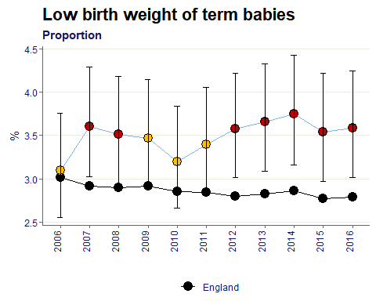
Since 2012 the proportion of low birth weight term babies in Dudley is significantly worse than England. For the time periods shown the average value for Dudley is 3.5% which is 0.6% points higher than the England value of 2.9%.

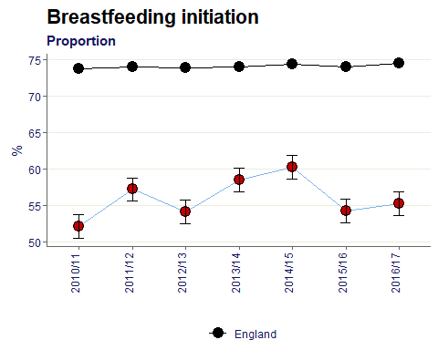
Measures the percentage of mothers who give their babies’ breast milk in the first 48 hours after delivery. The numerator is the number of mothers initiating breast feeding and the denominator is the total number of maternities.

For all data points the Dudley value for breastfeeding initiation is significantly lower than England. The average for Dudley is 56%, 8% points lower than England’s average of 74%.

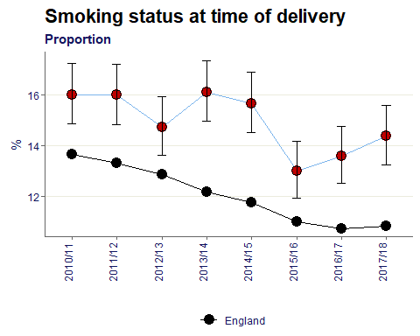
The number of mothers known to be smokers at the time of delivery as a percentage of all maternities. A maternity is defined as a pregnant woman who gives birth to one or more live or stillborn babies of at least 24 weeks gestation, where the baby is delivered by either a midwife or doctor at home or in a NHS hospital

The percentage of mothers known to be smokers at time of delivery in Dudley is significantly higher than England for all time periods shown. On average the Dudley value is 15% of all maternities.

Conceptions in women aged under 18 per 1,000 females aged 15-17
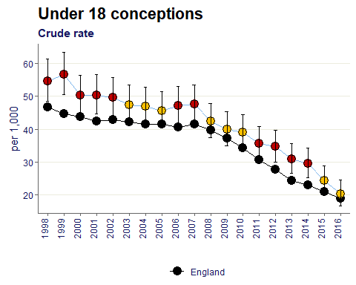
The trend of under 18 conceptions in Dudley has been consistently higher than England since 1998, however in two latest time periods the value has become similar to baseline. The most recent value however is 20 per 1,000, a significant reduction from over 50 per 1,000 in the late 90’s.

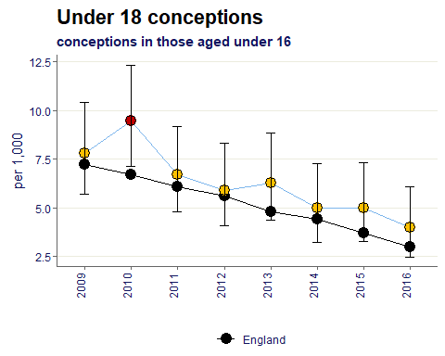
Conceptions in women aged under 16 per 1,000 females aged 13-15

The conception rate in under 16’s has been similar to the England rate since 2011. Overall the trend is a reduction in Dudley, the latest value for 2016 is the lowest shown, with a value of 4 per 1,000.

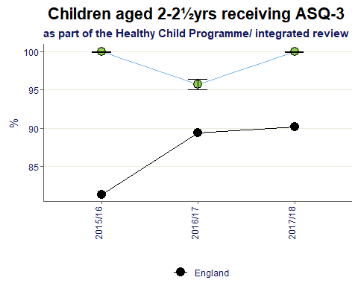
Percentage of children who received a 2-2½ year review in the period for whom the ASQ-3 is completed as part of their 2-2½ year review

For all time periods the Dudley value is significantly better than England, with an average of 98.5%.

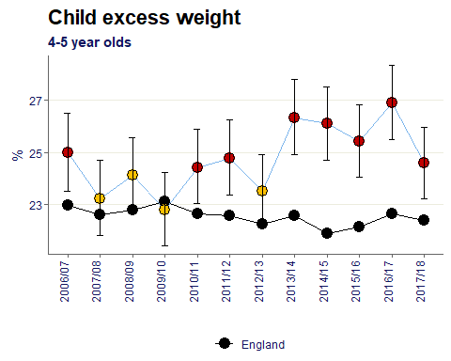
Proportion of children aged 4-5 years classified as overweight or obese. Children are classified as overweight (including obese) if their BMI is on or above the 85th centile of the British 1990 growth reference (UK90) according to age and sex.

Since the start of the NCMP Dudley’s % of reception children with excess weight has been significantly higher than the England baseline for 8 out of 12 years. The most recent time period of 2017/18 however has seen a decrease compared to the previous year by 2% points.

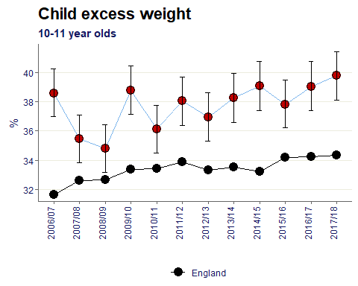
Proportion of children aged 10-11 classified as overweight or obese. Children are classified as overweight (including obese) if their BMI is on or above the 85th centile of the British 1990 growth reference (UK90) according to age and sex.

Conversely for the older cohort (in year 6) the % has increased in the latest time period, moving from 39% in 2016/17 to 39.8% in 2017/18.
For all data points Dudley’s proportion of year 6 children with excess weight is significantly worse compared to baseline.

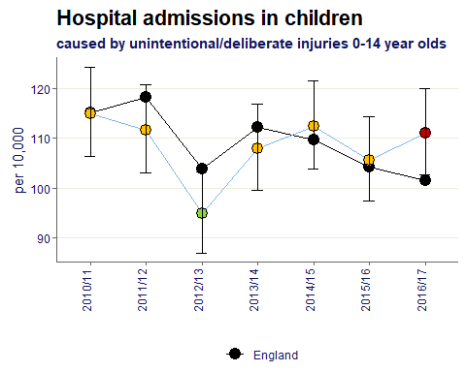
Crude rate of hospital admissions caused by unintentional and deliberate injuries in children aged under 15 years per 10,000 resident population aged under 15 years.

In the most recent time period the rate of hospital admissions in children 0-14 has become significantly worse than England. Dudley’s value is 111 per 100,000 compared to 101.5 in England.

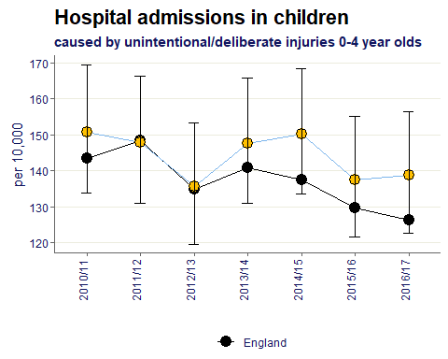
Crude rate of hospital admissions caused by unintentional and deliberate injuries in children aged under 5 years per 10,000 resident population aged under 5 years.

For all time periods the rate of admissions in children aged 0-4 in Dudley is statistically similar to England, averaging a value of 144 per 100,000.

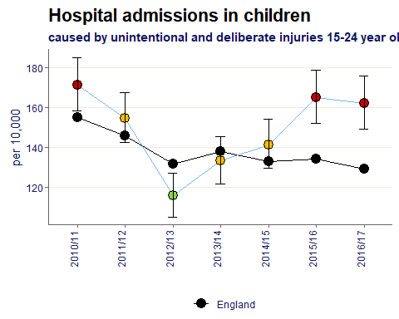
Crude rate of hospital admissions caused by unintentional and deliberate injuries in young people aged 15-24 years per 10,000 resident population aged 15-24 years.

For Dudley children aged 15-24 the rate of hospital admissions has become significantly worse than England in the two most recent data years. The 2016/17 value is 161.8 per 100,000 whereas England is 129.2.

Total difficulties score for all looked after children aged between 5 and 16 (inclusive) at the date of their latest assessment, who have been in care for at least 12 months on 31 March.
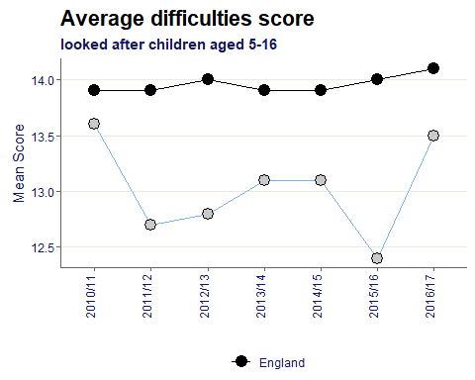
The average difficulties mean score for Dudley children is 13, for England the value is 14.

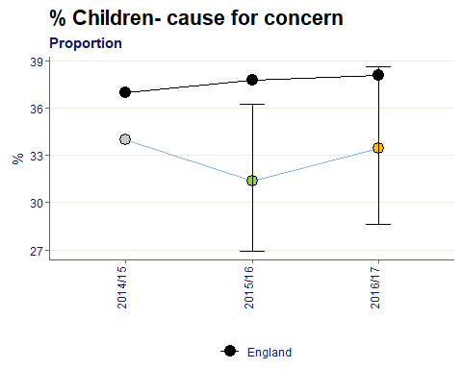
Proportion of all looked after children aged between 5 and 16 (inclusive) at the date of their latest assessment, who have been in care for at least 12 months on 31 March whose SDQ score was 17 or over.

The proportion of children in Dudley who are a cause for concern is similar to England in 2016/17, with a difference form benchmark of 5% points.

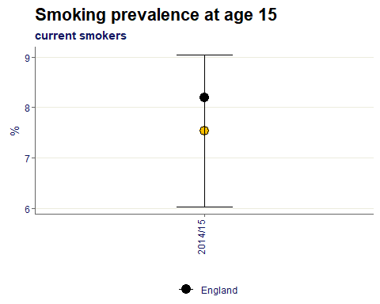
The percentage of 15 year olds who responded to Q17 in the What About YOUth (WAY) survey (“Now read the following statements carefully, and tick the box next to the one that best describes you”) with the answers “I sometimes smoke cigarettes now but I don’t smoke as many as one a week”, “I usually smoke between one and six cigarettes per week” or “I usually smoke more than six cigarettes per week”.
The proportion of current smokers at age 15 in Dudley is similar to England, the value is 7.5% below the 8.2% baseline.

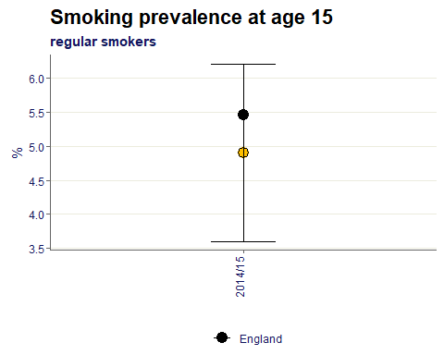
The percentage of 15 year olds who responded to Q17 in the What About YOUth survey (“Now read the following statements carefully, and tick the box next to the one that best describes you”) with the answers “I usually smoke between one and six cigarettes per week” or “I usually smoke more than six cigarettes per week”.

The proportion of regular smokers at age 15 in Dudley is also below the England value yet remaining statistically similar to.

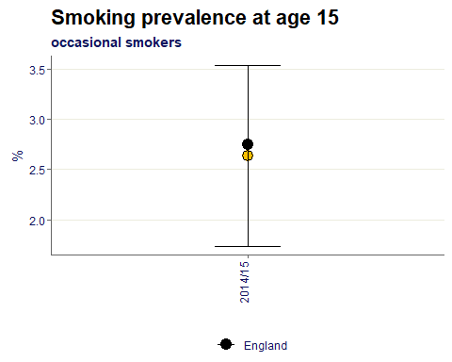
The percentage of 15 year olds who responded to Q17 in the What About YOUth survey (“Now read the following statments carefully, and tick the box next to the one that best describes you”) with the answer “I sometimes smoke cigarettes now but I don’t smoke as many as one a week”.

The occasional smokers at age 15 is also similar to the England value, with a small difference between the values, 2.6% in Dudley compared to 2.7% in England.

Emergency Hospital Admissions for Intentional Self-Harm, directly age standardised rate, all ages, Persons.
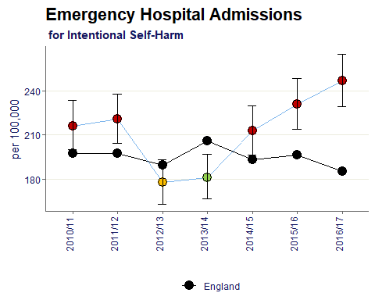
The rate of emergency hospital admissions for intentional self-harm in Dudley has been increasing since 2014/15 and for the past 3 data years has been significantly worse than England. The most recent data point for Dudley is 2016/17 and is a rate of 246.6 per 100,000.

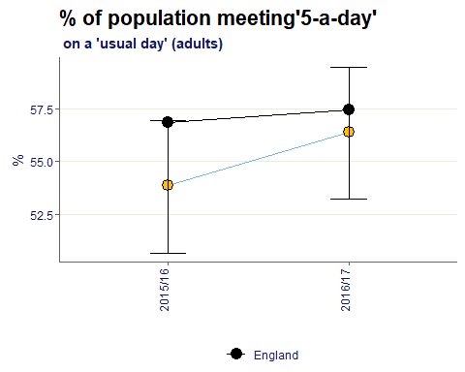
Proportion of the population who, when surveyed, reported that they had eaten the recommended 5 portions of fruit and vegetables on a usual day.

The percentage of adults meeting the recommended 5-a-day in Dudley is similar to the England value.
On average in Dudley the value is 55%, implying 45% of adults are not meeting the recommended amount of fruit and veg a day.

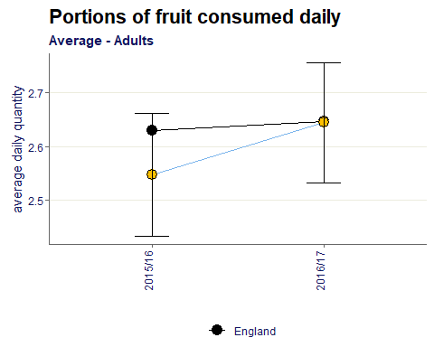
Average (mean) number of portions reported by survey respondents aged 16+ when asked how many portions of fruit they ate on the previous day.

The average daily portions of fruit consumed by adults in Dudley is 2.6, this is similar to the England value.

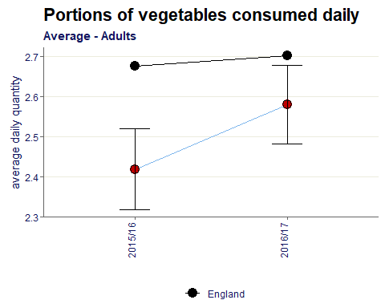
Average (mean) number of portions reported by survey respondents aged 16+ when asked how many portions of vegetables they ate on the previous day.

The average daily portions of veg consumed by adults in Dudley is 2.5, this is statistically worse compared to the England value of 2.7

Proportion of the population meeting the recommended “5-a-day” at age 15
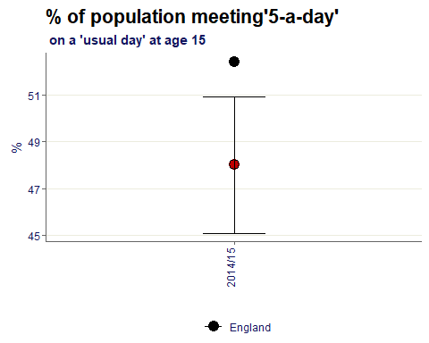
The percentage of 15 year olds meeting the 5-a-day recommendation was 48% in 2014/15, which is worse than the England proportion of 52.4%

The mean number of the daily portions of fruit and fruit juice consumed by 15 year olds in the What About YOUth (WAY) survey.
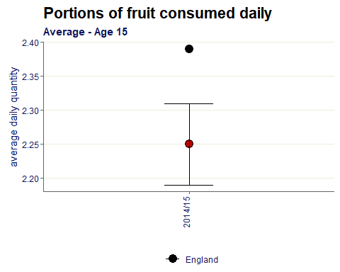
The average daily quantity of fruit consumed by 15 year olds in Dudley in 2014/15 is 2.25 which is worse than the England value of 2.39.

The mean number of daily portions of vegetables (not including beans or pulses) consumed by 15 year olds in a day (Q4) in the What About YOUth survey.
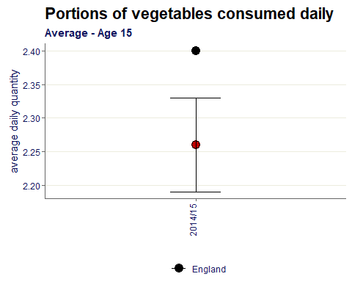
The average daily quantity of veg consumed by 15 year olds in Dudley in 2014/15 is 2.26 which is worse than the England value of 2.40.

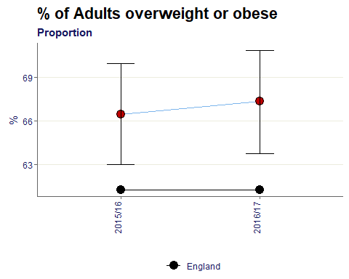
Percentage of adults aged 18 and over classified as overweight or obese

The average proportion of overweight/obese adults in Dudley is 67%, this is 6% points higher than the England rate and significantly worse.

Percentage of adults (aged 19+) that meet CMO recommendations for physical activity (150+ moderate intensity equivalent minutes per week).
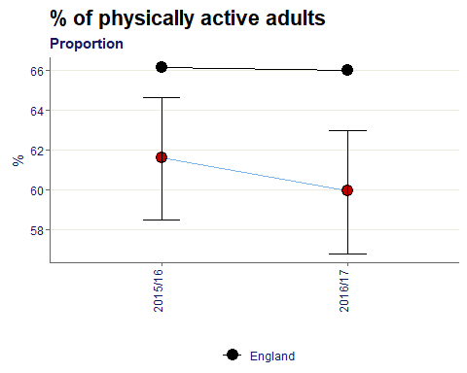
The average proportion of physically active adults in Dudley is 60.5% which is 5.5% points below the England value of 66%. For both time periods the value is significantly worse than baseline.

Percentage of adults (aged 19+) that are physically inactive (<30 moderate intensity equivalent minutes per week).
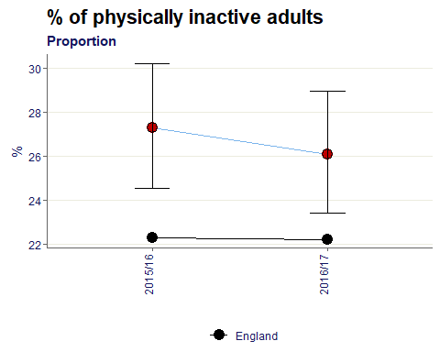
The proportion of physically inactive adults is 27% which is significantly higher than the England value of 22%

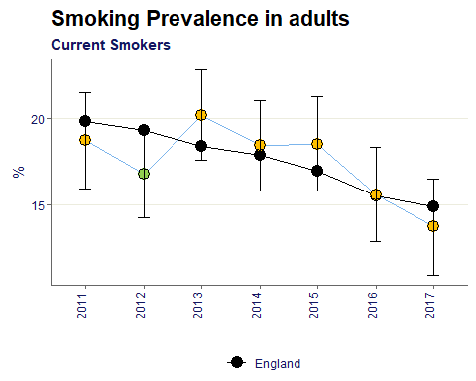
Prevalence of smoking among persons 18 years and over, Annual population survey.

Smoking prevalence in Dudley adults generally is similar to the England baseline. Since 2013 the proportion has been decreasing and in 2017 reached the lowest value shown of 13.7%.

Number of users of opiates that left drug treatment successfully (free of drug(s) of dependence) who do not then re-present to treatment again within 6 months as a percentage of the total number of opiate users in treatment.
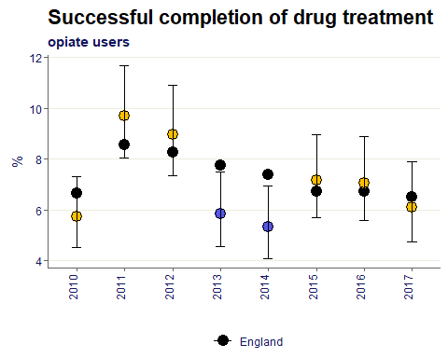
Although in the three most recent time periods Dudley’s value has been statistically similar to England, the proportion of users successfully completing drug treatment for opiates has been decreasing since 2015.

Number of users on non-opiates that left drug treatment successfully (free of drug(s) of dependence) who do not then re-present to treatment again within 6 months as a percentage of the total number of non-opiate users in treatment.
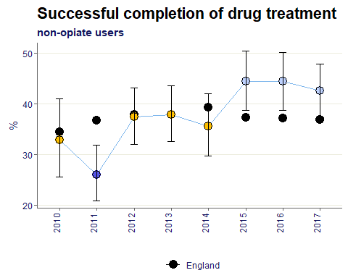
For the most recent time periods the Dudley percentage of users completing drug treatment for non-opiate users has been better than the England rate.

Number of alcohol users that left structured treatment successfully (free of alcohol dependence) who do not then re-present to treatment within 6 months as a percentage of the total number of alcohol users in structured treatment.
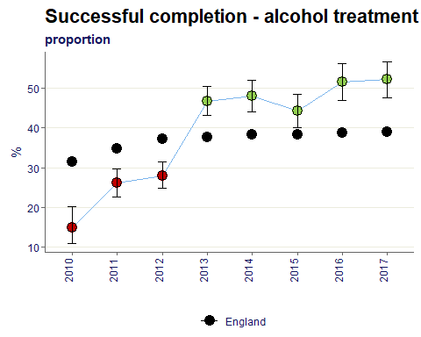
Since 2013 the proportion of alcohol users in Dudley completing treatment is significantly better than England. In 2017 the value has reached 52% which 13% points above baseline.

Age-standardised mortality rate from drug misuse per 100,000 population
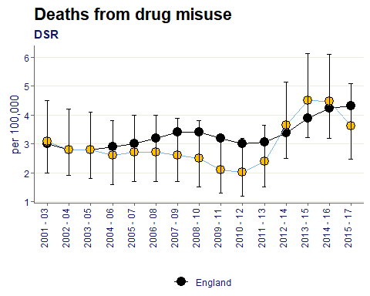
Overtime the Dudley rate of deaths from drug misuse has been similar to the England value.
In Dudley the value started to increase in 2011-13 but in the most recent time period of 2015-17 the value has started to decrease from the peak of 4.5 deaths per 100,000 seen in 2013-15 and 2014-16.

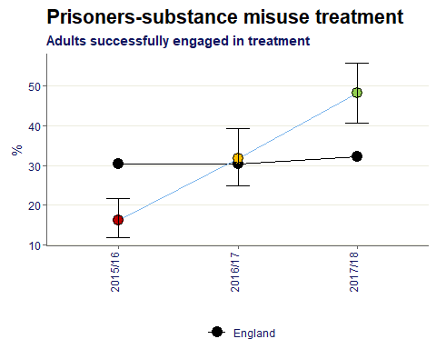
The indicator will measure the proportion of adults released from prison (into the Local Authority Area) with substance misuse treatment need who go on to engage in structured treatment interventions in the community within 3 weeks of release.

Over the three data years the rate of adults released from prisoners successfully engaged in a substance misuse treatment has increased from significantly worse to significantly better than England. Most recently in 2017/18 the proportion in Dudley was 48%.

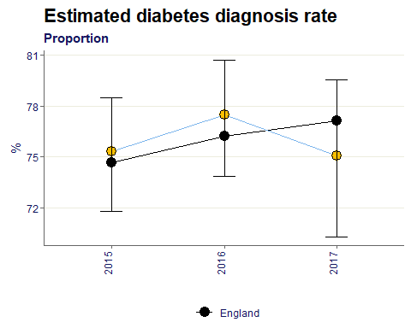
The estimated diabetes diagnosis rate, expressed as a percentage defined as the observed number of people with a formal diagnosis of diabetes as a proportion of the estimated number with diabetes

From 2015 to 2017 the estimated diabetes diagnosis rate in Dudley is statistically similar to England, on average the proportion is 76%.

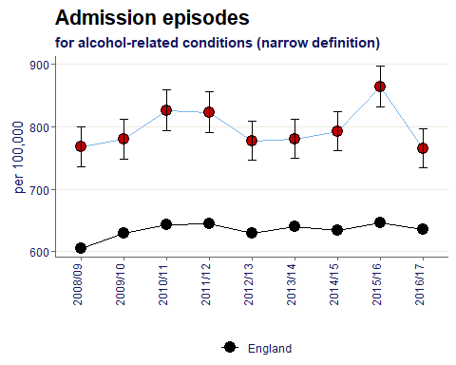
Hospital admissions for alcohol-related conditions (narrow definition), all ages, directly age standardised rate per 100,000 population European standard population.

For all time periods shown the rate of alcohol related condition admission episodes in Dudley is significantly higher than England. The average for Dudley is 797 per 100,000, compared to the baseline of 635.

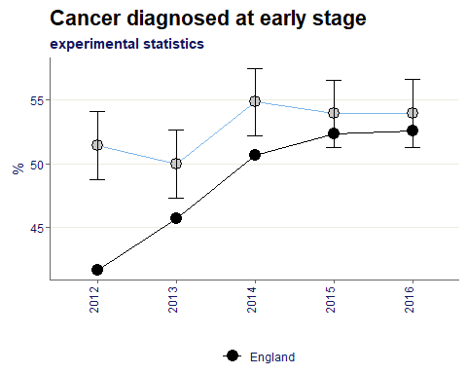
The proportion of invasive malignancies of breast, prostate, colorectal, lung, bladder, kidney, ovary and uterus, non-Hodgkin lymphomas, and melanomas of skin, diagnosed at stage 1 or 2

The proportion of cancer diagnosed at an early stage in Dudley averages 53%, which is 4% points above the England average of 49%.

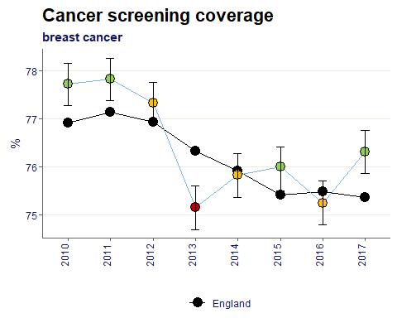
The percentage of women in the resident population eligible for breast screening who were screened adequately within the previous three years on 31 March

In the most recent time period of 2017, Dudley’s proportion of breast cancer screening coverage is significantly higher than England.
However compared to 2010 the value in Dudley has decreased by 1.5%.

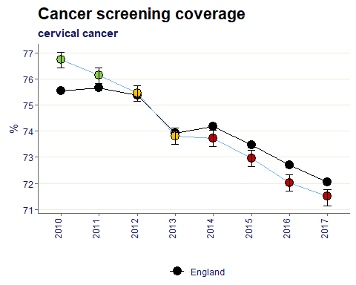
The percentage of women in the resident population eligible for cervical screening who were screened adequately within the previous 3.5 years or 5.5 years, according to age (3.5 years for women aged 25-49 and 5.5 years for women aged 50-64) on 31 March

Since 2010 the cervical cancer screening coverage has been decreasing in Dudley.
In the 4 most recent time periods the Dudley value has fallen below the England value and is significantly worse.

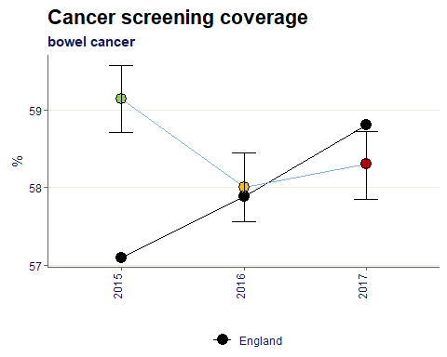
The percentage of people in the resident population eligible for bowel screening who were screened adequately within the previous 2½ years on 31 March

The Dudley value for bowel cancer screening coverage has worsened from 2015 to 2017 moving from significantly better than England to significantly worse. In 2017 the value is 58.3%.

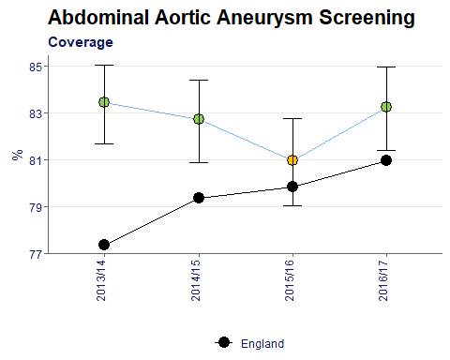
The proportion of men eligible for abdominal aortic aneurysm screening who are conclusively tested

Generally the coverage of abdominal aortic aneurysm screening is significantly better than England. On average the Dudley value is 82.6%.

The percentage of babies registered within the local authority area both at birth and at the time of report who are eligible for newborn blood spot screening and have a conclusive result recorded on the Child Health Information System within an effective timeframe.
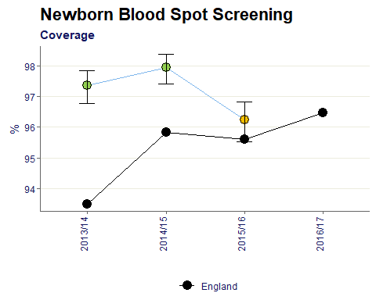
Newborn blood spot screening has dropped in the most recent time period of 2015/16 in Dudley but remains statistically similar to England.

The percentage of babies eligible for newborn hearing screening for whom the screening process is complete within 4 weeks corrected age (hospital programmes - well babies, all programmes - NICU babies) or 5 weeks corrected age (community programmes - well babies)
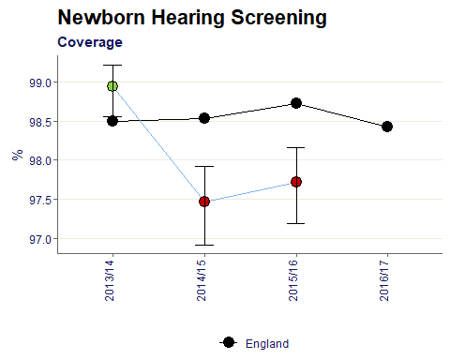
In the two most recent data years Dudley’s newborn hearing screening coverage has dropped from statistically better than England to Worse. In 2015/16 the Dudley value is 97.7% which is 1% point below baseline.

Cumulative percentage of eligible population aged 40-74 offered an NHS Health Check who received an NHS Health Check in the five year period 2013/14 - 2017/18
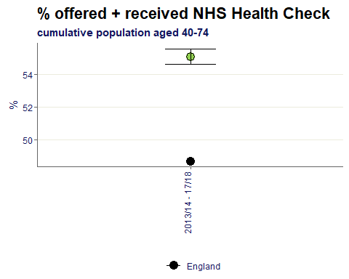
Between 2013/14 and 2017/18 the percentage of eligible population in Dudley that were offered and received a health check was 55%, which is statistically better than the England value of 48.7%.

Cumulative percentage of eligible population aged 40-74 who received an NHS Health Check in the five year period 2013/14 - 2017/18
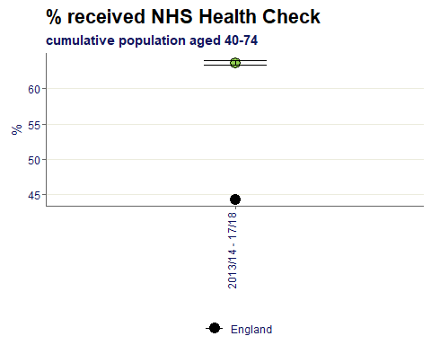
The percentage of the eligible population that received a health check in Dudley in the same 5 year period was 64%, which is again better than England, in this case by 20% points.

The percentage of respondents scoring 0-4 to the questions “Overall, how satisfied are you with your life nowadays”.
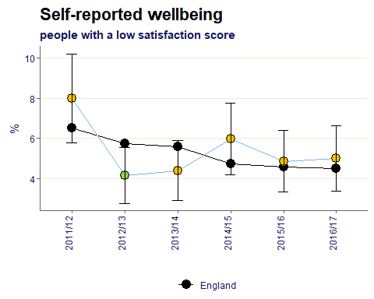
ONS are currently measuring individual/subjective well-being based on four questions included on the Integrated Household Survey

Over time the Dudley value has remained on the whole similar to the England value. On average 5.4% of respondents report a low satisfaction score.

% of respondents scoring 0-4 to the question “Overall, to what extent do you feel the things you do in your life are worthwhile?”
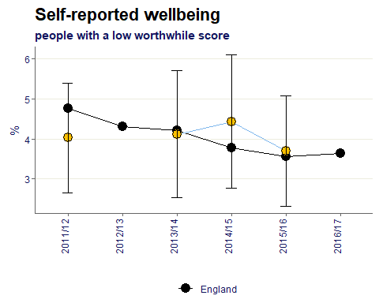
The Dudley value has remained similar to the England value over time and averages 4% of respondents reporting a low worthwhile score.

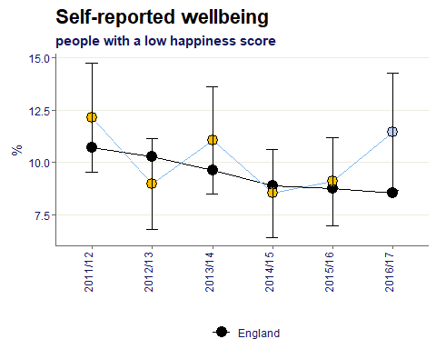
% of respondents scoring 0-4 to the question “Overall, how happy did you feel yesterday?”

The Dudley value has remained similar to the England value over time and averages 10% of respondents reporting a low happiness score. In the most recent survey however the value has become significantly worse than baseline.

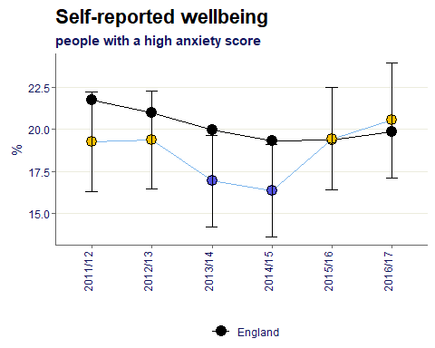
% of respondents scoring 6-10 to the question “Overall, how anxious did you feel yesterday?”

18.7% of Dudley respondents report a high anxiety score on average, most recently the Dudley value remains similar to the England value being only 1% point above.

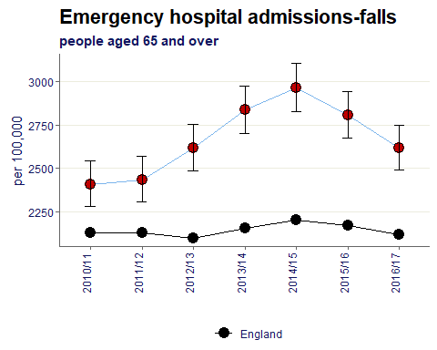
Age standardised rate of emergency hospital admissions for injuries due to falls in persons aged 65+ per 100,000 population

The rate of people aged 65 and over having falls that require emergency admission to hospital in Dudley remains significantly higher than England. Although the rate has been decreasing since the 2014/15 peak of 2,967 per 100,000 people.

Age standardised rate of emergency hospital admissions for injuries due to falls in persons aged 65-79 per 100,000 population
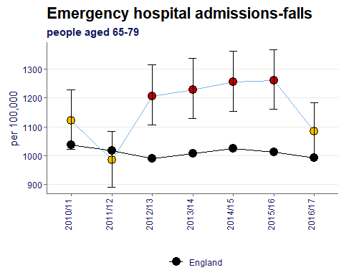
In the most recent time period of 2016/17 the rate of falls in the 65-79 cohort has become statistically similar to the England rate. Dudley’s value in 2016/17 is 1,084 per 100,000 compared to England’s value of 993.

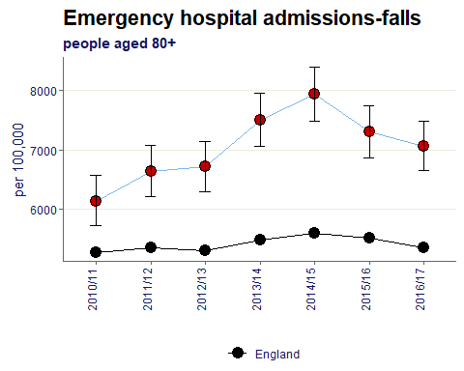
Age standardised rate of emergency hospital admissions for injuries due to falls in persons aged 80+ per 100,000 population
The case is the same for those aged 80 and over as the 65-80 cohort. Over time the rate remains significantly higher than England. However the reduction since the 2014/15 peak can also be seen in this subset of the population.

Citations:
All data sourced from https://fingertips.phe.org.uk/ under the terms and conditions of the Open Government Licence via the following software/packages:
R Core Team (2018). R: A language and environment for statistical computing. R Foundation for
Statistical Computing, Vienna, Austria. URL https://www.R-project.org/.

Sebastian Fox and Julian Flowers (2018). fingertipsR: Fingertips Data for Public Health.
R package version 0.2.0. https://CRAN.R-project.org/package=fingertipsR

Sebastian Fox (2018). fingertipscharts: Produce Charts that you See on the Fingertips
Website. R package version 0.0.3. https://CRAN.R-project.org/package=fingertipscharts

