Public Health Outcomes Framework

Wider determinants of health for Dudley compared to England

11 January 2019
Indicator | Page
Children in low income families (under 16s) | 4
Children in low income families (all dependent children under 20) | 4
School Readiness: the percentage of children achieving a good level of development at the end of reception | 5
School Readiness: the percentage of children with free school meal status achieving a good level of development at the end of reception | 5
School Readiness: the percentage of Year 1 pupils achieving the expected level in the phonics screening check | 6
School Readiness: the percentage of Year 1 pupils with free school meal status achieving the expected level in the phonics screening check | 6
Pupil absence | 7
First time entrants to the youth justice system | 7
16-17 year olds not in education, employment or training (NEET) or whose activity is not known - current method | 8
Adults with a learning disability who live in stable and appropriate accommodation | 8
Adults in contact with secondary mental health services who live in stable and appropriate accommodation | 9
Gap in the employment rate between those with a long-term health condition and the overall employment rate | 9
Gap in the employment rate between those with a learning disability and the overall employment rate | 10
Gap in the employment rate for those in contact with secondary mental health services and the overall employment rate | 10
Percentage of people aged 16-64 in employment | 11
Sickness absence - the percentage of employees who had at least one day off in the previous week | 11
Sickness absence - the percentage of working days lost due to sickness absence | 12
Killed and seriously injured (KSI) casualties on England's roads | 12
Domestic abuse-related incidents and crimes - current method | 13
Violent crime (including sexual violence) - hospital admissions for violence | 13
Violent crime (including sexual violence) - violence offences per 1,000 population | 14
Violent crime (including sexual violence) - rate of sexual offences per 1,000 population | 14
Re-offending levels - percentage of offenders who re-offend | 15
Re-offending levels - average number of re-offences per offender | 15
First time offenders | 16
The rate of complaints about noise | 16
The percentage of the population exposed to road, rail and air transport noise of 65dB(A) or more, during the daytime | 17
The percentage of the population exposed to road, rail and air transport noise of 55 dB(A) or more during the night-time | 17
Statutory homelessness - Eligible homeless people not in priority need | 18
Statutory homelessness - Households in temporary accommodation | 18
Utilisation of outdoor space for exercise/health reasons | 19
Fuel poverty | 19
Social Isolation: percentage of adult social care users who have as much social contact as they would like | 20
Social Isolation: percentage of adult carers who have as much social contact as they would like | 20

The number of children living in families in receipt of Child Tax Credit whose reported income is less than 60 per cent of the median income or are in receipt of Income Support or (Income-Based) Job Seeker’s Allowance divided by the total number of children in the area (determined by Child Benefit data).
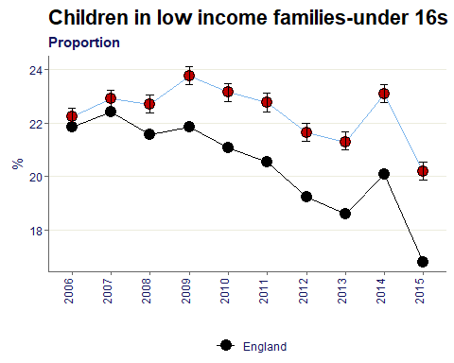
Dudley has a significantly higher proportion of children (under16s) in low income families compared to England. The average from 2006-2015 is 22%.

Number of all dependent children under the age of 20 living in families in receipt of Child Tax Credits (CTC) whose reported income is less than 60 per cent of the median income or in receipt of Income Support (IS) or (Income-Based) Job Seekers Allowance (JSA).

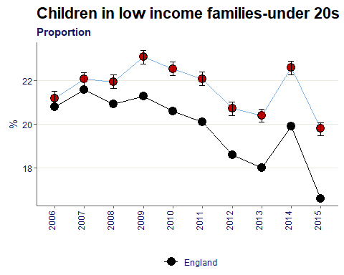
Dudley has a significantly higher proportion of children (under 20s) in low income families compared to England. The average from 2006-2015 is 22%.

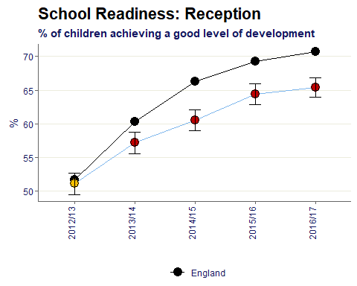
School Readiness: all children achieving a good level of development at the end of reception as a percentage of all eligible children.

Although over time Dudley’s percentage has been increasing, the gap between Dudley and England has been increasing also and has been significantly worse than baseline since 2013/14.

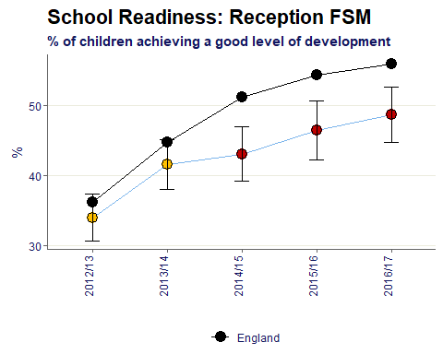
School Readiness: all children achieving a good level of development at the end of reception as a percentage of all eligible children by free school meal status

The pattern is similar for children with FSM status as all eligible children. However the average good level of development is lower at 43% compared to 60%.

School Readiness: Year 1 pupils achieving the expected level in the phonics screening check as a percentage of all eligible pupils
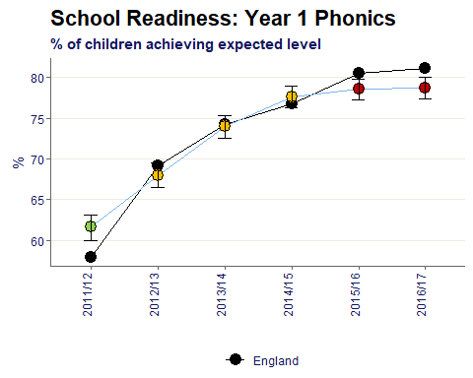

School readiness in year 1 pupils historically has been better in Dudley compared to reception, but in the two most recent time periods has dropped to become significantly worse than England.

School Readiness: Year 1 pupils achieving the expected level in the phonics screening check as a percentage of all eligible children by free school meal status
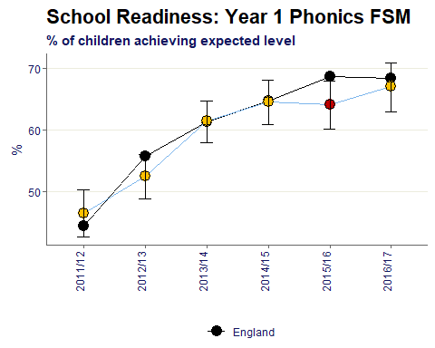
Dudley is similar to England in the most recent time period and overtime has been increasing.
On average however the FSM children are 14 percentage points behind all eligible children at 59% compared to 73%.

Percentage of half days missed by pupils due to overall absence (including authorised and unauthorised absence, children aged 5 to 15 at the start of the school year)
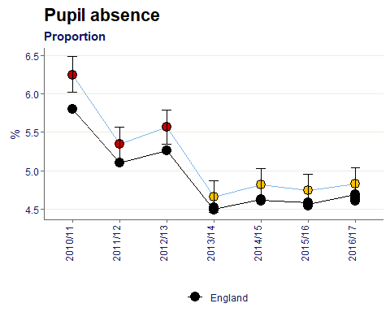
Pupil absence has been decreasing in Dudley since the peak in 2010/11. For the last 4 time periods from 2013-17 the proportion has been similar to the England value.

Rates of juveniles receiving their first conviction, caution or youth caution per 100,000 10-17 year old population by area of residence.
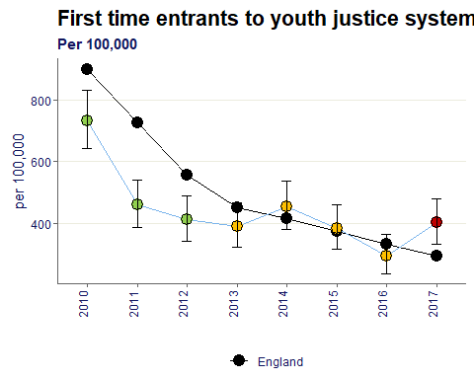
For the first time since 2010 Dudley has become significantly worse than England in the latest time period of 2017.
Although looking at Dudley in isolation the value has decreased by 45% comparing the 2010 to 2017.

% of 16-17 year olds not in education, employment or training (NEET) or whose activity is not known - current method
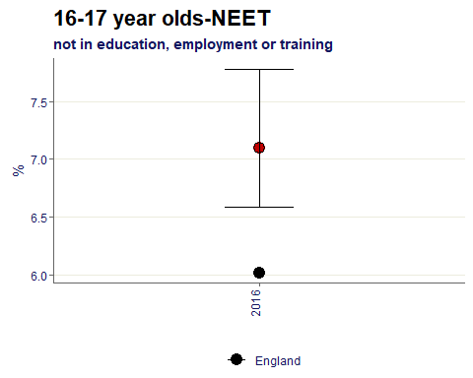
Note: methodology has recently changed for this indicator and the chart shows current method.
The Dudley value is significantly worse than the England baseline by 1.1% points.

% of adults with a learning disability who are known to the council, who are recorded as living in their own home or with their family
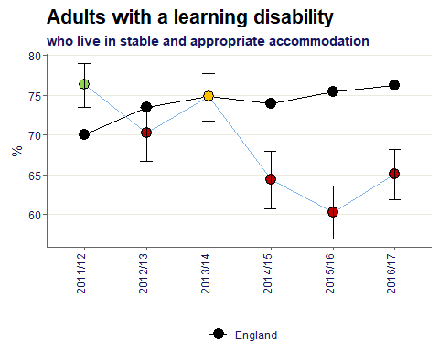
Over the time period shown Dudley’s percentage of adults with a learning disability living in appropriate accommodation has decreased by 10% points.
The value has been significantly worse than England since 2014/15.

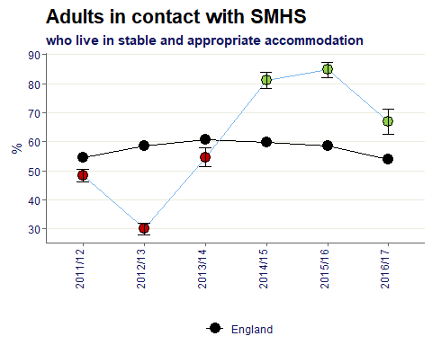
% of adults (age 18-69) who are receiving secondary mental health services on the Care Programme Approach recorded as living independently, with or without support.

Dudley has been significantly better than England for the latest 3 time periods, 2014-17.

The percentage point gap between the percentage of respondents in the Labour Force Survey who have a long-term condition who are classified as employed (aged 16-64) and the percentage of all respondents in the Labour Force Survey classed as employed (aged 16-64)
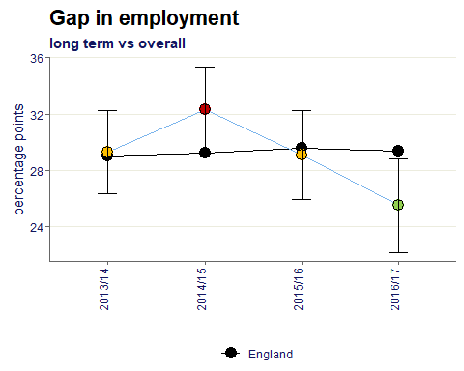
Since the highest value of 32.3% points in 2014/15, Dudley’s percentage points for gap in employment has reduced to 25.5% and is significantly better than England in 2016/17.

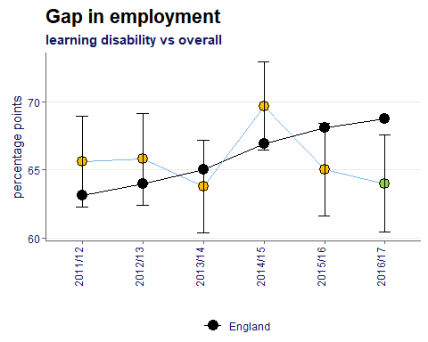
The percentage point gap between the percentage of working age learning disabled clients known to CASSRs in paid employment (aged 18 to 64) and the percentage of all respondents in the Labour Force Survey classed as employed (aged 16 to 64)

Since 2011/12 Dudley has historically been similar to England for the gap in employment for those with learning disabilities. However in 2016/17 has become better than the England value.

The percentage point gap between the percentage of working age adults who are receiving secondary mental health services and who are on the Care Programme Approach recorded as being employed (aged 18 to 69) and the percentage of all respondents in the Labour Force Survey classed as employed (aged 16 to 64)

The Dudley value has been similar to England for the most recent 4 data points.

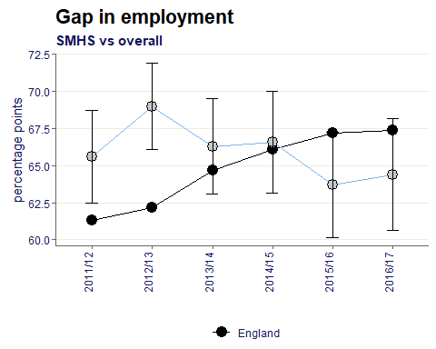

The percentage of all respondents in the Labour Force Survey classed as employed (aged 16-64)
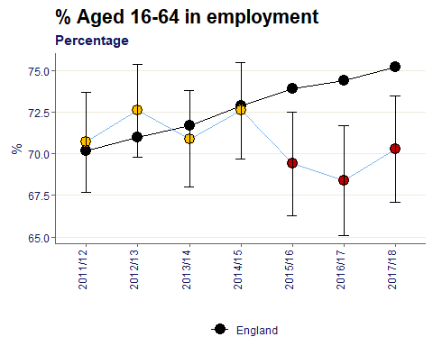
The percentage of people in employment in Dudley has fallen to become significantly worse than England since 2015/16. In the most recent data point of 2017/18 Dudley is 5% points behind the baseline with 70.3% of 16-64 year olds employed.

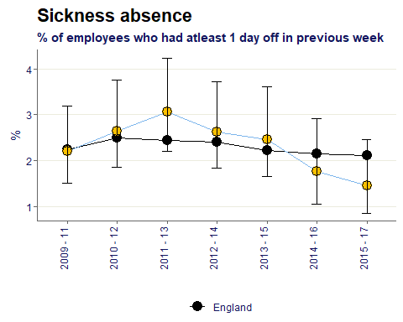
Percent of employees who had at least one day off due to sickness absence in the previous working week.

Sickness absence in Dudley is consistently similar to the England value. On average from 2009-17 the percentage of employees who had at least 1 day off in the previous week is 2.3%.

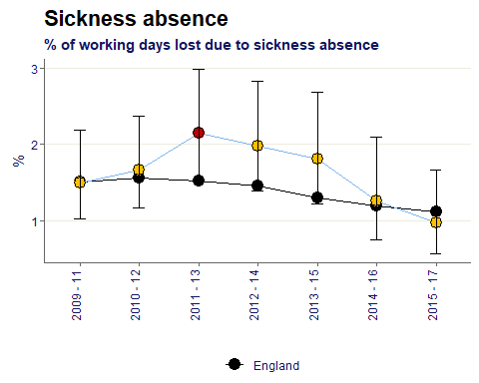
The percentage of working days lost due to sickness absence in the previous week

Generally the percentage of working days lost due to sickness in Dudley is consistently similar to England, with the exception of one year. The average value is 1.6% compared to the baseline of 1.4%.

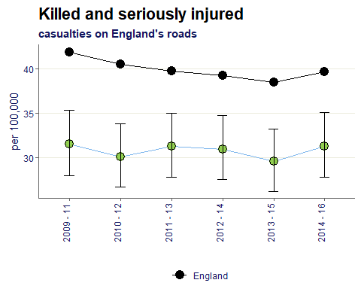
Rate of people KSI on the roads, all ages, per 100,000 resident population

The rate of serious casualties on Dudley roads is significantly better than England. The average from 2009-16 is 31%, which is 9% points lower than the baseline average.

Domestic abuse-related incidents and crimes recorded by the police, crude rates per 1,000
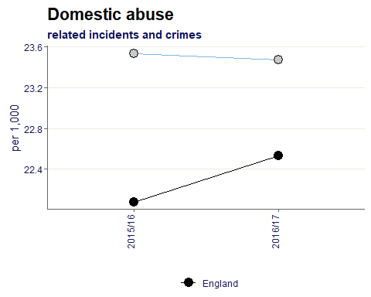
Note: the methodology has recently changed so there are a small amount of data points available for the current method.
Dudley’s rate is 23.5 per 1,000 compared to the Baseline value of 22.3.

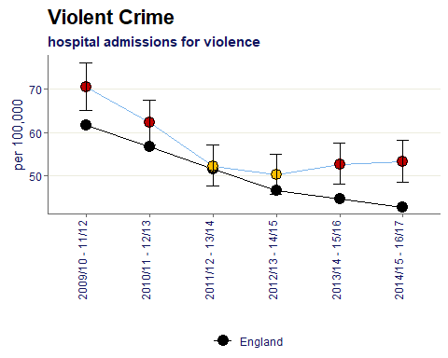
Age-standardised rate of emergency hospital admissions for violence per 100,000 population

Dudley’s rate of violent crime has reduced over time from 2009 to 2017 however is significantly worse than England in the most recent data point.

Violence against the person offences, based on police recorded crime data, crude rate per 1,000 population
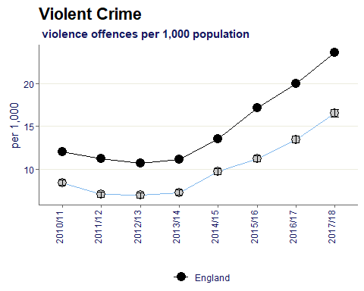
The rate of violent crime in Dudley has been increasing since 2014/15 to 2017/18, moving from 9.7 per 1,000 to 16.6 per 1,000.
The trend can be seen in the England values, although Dudley has remained below through the time periods given.

Rate of sexual offences based on police recorded crime data per 1,000 population
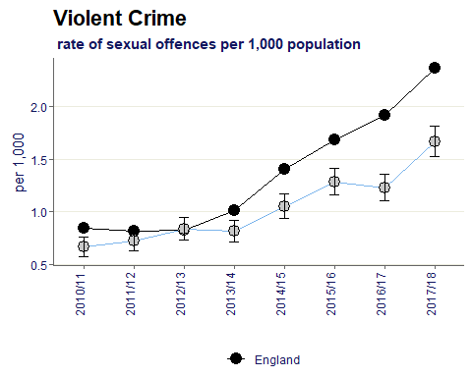

The same trend can be seen in the rate of sexual offences as violent crime. In the most recent time period the Dudley value is 1.7 per 1,000 whereas England is above at 2.4 per 1,000.

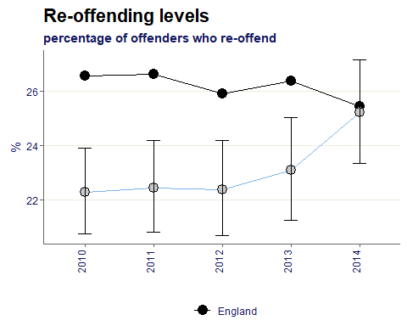
The percentage of offenders who re-offend from a rolling 12 month cohort.

Dudley’s percentage of offenders re-offending was consistently below the England values for 2010-2013, however in the most recent time period of 2014 the percentage is almost equal to England at 25.2% compared to 25.4%.

The average number of re-offences committed per offender from a rolling 12 month cohort.
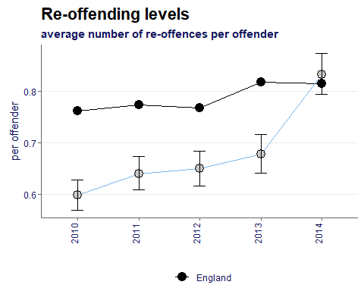

The same trend can be seen in the average of re-offences, however in 2014 the Dudley value has overtaken the England value at 0.83 per offender compared to 0.82.

Rate of first time offenders based on recorded via Police National Computer crime data per 100,000 population
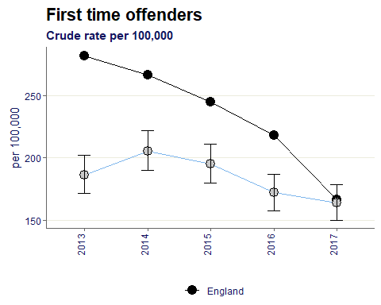
The rate of first time offenders in Dudley has fallen from the 2014 peak of 205.5 per 100,000 to 163.7 per 100,000 in 2017. In the latest time period the Dudley value is very close to the England benchmark.

Number of complaints per year per local authority about noise per thousand population (according to statistics collected by the Chartered Institute of Environmental Health (CIEH)).
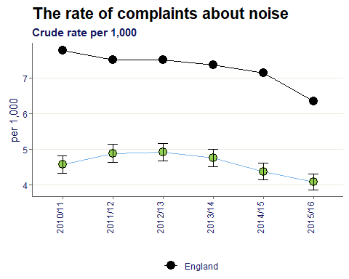

The rate of complaints about noise in Dudley is significantly better than England for all time periods shown.

The percentage of the population exposed to road, rail and air transport noise of 65 dB(A) or more, LAeq,16h per local authority (16h is the period 0700 - 2300) according to the results of the strategic noise mapping carried out as required by the Environmental Noise (England) Regulations 2006, as amended.
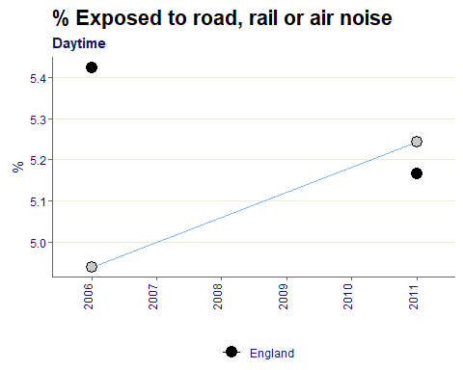
The Dudley value has increased from between 2006 to 2011 from 4.9% to 5.2% which means the values remain similar to the England average of 5.3%.

The percentage of the population exposed to road, rail and air transport noise of 55 dB(A) or more, Lnight (LAeq,8h) per local authority (8h is the period 2300 - 0700) according to the results of the strategic noise mapping carried out as required by the Environmental Noise (England) Regulations 2006, as amended.

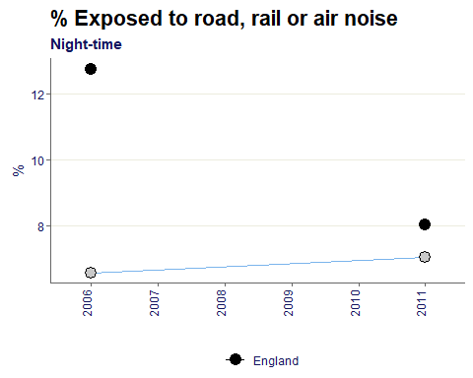
The complaints received for night time exposure is higher than the daytime naturally and averages 6.8% in Dudley compared to the England value of 10.4%.

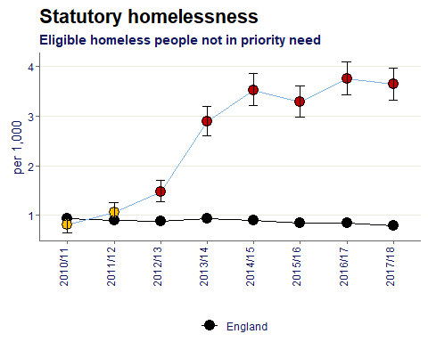
Eligible homeless people who are assed by their local authority but deemed to be not in priority need, crude rate per 1,000 estimated total households, all ages

The rate of eligible homeless people not in priority need in Dudley has been significantly higher than the England rate since 2012/13.
The Dudley trend has been increasing since 2012/13 moving from 1.5 per 1,000 to 3.6 per 1,000 in 2017/18.

Households in temporary accommodation, crude rate per 1,000 estimated total households, all ages, snapshot at 31st March, persons.
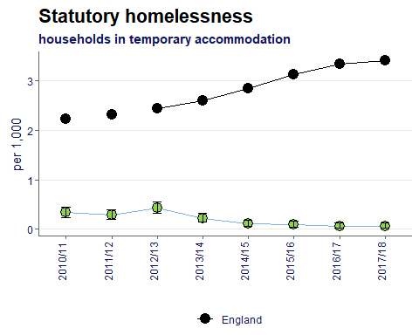
The rate of households in temporary accommodation in Dudley has been significantly better than England for all time periods shown.

The weighted estimate of the proportion of residents in each area taking a visit to the natural environment for health or exercise purposes.
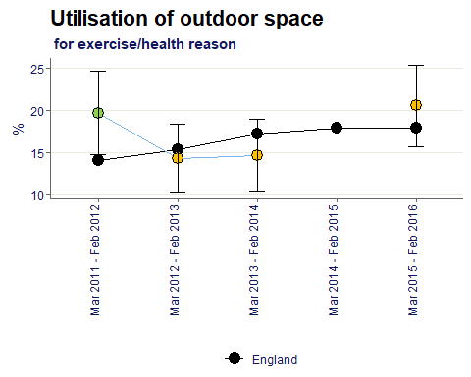
In the most recent time period of March 2015- Feb 2016, Dudley is similar to England for utilisation of outdoor space.

The percentage of households that experience fuel poverty based on the “Low income, high cost” methodology
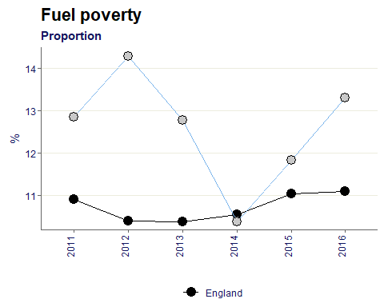
Fuel poverty has been increasing in Dudley since the 2014 lowest value of 10.4%. Most recently in 2016 the value has grown to 13.3% which is 2% points higher than England.

The percentage of respondents to the Adult Social Care Users Survey who responded to the question “Thinking about how much contact you’ve had with people you like, which of the following statements best describes your social situation?” with the answer “I have as much social contact as I want with people I like”.
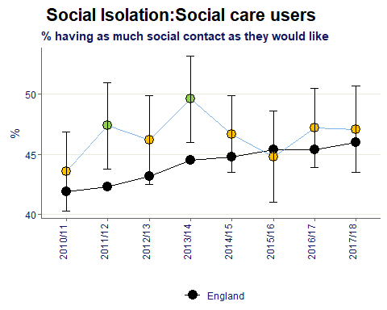
For the majority of surveys the percentage of social care users in Dudley having as much social contact as they would like is similar to the England value. On average in Dudley the value is 46.6%.

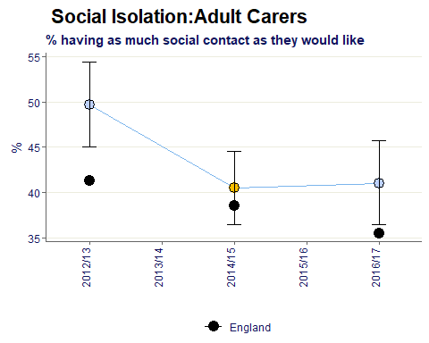
The percentage of respondents to the Personal Social Services Carers Survey who responded to the question “Thinking about how much contact you have had with people you like, which of the following best describes your social situation?” with the answer “I have as much social contact I want with people I like”.

On average in Dudley, 44% of adult carers get as much social contact as they would like is.

Citations:
All data sourced from https://fingertips.phe.org.uk/ under the terms and conditions of the Open Government Licence via the following software/packages:
R Core Team (2018). R: A language and environment for statistical computing. R Foundation for
Statistical Computing, Vienna, Austria. URL https://www.R-project.org/.

Sebastian Fox and Julian Flowers (2018). fingertipsR: Fingertips Data for Public Health.
R package version 0.2.0. https://CRAN.R-project.org/package=fingertipsR

Sebastian Fox (2018). fingertipscharts: Produce Charts that you See on the Fingertips
Website. R package version 0.0.3. https://CRAN.R-project.org/package=fingertipscharts

