Public Health Outcomes Framework

Overarching Indicators for Dudley compared to England

9 January 2019
Indicator | Page
Healthy life expectancy at birth-Female | 3
Healthy life expectancy at birth-Male | 3
Life expectancy at birth-Female | 4
Life expectancy at birth-Male | 4
Inequality in life expectancy at birth-Female | 5
Inequality in life expectancy at birth England-Female | 5
Inequality in life expectancy at birth-Male | 6
Inequality in life expectancy at birth England-Male | 6
Life expectancy at 65-Female | 7
Life expectancy at 65-Male | 7
Inequality in life expectancy at 65-Female | 8
Inequality in life expectancy at 65 ENGLAND-Female | 8
Inequality in life expectancy at 65-Male | 9
Inequality in life expectancy at 65 ENGLAND-Male | 9

Key Points
- For both genders Healthy life expectancy at birth has become significantly worse than England in the most recent time period.
- General life expectancy in females has increased overtime to 82.9 years and is similar to England. For males the growth has recently stopped and become worse than England dropping to 78.6 (a difference of 0.9 from baseline).
- There is a difference between genders in the inequality of life expectancy at birth. For females the gap has been increasing in recent years and the most recent value is higher than the England baseline. The opposite is true for males, the gap has been narrowing and is 0.3 years below the England value for the latest time period.
- Life expectancy at 65 follows the same trends as at birth life expectancy, however when looked at closely the male most recent time period that is significantly worse is 0.4 years difference from England.
- The inequality of life expectancy at 65 shows the same pattern as the at birth trends. Female inequality is increasing whereas males is decreasing.

Healthy life expectancy is a measure of the average number of years a person would expect to live in good health based on contemporary mortality rates and prevalence of self-reported good health.
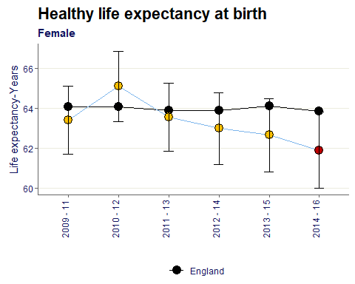
The healthy life expectancy at birth for females in Dudley has consistently been below yet still similar to the England value over time, however in the most recent data year is significantly worse than the baseline, with a 2 year age gap.

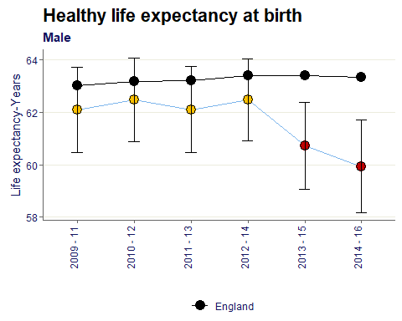
For all time periods shown Dudley’s male healthy life expectancy has been below the England baseline, in the most recent two time periods however the value has become significantly worse reaching the lowest point with a 3.5 year age gap in the most recent data.

Life expectancy at birth is the average number of years a person would expect to live based on contemporary mortality rates. For a particular area and time period, it is an estimate of the average number of years a newborn baby would survive if he or she experienced the age-specific mortality rates for that area and time period throughout his or her life.
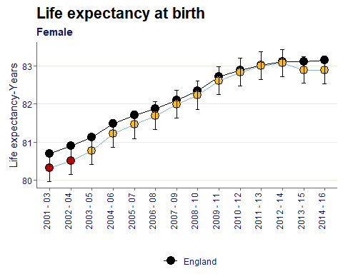
Female life expectancy has steadily been increasing since 2001-03 and has moved from worse than England to similar to. In the last two time periods however the growth plateaued at 82.9 years.

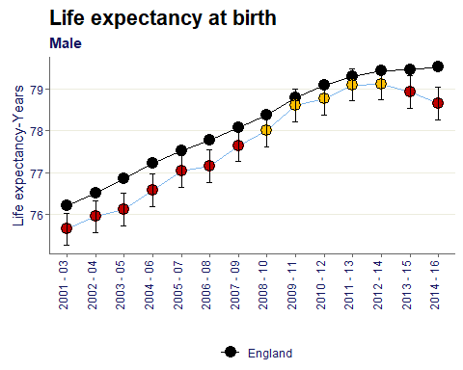
Similar to the female life expectancy the male counterpart also saw steady growth from 2001-03, unfortunately in the two latest time periods the value has become significantly worse than the England baseline and decreased from the 2012-14 peak of 79.1 years.

Inequality in life expectancy at birth represents the range in years of life expectancy across the social gradient from most to least deprived, based on a statistical analysis of the relationship between life expectancy and deprivation across all deprivation deciles.
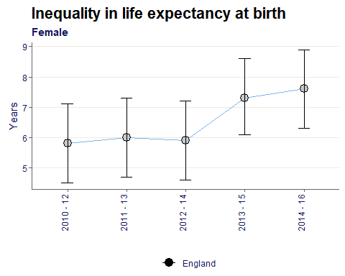
The gap between most and least deprived has increased by 1.5 years, from 2010-14 where the value was stable around 6 years to 7.6 in the most recent data point.
As seen from the chart below, this increase is shown in the England baseline also. The Dudley value is also higher than the baseline in the most recent year.

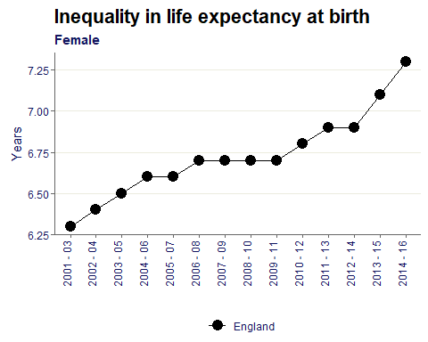

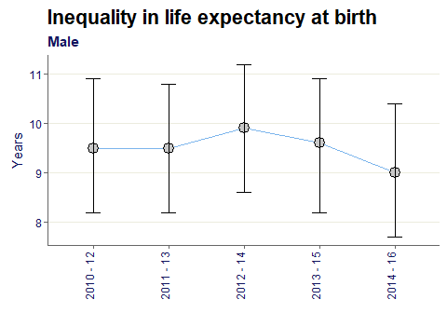
Contrary to female inequality the male gap has decreased in recent years. However generally for males the gap is wider compared to females, most recently the value is 9 years between lowest and highest deprivation.
For the latest time period the Dudley value is below the England baseline by 0.3 years.

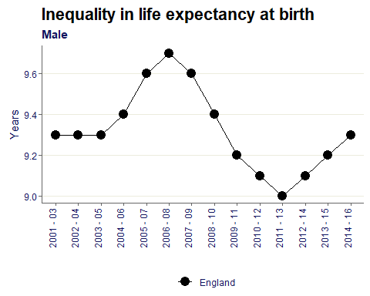

Life expectancy at age 65 is a measure of the average number of years a person would expect to live based on contemporary mortality rates. For a particular area and time period, it is an estimate of the average number of years a person aged 65 would survive if he or she experienced the age-specific mortality rates for that area and time period throughout the remainder of his or her life.
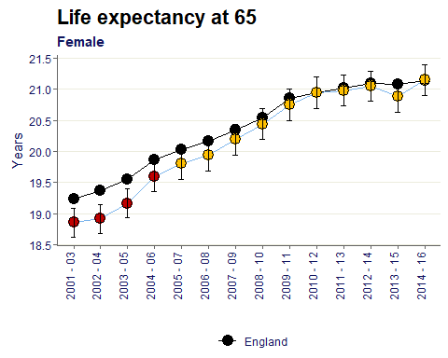
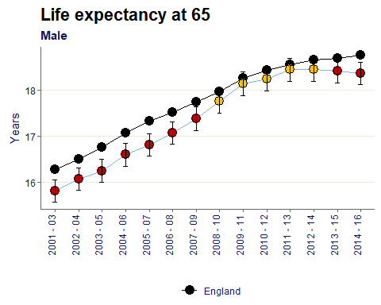

The trend here is very similar to life expectancy at birth. The Dudley value is almost the same as the England baseline in the most recent time period, with a difference of only 0.1 years.

The trend is similar to the life expectancy at birth whereby the most recent time period shows males being significantly worse compared to baseline. For life expectancy at 65 however the difference between Dudley and England is only 0.4 years.

Inequality in life Expectancy at 65 represents the range in years of life expectancy across the social gradient from most to least deprived, based on a statistical analysis of the relationship between life expectancy and deprivation across all deprivation deciles.
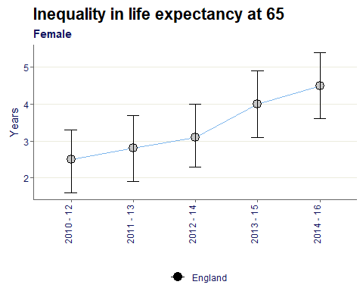
The difference between most and least deprived persons for life expectancy at 65 has steadily increased. With the gap growing from 2.5 years in 2010-12 up to 4.5 most recently.
This trend in a widening inequality gap is shown in the England values also.

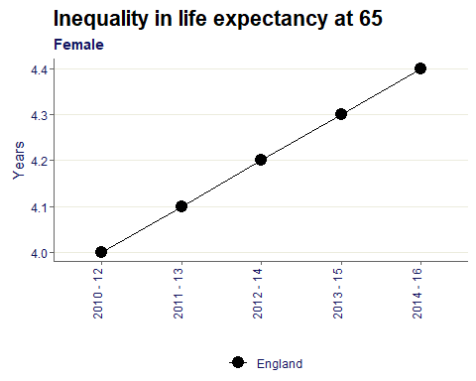

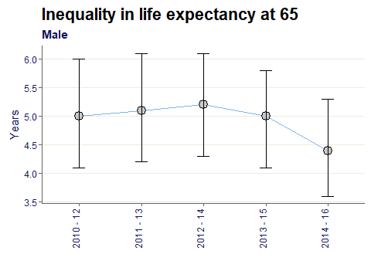
The gap shows to be decreasing for males from the 2012-14 peak down to 4.4 years.
Dudley is now below the England baseline by 0.4 years.

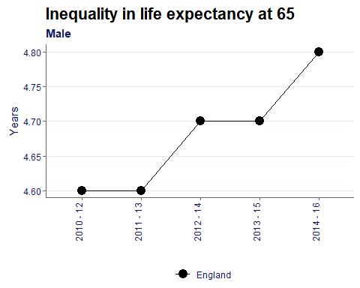

Citations:
All data sourced from https://fingertips.phe.org.uk/ under the terms and conditions of the Open Government Licence via the following software/packages:
R Core Team (2018). R: A language and environment for statistical computing. R Foundation for
Statistical Computing, Vienna, Austria. URL https://www.R-project.org/.

Sebastian Fox and Julian Flowers (2018). fingertipsR: Fingertips Data for Public Health.
R package version 0.2.0. https://CRAN.R-project.org/package=fingertipsR

Sebastian Fox (2018). fingertipscharts: Produce Charts that you See on the Fingertips
Website. R package version 0.0.3. https://CRAN.R-project.org/package=fingertipscharts

