

**Healthy Life Expectancy Report**

**Dudley**

May 2018

Produced by West Midlands Public Health Intelligence Group (WMPHIG)

Project Team

Greg Barbosa: Dudley Metropolitan Borough Council

Paul Campbell: Birmingham City Council

Paul Kingswell: Warwickshire County Council

Stella Botchway: Public Health England

Gareth Wrench: Public Health England

John Berry: Public Health England

Matthew Francis: Public Health England

# Executive Summary

Life expectancy at birth (LE) in females is not significantly different to the national average and has been stable whilst in males it has been falling and is now significantly worse than the England average.

Healthy life expectancy has been falling in both genders and is now significantly worse in Dudley when compared to the England average for both males and females.

The window of need is larger in Dudley for males and females than the England average. Males can expect to live 24% of their lives in poor health (18.7 years). In females the situation is worse and they can expect to live 27% of their lives in poor health (21.0 years).

In males the inequalities gap between the most and least deprived areas of Dudley is smaller when compared with the West Midlands and England. The gap is slightly larger for females in Dudley compared to the West Midlands and England however it is increasing.

Three of the top specific causes or variation in mortality are the same in both males and females, chronic obstructive pulmonary disease (COPD), coronary heart disease (CHD) and lung cancer.

Reducing smoking rates in the most deprived communities will reduce the incidence of lung cancer and prevalence of COPD and help reduce the inequalities gap.

Contents

Executive Summary 1

Introduction 3

Definitions 3

Life Expectancy at Birth in Dudley 4

Healthy Life Expectancy in Dudley 5

The ‘window of need’ 6

Local variation in healthy life expectancy and life expectancy 7

Causes of local variation in life expectancy and healthy life expectancy 10

Appendix 1: Supporting Information 13

# Introduction

This is the first in a series of reports that are being produced to strengthen evidence-based decision making and collaborative working between public health organisations within the West Midlands. The reports are intended for local authority colleagues working in a public health setting.

The reports have been shared with local authority public health intelligence leads for comment, and have also been discussed with members of the West Midlands Public Health Intelligence Group. For details on the context, rationale for selecting the included indicators, notes for interpretation, methodology, limits and caveats please read Appendix 1.

All of the data used in this report is from publically available sources which are detailed in Appendix 1.

# 

# Definitions

**CHD –** coronary heart disease

**Deciles –** deprivation deciles are based on the Index of Multiple Deprivation 2015. They are calculated by ranking the 32,844 low-layer super output areas in England from most to least deprived and dividing them into ten equal groups.

**Healthy life expectancy at birth** – the average number of years a person would expect to live in good health. The calculations are based on contemporary mortality rates and self-reported good health.

**Life expectancy at birth** – the average number of years a person would expect to live based on contemporary mortality rates. For a particular area and time period, it is an estimate of the average number of years a newborn baby would survive if he or she experienced the age-specific mortality rates for that area and time period throughout his or her life.

**Quintiles** – see the definition for “Deciles”. The data are divided into five equal groups rather than ten

**Slope Index of Inequality** – a measure of the social gradient in life expectancy. It is used to estimate how much life expectancy varies with deprivation within a population.

**‘Window of need’** – period of time between healthy life expectancy and life expectancy. It refers to the average time that a person can expect to live in poor health.

# Life Expectancy at Birth in Dudley

**Table 1: Life expectancy at birth, by West Midlands Local Authority 2012-14 to 2014-16**

|  |  |  |  |  |  |  |
| --- | --- | --- | --- | --- | --- | --- |
| **Geography** | **2012-14** | | **2013-15** | | **2014-16** | |
| **Male** | **Female** | **Male** | **Female** | **Male** | **Female** |
| England | 79.4 | 83.1 | 79.5 | 83.1 | 79.5 | 83.1 |
| West Midlands | 78.8 | 82.8 | 78.7 | 82.7 | 78.8 | 82.7 |
| Birmingham | 77.2 | 82.0 | 77.1 | 81.9 | 77.2 | 81.9 |
| Coventry | 78.5 | 82.2 | 78.4 | 82.3 | 78.5 | 82.4 |
| **Dudley** | **79.1** | **83.1** | **78.9** | **82.9** | **78.6** | **82.9** |
| Herefordshire | 80.5 | 84.1 | 80.4 | 83.9 | 80.1 | 83.6 |
| Sandwell | 77.0 | 81.2 | 77.1 | 81.3 | 77.0 | 81.4 |
| Shropshire | 80.1 | 84.0 | 80.3 | 83.8 | 80.5 | 83.7 |
| Solihull | 80.1 | 84.3 | 80.4 | 84.2 | 80.4 | 84.2 |
| Staffordshire | 79.6 | 83.1 | 79.6 | 83.0 | 79.7 | 82.9 |
| Stoke-on-Trent | 76.5 | 80.9 | 76.4 | 81.0 | 76.4 | 81.2 |
| Telford and Wrekin | 78.6 | 81.8 | 78.4 | 82.0 | 78.6 | 82.4 |
| Walsall | 77.9 | 82.4 | 77.3 | 82.3 | 77.2 | 82.0 |
| Warwickshire | 80.0 | 83.8 | 80.0 | 83.6 | 79.9 | 83.6 |
| Wolverhampton | 77.5 | 81.7 | 77.4 | 81.4 | 77.2 | 81.3 |
| Worcestershire | 79.6 | 83.4 | 79.7 | 83.5 | 80.0 | 83.8 |
|  |  |  |  |  |  |  |
| Key | Significantly worse than England | | No significant difference to England | | Significantly better than England | |

Source: ONS

* Life expectancy at birth in males is statistically significantly worse in Dudley than England. Life expectancy has been falling and has dropped by 0.5 years between 2012-14 and 2014-16.
* There is no statistically significant difference between life expectancy at birth in females in Dudley and England.
* Life expectancy in females is stable in Dudley.
* In 2014-16, life expectancy at birth in Dudley was ranked 96th highest out of 150 upper tier Local Authorities for males, whilst for females the corresponding figure was ranked 81st (Figures 1 & 2)

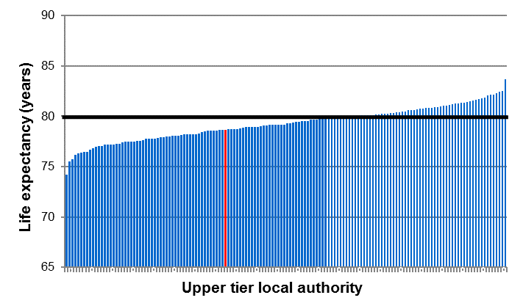

**Figure 2: Dudley female life expectancy compared with all upper tier LAs in England (2014-16)**

**Figure 1: Dudley male life expectancy compared with all upper tier LAs in England (2014-16)**

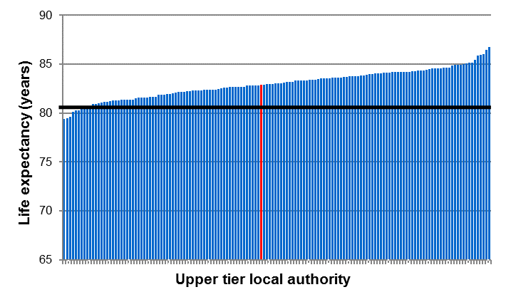

# Healthy Life Expectancy in Dudley

**Table 2: Healthy life expectancy, at birth, by West Midlands Local Authority, 2012-14 to 2014-16**

|  |  |  |  |  |  |  |
| --- | --- | --- | --- | --- | --- | --- |
| **Geography** | **2012-14** | | **2013-15** | | **2014-16** | |
| **Male** | **Female** | **Male** | **Female** | **Male** | **Female** |
| England | 63.4 | 63.9 | 63.4 | 64.1 | 63.3 | 63.9 |
| West Midlands | 62.4 | 62.8 | 62.4 | 63.2 | 62.6 | 63.2 |
| WMCA |  |  |  |  | 59.7 | 60.3 |
| Birmingham | 57.8 | 58.7 | 58.4 | 59.4 | 59.7 | 59.3 |
| Coventry | 61.3 | 63.4 | 62.9 | 63.8 | 62.2 | 62.9 |
| **Dudley** | **62.5** | **63.0** | **60.7** | **62.7** | **59.9** | **61.9** |
| Herefordshire | 66.9 | 66.4 | 67.9 | 68.2 | 67.4 | 66.5 |
| Sandwell | 59.0 | 57.8 | 57.7 | 59.7 | 57.1 | 59.5 |
| Shropshire | 64.7 | 66.2 | 64.7 | 65.7 | 65.4 | 67.6 |
| Solihull | 63.4 | 67.6 | 63.8 | 67.9 | 64.6 | 66.0 |
| Staffordshire | 63.7 | 62.8 | 64.4 | 63.8 | 64.9 | 65.4 |
| Stoke-on-Trent | 60.7 | 59.0 | 60.2 | 59.6 | 58.7 | 58.1 |
| Telford and Wrekin | 59.8 | 58.1 | 59.5 | 58.5 | 62.0 | 60.7 |
| Walsall | 59.1 | 60.4 | 58.1 | 59.0 | 57.7 | 57.2 |
| Warwickshire | 67.6 | 67.6 | 68.0 | 67.6 | 66.2 | 66.3 |
| Wolverhampton | 57.2 | 58.4 | 56.4 | 59.5 | 56.6 | 58.6 |
| Worcestershire | 66.6 | 67.9 | 65.6 | 67.7 | 66.7 | 68.0 |
|  |  |  |  |  |  |  |
| Key | Significantly worse than England | | No significant difference to England | | Significantly better than England | |

Source: ONS

* Healthy life expectancy in males is statistically significantly worse in Dudley than England and has been declining.
* In females there was no statistically significant difference between Dudley and England, but in 2014-16 healthy life expectancy in females dropped to significantly worse than the England average.
* In 2014-16, healthy life expectancy at birth in Dudley was ranked 112th highest out of 150 upper tier Local Authorities for males, whilst for females the corresponding figure was ranked 97th (Figures 3 & 4).

**Figure 3: Dudley male HLE compared with all upper tier LAs in England (2014-16)**

**Figure 3: Dudley female HLE compared with all upper tier LAs in England (2014-16)**

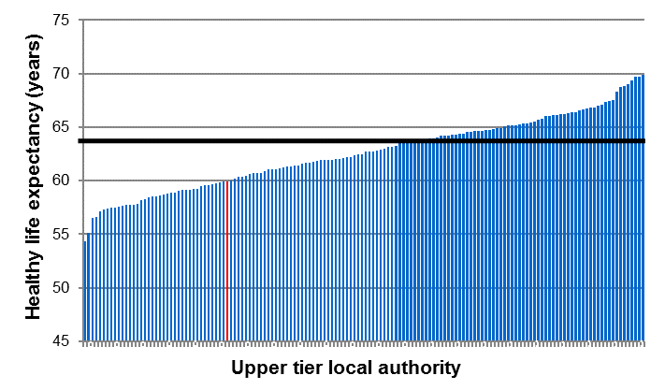



# The ‘window of need’

**Figure 5: Life expectancy and health life expectancy at birth and the ‘window of need’ Dudley and England, 2014-16**

**‘Window of Need’**

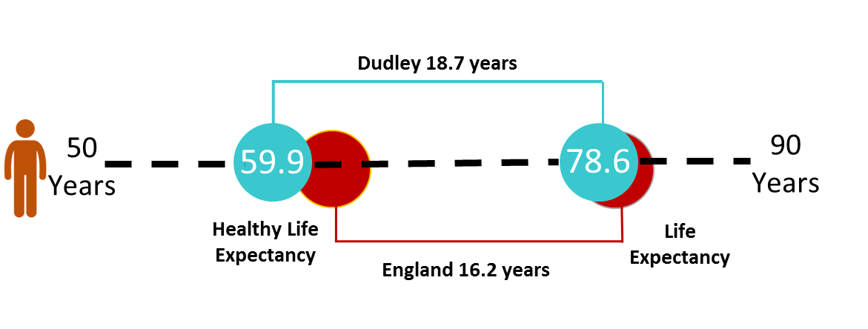

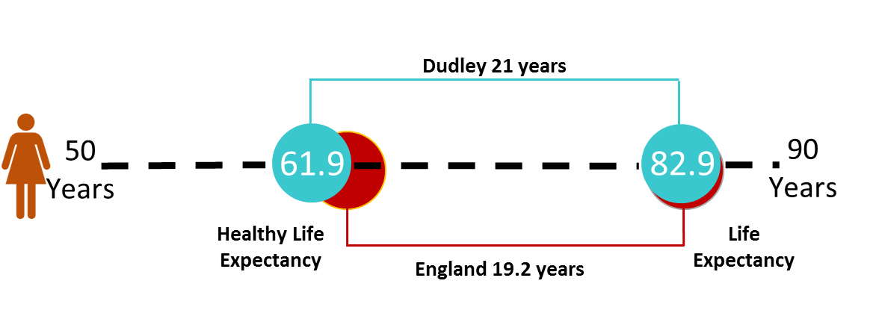

Source: ONS

* The ‘window of need’ is calculated as the difference between life expectancy and healthy life expectancy
* Average life expectancy and relatively low healthy life expectancy mean the ‘window of need’ in Dudley is larger than that for England.
* The ‘window of need’ is larger in females than males in both Dudley and England.
* The high ‘window of need’ in females in Dudley is a consequence of average life expectancy and a lower than average healthy life expectancy.
* The ‘window of need’ for males living in Dudley is larger than the England average, although life expectancy in males in Dudley is lower than in England the larger factor is the low healthy life expectancy in males in Dudley.

# Local variation in healthy life expectancy and life expectancy

**Figure 6: Variation in life expectancy between the most and least deprived deciles, 2014-16 Dudley**

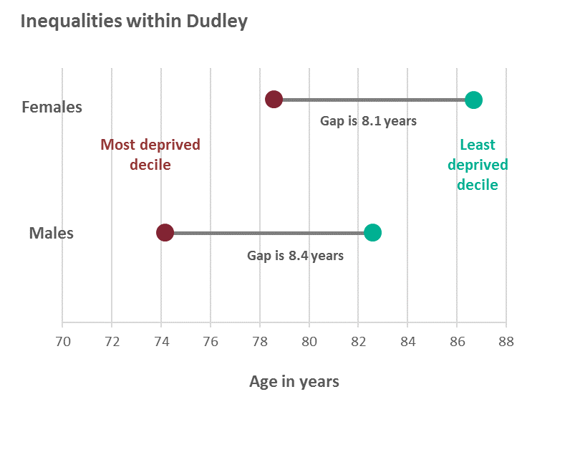

Source: Public Health Outcomes Framework. PHE

* The life expectancy gap is calculated as the difference between life expectancy in the least and most deprived areas of Dudley
* There is a larger gap between the most deprived decile and least deprived decile in life expectancy in males (8.4 years) than females (8.1 years).
* The life expectancy gap in males is much smaller compared to the West Midlands (9.1) and England (9.4)
* The life expectancy gap in females is slightly wider compared to the West Midlands (6.8) and England (7.4)

**Figure 7: Trend in the life expectancy inequalities gap (based on the Slope Index of Inequality) in Dudley, 2010-12 to 2014-16**

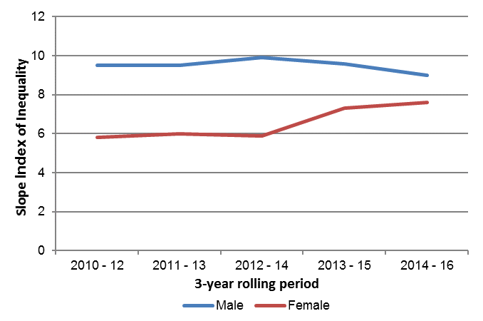

Source: Public Health Outcomes Framework. PHE

* The values in Figure 6 are based on the absolute difference between the most and least deprived quintiles, whereas this section is based on the Slope Index of Inequality.
* Since 2012-14 the life expectancy gap in males has been declining
* In females there has been an increase in the life expectancy gap in the two time periods since 2012-14.

**Figure 9: Life expectancy in females in Dudley, 2011-15**

**Figure 8: Life expectancy in males in Dudley, 2011-15**

2011-15

Life expectancy at birth for females, 2011-2015 *– source ONS © Crown Copyright* *2017*

Life expectancy at birth for males, 2011-2015 *– source ONS © Crown Copyright 2017*

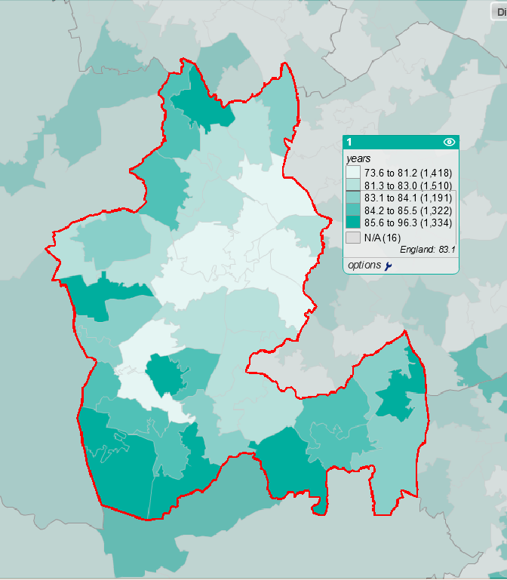



Source: Local Health. ©PHE - © Crown copyright and database rights 2014, Ordnance Survey 100016969 – ONS © Crown Copyright 2014 – Middle level SOA (2011)

**Figure 11: Healthy life expectancy in females in Dudley, 2009-13**

Healthy life expectancy at birth for females, 2009-2013 *– source ONS © Crown Copyright 2015*

Healthy life expectancy at birth for males, 2009-2013 *– source ONS © Crown Copyright 2015*

**Figure 10: Healthy life expectancy in males in Dudley, 2009-13**

* There is significant variation in life expectancy in Dudley with the central areas focused on Dudley town experiencing the lowest life expectancy whilst higher figures are observable in the south near Stourbridge and Halesowen and north near Sedgley.
* Patterns for healthy life expectancy follow a similar geographic distribution in males and females to life expectancy.
* Dudley town is dominated by areas with low levels of healthy life expectancy. In contrast in the south of the borough 3 Middle Super Output Areas (MSOAs) out of 46 are in the highest healthy life expectancy quintile in males and only one in females.

# Causes of local variation in life expectancy and healthy life expectancy

There are different causes for the gap in life expectancy between the most and least deprived areas which vary across the different local authorities. In some locations there may be one dominant cause which can provide a focus for policy and strategy, whereas for others there may be a number of causes which add up to a large impact.

**Figure 12: Scarf chart showing the distribution of the life expectancy gap between Dudley’s most and least deprived quintiles, by broad cause of death, 2012-2014**

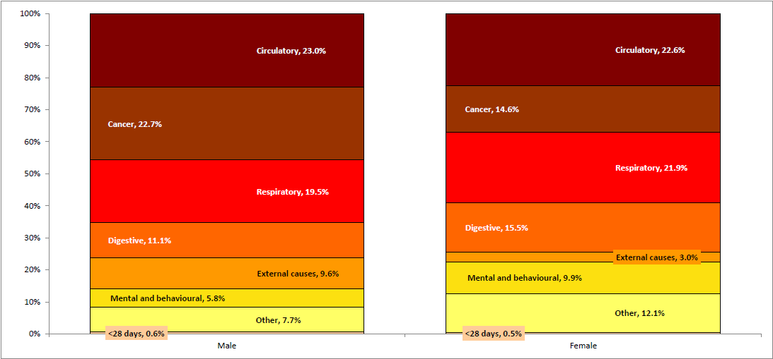

Source: Segment Tool updated May 2016. PHE

In Dudley the largest contributors to the gap in life expectancy in males are:

1. Circulatory Disease (23.0%)
2. Cancer (22.7%)
3. Respiratory Disease (19.5%)

Together these 3 causes account for 65.2% of the variation between males living in the least and most deprived areas of Dudley.

In Dudley the largest contributors to the gap in life expectancy in females are:

1. Circulatory Disease (22.6%)
2. Respiratory Disease (21.9%)
3. Digestive (15.5%)

The three top causes in females account for 60.0% of the difference between females living in the least and most deprived areas of Dudley.

**Figure 13: Tree chart showing the distribution of the male life expectancy gap between Dudley’s most and least deprived quintiles, by detailed cause of death, 2012-2014**



The Tree chart shows the largest causes of local variation in life expectancy by specific disease type in males in Dudley. The larger the square the bigger the variation between the most deprived and least deprived quintiles.

The single biggest cause of early mortality in the most deprived males in Dudley compared to the least deprived are cancers. ‘Other cancer’ and lung cancer are two of the top 4 causes. Chronic obstructive pulmonary disease (COPD) is the second highest cause followed by coronary heart disease (CHD).

If outcomes in these 4 causes of mortality improved so that most deprived experienced the same mortality rates as the least deprived the life expectancy gap in males in Dudley would reduce by almost 3 years.

Improving cancer survival in males should be a priority for reducing inequalities in mortality.

**Figure 14: Tree chart showing the distribution of the male life expectancy gap between Dudley’s most and least deprived quintiles, by detailed cause of death, 2012-2014**



In females 6 causes of mortality (although one of these is ‘other’) account for the majority of the variation between the most and least deprived quintile.

Lung cancer and COPD account for 30% of the variation and are responsible for almost a 1.5 year decrease in life expectancy in people living in the most deprived quintile.

The top causes of variation in females are more disparate (respiratory, cancer, neurological and cardiovascular) however reducing smoking rates in females living in deprived areas should reduce the incidence of lung cancer and COPD.

# Appendix 1: Supporting Information

**Data Sources:**

Life expectancy at birth - <https://www.ons.gov.uk/releases/healthstatelifeexpectanciesuk2014to2016>

Healthy life expectancy at birth -

<https://www.ons.gov.uk/releases/healthstatelifeexpectanciesuk2014to2016>

Variation in life expectancy between the most and least deprived areas of a local authority –

<https://fingertips.phe.org.uk/profile/public-health-outcomes-framework>

Slope index of inequality -

<https://fingertips.phe.org.uk/profile/public-health-outcomes-framework>

Maps of life expectancy and healthy life expectancy at birth -

<http://localhealth.org.uk>

Causes of local variation in life expectancy gap -

<https://fingertips.phe.org.uk/profile/segment>

**Definitions**

**Life Expectancy**

Two life expectancy calculations are commonly used in public health analysis: life expectancy at birth, and life expectancy at 65 years.

Life expectancy at birth is the average number of years that would be lived by babies born in a given time period if mortality levels at each age remain constant. For a particular area and time period, it is an estimate of the average number of years a newborn baby would survive if he or she experienced the age-specific mortality rates for that area and time period throughout his or her life.

Similarly, LE at age 65 is the average number of remaining years of life that a man or woman aged 65 will have if mortality levels at each age over 65 remain constant. For a particular area and time period, it is an estimate of the average number of years at age 65 a person would survive if he or she experienced the age-specific mortality rates for that area and time period throughout his or her life after that age.

**Healthy Life Expectancy**

HLE at birth is an estimate of the average number of years babies born in a given time period would live in a state of ‘good’ general health if mortality levels at each age, and the level of good health at each age, remain constant in the future. Similarly, healthy life expectancy at age 65 is the average number of remaining years a man or woman aged 65 will live in ‘good general health’ if mortality levels and the level of good health at each age beyond 65 remain constant in the future.

HLE is often used in conjunction with life expectancy (LE).

**Methodology**

LE calculations are based on observed mortality data, so are a robust way of estimating levels of mortality which can be reported in a way which is easily understood.

It is worth noting that barring significant catastrophic events, mortality rates in developed countries have tended to reduce and therefore LE has, over time, increased.

Since the method to calculate HLE is really an extension of the method used to calculate LE, appropriate consideration of the tendency for year on year increases needs to be made when working with HLE estimates.

HLE adds a ‘quality of life’ dimension to estimates of life expectancy by dividing it into time spent in different states of health. HLE can be calculated with different measures of good health, but the method currently used by the Office for National Statistics (ONS) uses the general health question in the Annual Population Survey (APS).

From the question “How is your health in general; would you say it was….”, there are five possible responses: “Very good”, “Good” (characterised as “Good health”), “Fair”, “Bad” or “Very bad” (characterised as “Not good” health).

Data from the APS are used to calculate the prevalence of good health in each age band. For younger age bands, estimates are achieved using a Census imputation method. The Census is being further explored as a mechanism for imputing values for areas with low APS survey response.

These figures are used by ONS with age-specific mortality rates, so that they can calculate estimates not only of the number of years lived within a population, but also the number of years lived in good health. These estimates can then be used to calculate both LE and HLE.

The current methodology can be examined in detail using the ONS healthy life expectancy template:

<https://www.ons.gov.uk/peoplepopulationandcommunity/healthandsocialcare/healthandlifeexpectancies/datasets/healthstatelifeexpectancytemplate>

**Limitations**

As the data are self-reported, the answers reflect respondents’ subjective perception of their general health. Therefore, two people with the same, or similar, health conditions may respond differently to the questionnaire.

The APS only covers around 1% of the UK population and does not include residents of communal establishments. At a local level this means that some population groups may be under-represented. This under-representation is adjusted for in the modelling calculations, but there is still a possibility that a small number of responses may be driving the derivation of the overall response for that population group. The responses are also open to bias based on respondents’ social and cultural backgrounds and other demographics such as responder age.

Despite its limitations, HLE provides insight into how long people may be expected to live in good health, and allows policy makers to act accordingly. It captures mortality risk and health states with a clear method.

**Interpretation**

HLE combines measures of both mortality and morbidity. This means that there are two variables that interact with each other and can change. Therefore, two areas with identical HLE estimates may have very different underlying prevalence of good health, or they could have the same underlying prevalence of good health but very different rates of mortality.

It is important to note that estimates of HLE can change as a result of demographic shifts or subtle adjustments to the survey questions, as well as changes in the prevalence of good health and life expectancy. These issues should be considered when comparing different populations, or the same population over time. For example, when comparing progress over time it is possible for an area to have increasing HLE, but the true prevalence of good health may actually be falling.